University of Bradford Rotary Peace Centre
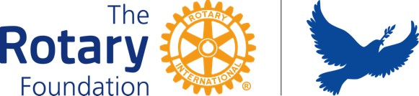

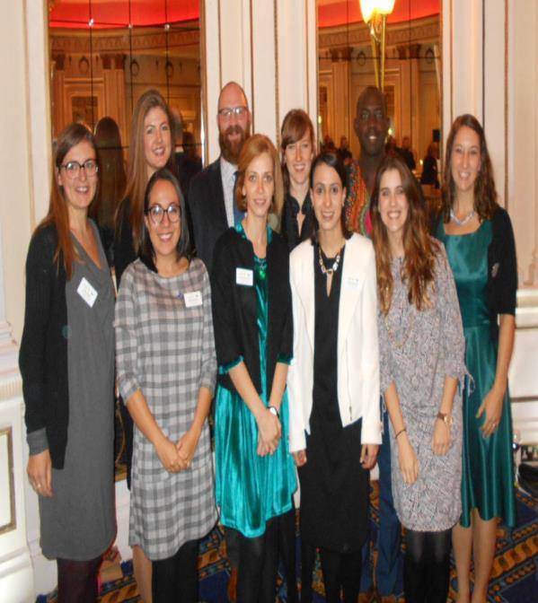
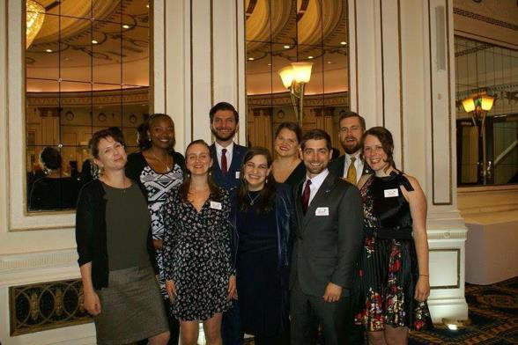
Class XVI – Rotary Peace Fellows Class XV – Rotary Peace Fellows



Annual Repot 2017/2018

Board 63
Rotary International Staff 63 Further Information 65
54
59
Extra Curriculum Activities and Leaning 7 The Hague Study Visit 7
Oslo Visit 9
Rotary International Presidential Peacebuilding Conference: Coventry 11
Crisis Game 13
Conflict Sensitivity Training: Making Knowledge Work 14
Living History - From Brazil to Ethiopia 15 Hawassa Industrial Park 17
Distinct and Identical: A Reflection on the WWI Centenary 19 Study Trip: Northern Ireland 21
Invited Speakers at Peace Studies and International Development 24
Visitors from Rotary Foundation 26
Area Host Rotarian 26
Curriculum by Degree Programme 28
Academic Staff 49 PSID Support Staff 52
Rotary Peace Fellows 2017-18, class XVI Rotary Peace Fellows 2016-17, class XV
Table of Content
Overview of the Programme 3 Away Day/ Team Building 5 Teaching 6

Overview of the Programme 2017/2018

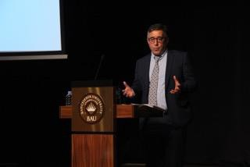
Professor Behrooz Morvaridi, Director, Bradford Rotary Peace Centre

The Division of Peace Studies and International Development has undertaken a fundamental curriculum review in order to ensure that our programmes at postgraduate level remain innovative and pioneering in approach, combining the latest developments in pedagogy with cutting edge research in the field of peace and development studies. The degrees build on, integrate and enhance the MA Programmes in Peace Studies (see pages 28 -48).
In developing the new programme structure, the Division has paid close attention to national level statements made by British Higher Education bodies on standards and disciplinary conventions, including the Framework for Higher Education Qualifications issued by the UK Quality Assurance Agency for higher education and the Subject-Specific Benchmarks. We have also paid close attention to Bradford University’s new Learning and Teaching Strategy and the University’s Statement of Graduate Attributes. In so doing, we ensure that our programmes are delivered in a student-centred and participatory way, to promote development of learner autonomy and development of professional competencies relevant to the kinds of employment that our students typically enter after leaving our programmes.
The programmes provide opportunities for students to engage in analysis, decision- making and problem-solving around real-world practice-based scenarios, developing capacities for informed judgement, critical thinking, and effective engagement with international and local practitioner communities. Students undertake guided projects that allow the pursuit of individual interests and responses to contemporary issues. We have increased our use of out-of-classroom study experiences, including

fieldwork, study tours, simulations and role-play scenarios, and we are already trialling this through a range of initiatives such as the Northern Ireland Study Tour and the Crisis Game that took place in March this year (see detailed reports on various activities in the following pages).
Our programmes directly address the University’s priority theme of ‘Sustainable Communities’, not only in relation to regions, countries and local communities in developing, fragile and conflict affected regions, but also in relation to the international community whose long term sustainability and well-being depends on addressing peace, conflict, security and development issues globally. Our programmes are concerned with “applying knowledge for the prosperity and well- being of people”. We help students to develop knowledge, skills and competencies that support ethical and effective responses to peace, conflict relationships. Our approach is informed by current research on the contexts of practice within which peace practitioners operate, including many global challenges signalled in development studies (poverty and inequality, climate change, food security, water and sanitation, health, education etc.).
For Rotary Fellows, the MA course is fifteen months in length and comprises four semesters. In Semesters 1 and 2, the Fellows study six core and optional modules, which differ depending on their programme. In Semester 3, the Fellows undertake a period of Applied Field Experience of 8-12 weeks. This takes the form of a placement with an organisation engaged in peace work of some form and must be approved by the Centre Director. In Semester 4, the Fellows complete a 15,000 words dissertation on a topic of their choice under the guidance of a supervisor from within the Division of Peace Studies. The programme is structured around compulsory core modules, with flexibility built in through optional modules chosen by students to meet their own objectives and interests. Students must normally complete a total of 120 credits of taught modules. They also must complete a dissertation (60 credits). To be awarded the degree of MA or MSc, students must complete a total of 180 credits.

While at Bradford, Rotary Peace Fellows develop a balance of theoretical and practical knowledge and skills by completing a rigorous MA programme, working and volunteering with Rotarians across the UK and engaging in a three month Applied Field Experience (AFE). AFEs occur during the middle of the fellowship and give Peace Fellows an opportunity to extend their professional skills and knowledge into new areas while collecting data for their Master’s dissertation.

Class XV Fellows completed their AFEs in September 2017 with a variety of influential and impactful organizations across eleven countries and six continents.

Rotary Peace Fellows - Class XV Applied Field Experiences

- Annelies Hickendorff: Stockholm International Peace Research Institute – SIPRI (Sweden)
- Holly White: Migration Research Center at Koç University (Turkey)
- Jody-Ann Anderson: Igarape Research Institute (Brazil) and BRICS Policy Center (Brazil)
- Kristyn Behrends: Mercado Global (Guatemala)
- Melissa Diamond: International Organization for Migration (Egypt), The Melissa Network (Greece), and Summer University Srebrenica (Bosnia and Herzegovina)
- Mike Niemiec: Center of Excellence for Stability Policing Units (Italy)
- Sasha Davis: Mercy Corps (Lebanon)
- Will McInerney: UN Women National Committee (Australia) and Cambridge Peace and Education Research Group (UK)
- Zach Tilton: International Alert (UK) and Everyday Peace Indicators (UK)

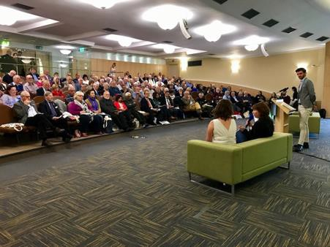
In October 2017, the Rotary Peace Centre hosted The Annual Bill Huntley Rotary Peace Seminar. Over 200 students, scholars, Rotarians, and community members gathered at the University of Bradford to listen to the Class XV Rotary Peace Fellows talk about their background and motivations, their AFEs and dissertation research. Nava Ghalili, an
Emmy-nominated journalist from US, was the seminar keynote speaker. Nava spoke about her work on youth radicalization, countering violent extremism and promoting global human rights.
We are proud of the achievements of our Peace Fellows. Last Academic year all Rotary Peace Fellows were awarded MA degrees with Distinction. We hope to pursue similar results this year and we are looking forward to welcoming this year’s cohort of Peace Fellows, Class 2017. Throughout this academic year, an exciting range of courses and topics will be offered and the new peace fellows will have plenty of scope to develop a personal and creative study experience.

Professor Behrooz Morvaridi
Director, Bradford Rotary Peace Centre b.morvridi@bradford.ac.uk

Away Day Team Building
On the arrival of Class XVI at Bradford we organised an interactive team-building workshop at the Saltaire UNESCO World Heritage Site. A key theme of the team-building workshop was play and being playful. The aim of the day-long workshop was to encourage trust, reflection, engagement and conversation through movement. The instructor encouraged Peace Fellows to think about how this approach might be applicable and transferable to situations in which they are trying to bring people together on common ground and to create a sense of shared space. The outcomes were positive: the participants felt better connected and a deepened sense of community with their peers.
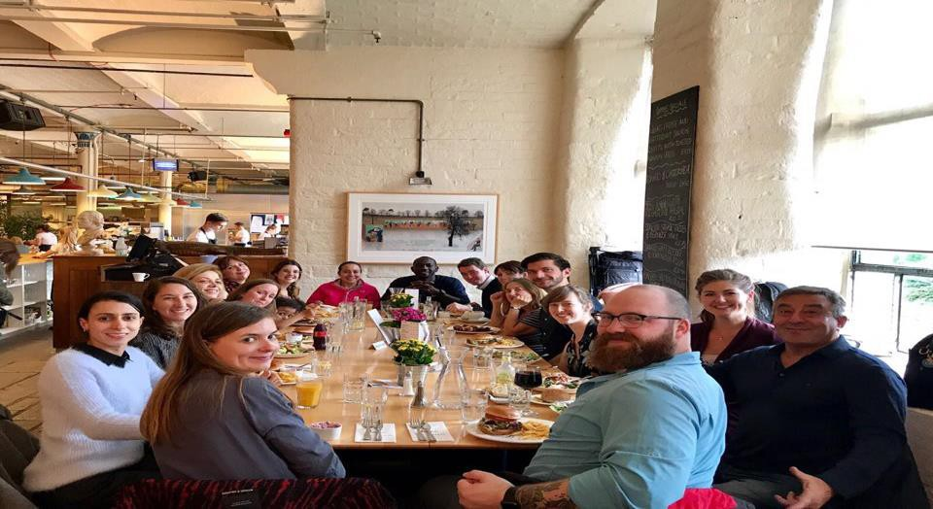
Rotary Peace Fellows – Class XVI at away day/team building at Salts Mill near Bradford

Teaching

Our teaching is very interactive and focussed on professionalism and employability. Our degree courses promote the development of analytical, practical and interpersonal skills. We give Peace Fellows materials in different formats -- verbal, visual and written -- as well as opportunities for direct experience and observation. Throughout the programme, they are encouraged to actively engage in a diverse range of learning activities designed to develop their capacities for thoughtful analysis and reflective practice. These include individual and group tasks that require them to apply theoretical concepts to real-world dynamics and scenarios through field trips, extended simulation games and ‘immersion days’ on key topics. The aim is that they develop a wide range of tangible skills directly applicable to a wide range of careers in peace, conflict and international development. Our teaching and assessment methods are tailored to a wide range of learning styles, and meant to keep peace fellows busy, engaged and enjoying their course.
The new curriculum has been carefully designed to ensure coherence and progression through the different stages of study. So, all the modules in a year are connected to each other thematically. Each semester Peace Fellows build on the

learning of the previous semester and are asked to work at a higher level of skill. The many and varied opportunities to learn from each other foster an inclusive learning environment. We want to encourage collaboration and honest dialogue and we stress the development of interpersonal and intercultural skills. Our aim is to develop reflective practitioners who take a thoughtful approach to engaging with others.
Our assessment is designed not just to measure achievement, but also to shape and guide students’ learning through preparing them for the increasing level of challenge as they progress through their degree. Together, these lead to developing a distinctive set of graduate attributes, which will prepare students for life beyond university.
Extra-Curricular Activities and Learning
In addition to the formal curriculum, we offer many exciting extra-curricular activities. Extra-curricular activities include study trips, visiting speakers, trainings and attendance at relevant conferences, and visits to and from projects and practitioners. For example, the Northern Ireland study trip benefits from our close ties to many peace building organisations and groups in the region, such as the Corrymeela Community. It is a wonderful opportunity to see at close hand how divided communities are building bridges and practising reconciliation (see detailed report on page 21).

The Hague Study Visit 10 – 13 January 2018
Natalia Gutierrez Trujillo, Bradford Rotary Peace Fellow, class XVI
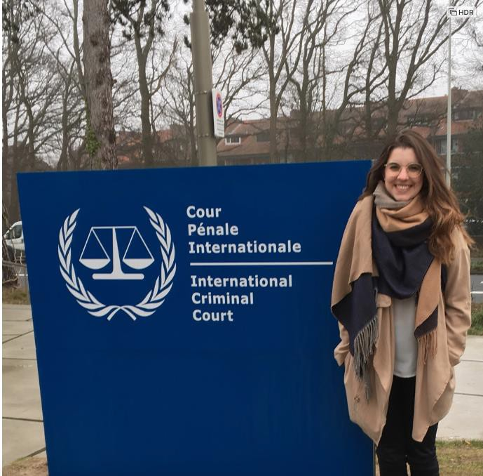

In our annual visit to The Hague, students meet with international bodies based there such as the Organisation for the Prohibition of Chemical Weapons. At the International Criminal Tribunal for the Former Yugoslavia, our students were able to listen to live testimony in actual criminal proceedings that resulted in November 2017 in the conviction of Ratko

Mladić, a Bosnian Serb army commander on charges on genocide and crimes against humanity. For those studying justice and reconciliation, it was an extraordinary moment.
In January we had the wonderful opportunity to travel to The Hague-Netherlands in a study visit with the University. Our journey began in the Organization for the Prohibition of Chemical Weapons (OPCW) where we were able to see how this important organization works, to meet students from other parts of Europe and ask interesting questions about outcomes related to the control and destruction of these types of weapons. We were able to analyze the cases, such as that of Syria, while we explored the different challenges that come with weapons treaties.

We visited Humanity House, an amazing building where different organizations work everyday to make our world more peaceful. Here we met with Anton Petrenko, the OSCE High Commissioner on National Minorities, who talked about the conflict in Moldova and explained the importance of inclusion of different kinds of minorities (religious, racial, ethnical, etc) in the policy-making process and in society in general. After dinner together, we had a fun quiz, which tested our knowledge about peace, music, climate change and conflict.

The next day was one of the most incredible days in my life. At the International Criminal Court (ICC) we had the opportunity to observe the trial against Dominic Ongwen, accused of war crimes in the conflict in Uganda. It was a dream that finally came true for me personally - witnessing how the court works and developing my understanding of the complexities of the law, its multiple interpretations and tension points was one of the best opportunities I ever had in my life.

Afterwards we went to the International Criminal Tribunal for the former Yugoslavia (ICTY), where we had a tour through the Public Gallery and the Courtroom Ms. Rada Pejic-Sremac, a member of the prosecution team, talked about processes, the difficulties of trials and the different emotions they are exposed to everyday. She showed us a video of criminals confessing their crimes and telling the truth to victims, which was one of the most painful things I have ever seen in my life. I had a mix of feelings during this whole process - on the one hand I was thinking about the importance of international organizations that work on behalf of victims, how in my country Colombia our victims are waiting to finally know the truth and for their aggressors to ask for their forgiveness, and that, even though international trials take many years, at least something is being done. On the other hand, I felt happy to be part of an amazing group of students and with people who are working really hard to make a better world, to promote peace and find ways to prevent terrors like the ones we were witnessing.

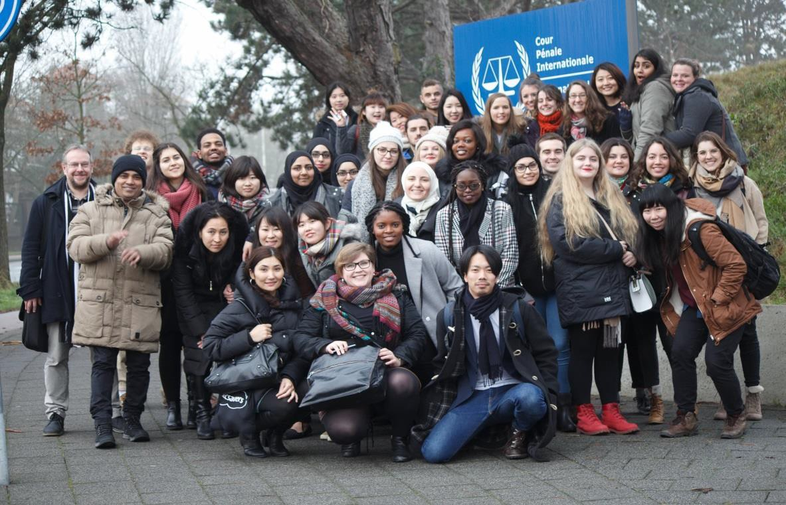

Finally we had the chance to see how all our theories, ideals and knowledge can deliver real change. Two young women from the Clingendael Institute and the Secretariat of the Global Partnership for the Prevention of Armed Conflict talked to us about their different professional fields, the kind of roles where we could put our learning into practice. They worked in field research, policy-making and project funding in almost every region in the world. They showed us how our work can apply to different territories and communities, and how we can impact the process of policy-making to have better and more sensitive policies that benefit the most vulnerable and conflict-affected communities.

Making this long journey short, we were able to understand the importance of what we are doing, to see that our efforts in every essay or piece of research has a meaning and will have an important and life-changing impacts. This was an incredible opportunity, where we were able to enjoy a beautiful city and to learn from extraordinary people that every day dedicate their energy and knowledge to build a more peaceful and just world.

OSLO VISIT 18 – 21 January 2018
Kate Keator, Rotary Peace Centre Study Trip, Oslo, 2018

From 18-21 January 2018 the Bradford Rotary Peace Fellows joined with the Uppsala Rotary Peace Fellows in a visit to Oslo, Norway and its peace-focused institutions, hosted by the Norwegian Rotary International District 2310.

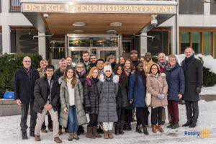
Rotary Peace Fellows outside the Norwegian Ministry of Foreign Affairs

On the first day we visited the Norwegian Ministry of Foreign Affairs and met with Mr. Espen Lindbaeck, Deputy Director to learn more about the Norwegian government’s policies and efforts towards achieving Peace and Reconciliation in countries such as Colombia, Guatemala and the Philippines and how they build their international relations on this matter.

Later that day the two classes of Fellows went to the Norwegian Institute of International Affairs (NUPI) where Dr. Cedric de Coning, Senior Research Fellow, explained the different areas of research the Institute is working on such as War and Peace, Economy and Development, and Diplomacy and Global Governance. He also highlighted their research on the United Nations’ Peacekeeping Operations and how they build relationships with policymakers to ensure that their research has impact.

The Fellows’ second day in Oslo took us first to the Peace Research Institute Oslo (PRIO) where Research Professor Halvard Buhaug gave a history of PRIO and its strong academic standing in the peace research community before diving into the question of the connection between environmental change and conflict. He was followed by his colleague, Research Professor Marta Bivand Erdal, who presented her findings concerning the concept of migration and the powerful role this plays in global trade and security policy. Many of the Bradford and Uppsala Fellows had explored these above ideas in their classes and had plenty to say during the discussion that followed the presentations!

The trip ended with a truly insightful visit to the Norwegian Nobel Institute, where we were greeted by the Director of the Research Consultants who compile the thorough background papers on Nobel Peace Prize candidates which is then provided to the Norwegian Nobel Committee. He took us to the ceremonial room where the Nobel Peace Prize was presented for many years, and gave us the biography of the Institute’s namesake, Alfred Nobel. He also shared instances of formative experiences the committee faced over the years that helped

elevate the Nobel Peace Prize to the status it maintains today. He also showed the Fellows the room where the Committee deliberates, and candidly answered our questions about the Institute’s influence and his interactions with Nobel Peace Laureates. It was a trip to remember!

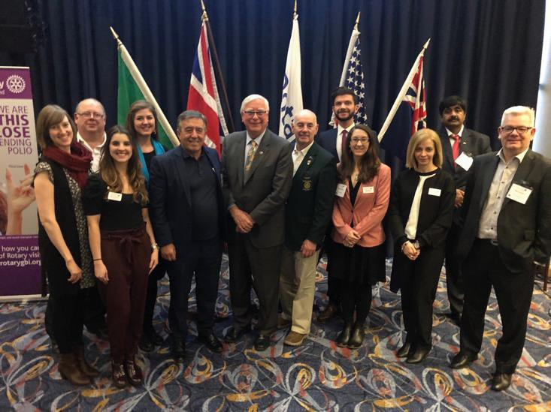
Rotary International Presidential Peacebuilding Conference: Coventry, United Kingdom, February 24th, 2018
Rotary International Predent Ian Riseley with Peace Fellows and staff

On February 24th, the Bradford Rotary Peace Fellows, Host Area Coordinator, Rotary Liaison Officer, Rotary Peace Centre Director, and the head of the University of Bradford Peace Studies and International Development Division traveled to Coventry to take part in Rotary International’s Presidential Peacebuilding Conference. Several hundred Rotarians and community members from across the UK and the wider region gathered to listen to thought- provoking presentations and engage in insightful discussions with RI President, Ian Riseley, Member of Parliament and Minister of State for Africa, the Rt Hon Harriet Baldwin, Assistant Director-General for Special Initiatives at the WHO, Dr. Ranieri Guerra, and Nobel Peace Laureate, Dr. Shirin Ebadi.

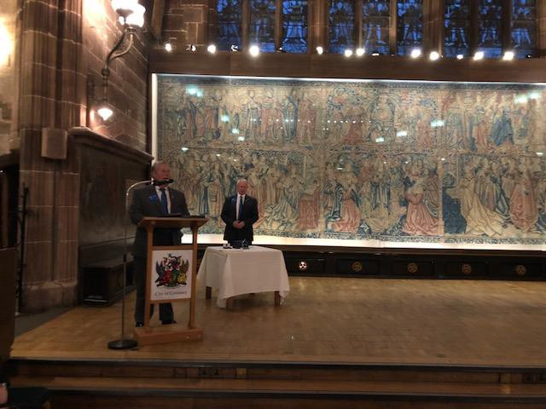
Kenneth Schuppert Opening Speech

Amongst these esteemed leaders, two of our own Bradford Peace Fellows, Natalia Gutiérrez Trujillo and Jessica Tissell, were invited to address the conference. The theme of the conference was Disease Prevention and Treatment, and Peace. Natalia discussed her experience working on issues related to the Colombia conflict and peace process. She discussed the complexities of the conflict, its impact on health outcomes, and the prospects for peace and resilience to prevail in her home country. Jessica talked about her experiences working in Lebanon, Uganda, and Bangladesh on global public health projects. She discussed the connections between man-made conflicts and health care emergencies and talked about how she is using her Rotary Peace Fellowship to better understand the drivers and causes of those connections and conflicts.

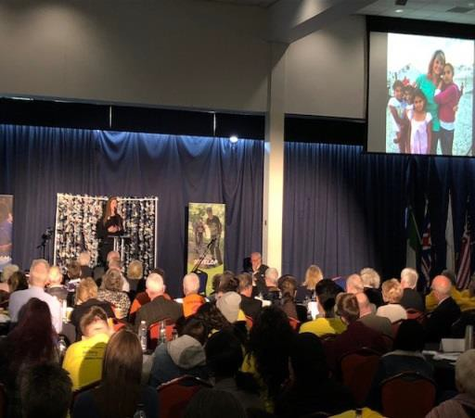

The over 1,100 Rotary Peace Fellows around the world today are the seeds for the growth of those future peace ministries and the gardeners ensuring the success of our existing peace institutions. The RI Presidential Peacebuilding Conference in Coventry was a celebration of
RI’s amazing global peace work and a call to action to double our efforts. The Rotary Peace Fellows returned to Bradford inspired and ready to work.

Crisis Game 2018

Peace Fellow Class XVI

A highlight of the year is the Crisis Game, a simulated international humanitarian emergency which we play out over the course of a two-day residential in a youth hostel. It is challenging, both very serious and a lot of fun, and a great way to apply the knowledge about international conflict resolution and governance that you have learned during the year! Check out the video (made by a student participant) at:
https://www.youtube.com/watch?v=KzJkn5pUM64

The Crisis Game is supported by the University of Bradford Division of Peace Studies and International Development and the Rotary Peace Centre. Following the successful launch of the PSID Crisis Game in Buxton in May 2017, the Crisis Game simulation was organised for the second time on the weekend of 10th-11th of March 2018. The activity took 27 PSID students and staff members, including Bradford Rotary Peace Fellows, Rotary Peace Centre Director Professor Behrooz Morvaridi, and Rotary Liaison Officer Will McInerney, to YHA Haworth, a former manor house turned hostel, near the historic village of Haworth in West Yorkshire.
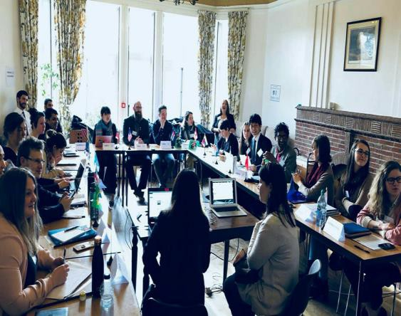
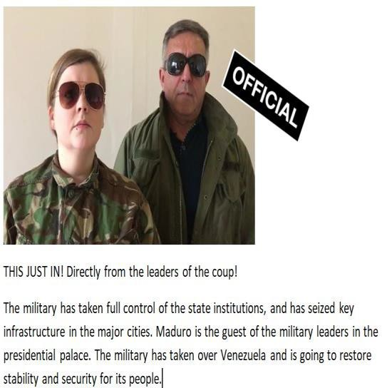

Throughout the weekend the participants stepped into the roles of delegates from various states and international organisations attending a specially convened UN crisis meeting that was called to find ways to deal with an escalating international conflict. For the purpose of the simulation, a real political and humanitarian crisis in Venezuela was taken as the starting point, and in an inspired storyline created by the PSID staff, the scenario was escalated over a series of surprising events unfolding over the course of two days. The students representing their countries and organisations had to rely on their knowledge on international relations, high level diplomacy and conflict resolution, and the research they had conducted in preparation for the game to navigate the complex multilateral negotiations in a volatile international environment.

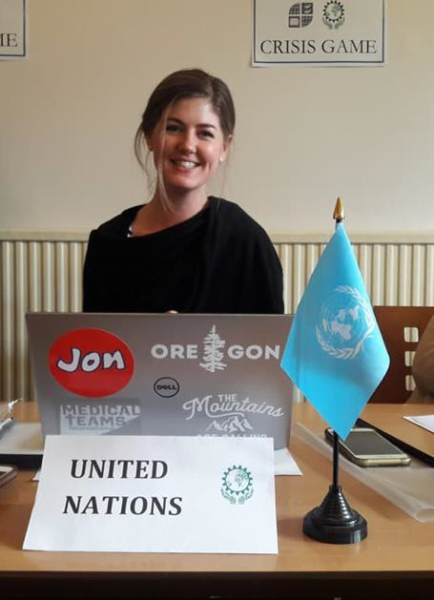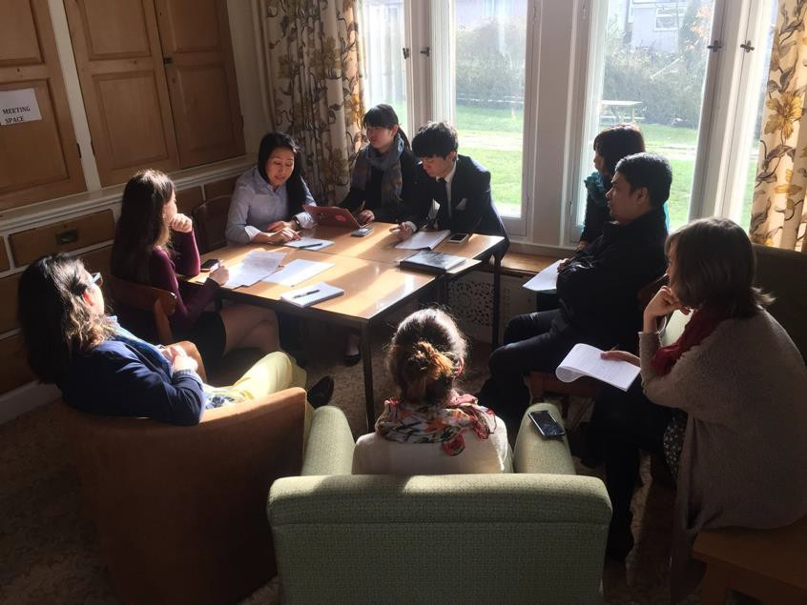

Two media teams formed from the game participants were assigned with documenting the plenary sessions and the negotiations between clusters of states, interviewing the delegates, and contributing to the game dynamics by revealing new information to the participants through media blasts taking place several times a day over the course of the event. This year also fake news, social media and leaked information were brought in through a whatsapp group that gave both the organisers and the players an opportunity to feed information – false or real – into the negotiations.

The student feedback on the event was overwhelmingly positive, and noted that the crisis game was ‘an extraordinary way for students to experience the challenges and complexities of international diplomacy. To listen and read about the process is one thing, but to…experience it is another. The frustrations of the game were the most valuable… they will stick with me as motivation to always do what is in my power to protect human dignity and rights’”

The experiential learning approach allowing the students to put theory into practise was highly valued by the participants, and represents the PSID aspiration to equip their students with skills and insights that are directly applicable to real life issues in the field of peace, conflict and international development.

Conflict Sensitivity Training: Making Knowledge Work
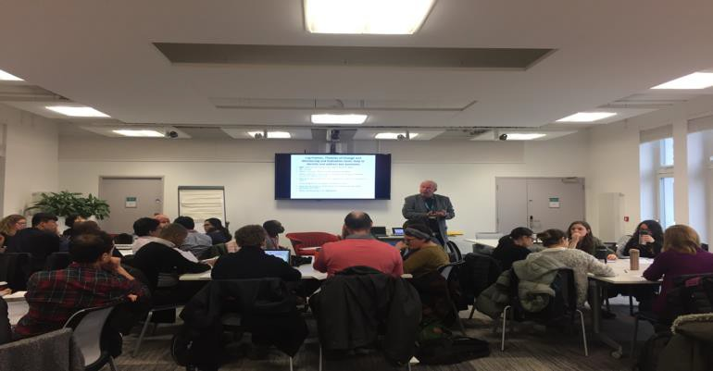
Forty University of Bradford Peace Studies and International Development students, including the Class XVI Rotary Peace Fellows, took part in an all-day immersive Conflict Sensitivity Professional Development Training Course with renowned scholar- practitioner, Professor Owen Greene. Professor Green is a global expert on issues concerning conflict, security, and conflict

sensitivity and has worked in high-profile consultancies with dozens of governments and INGOs. The training course, now in its third year at Bradford, is sponsored by the Rotary Peace Centre. The training concentrates on practitioner skills and teaching students how to design programmes and ensure conflict sensitivity in fragile and conflict-affected contexts. In addition, the programme highlights the impact and importance of gender analysis in conflict sensitivity work.

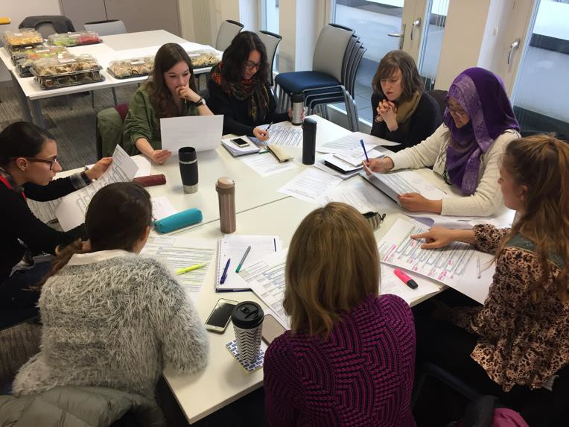
During the training course, Professor Greene discussed the various components and considerations within a conflict sensitive analysis and he highlighted the importance of theories of change and log frame analytical
tools. Professor Greene used real life examples from his own practice to help the students connect the theoretical classroom conversations to real world practitioner situations. Rotary Peace Fellows and their Bradford colleagues then selected a case study country, Liberia, Myanmar, or Kenya, to examine in groups. The students were tasked with developing their own theories of change, log frames, and conflict and gender
sensitive analysis based on their research and understanding of the case study.

Throughout the course of the day students then utilized the knowledge learned from Professor Greene to develop, present, refine, and discuss their case study projects. This hands-on learning experience gave students the opportunity to work together with their globally-diverse colleagues to engage relevant and valuable skills they will soon be practicing in the field after finishing their degrees. The University of Bradford and the Rotary Peace Fellowship programme continue to emphasize the importance of experiential education and practice-based learning. As the University of Bradford motto says, it’s about “making knowledge work.

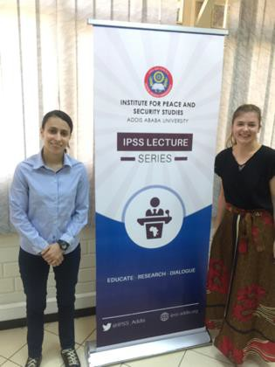
Living History - From Brazil to Ethiopia
A post by Cinthia Gonçalez da Silva – Bradford Rotary Peace Fellow, class XVI
This February, I had the opportunity to travel to Ethiopia as a student enrolled in the Africa Study Visit module, which is part of my master's program at the University of Bradford. Accompanied by seven other students, one of them also Rotary Peace Fellow - Lydia Kröeger - I stayed in Addis Ababa for two weeks, leaving only one weekend for a visit to the city of Hawassa.

The organization of the trip was under the responsibility of Dr. David Harris and Dr. Sarah Njeri, and included pre-departure academic preparation, as well as an agenda of visits to

government offices, NGO's, CSO’s, international organizations, and the Hawassa Industrial Park. As the students enrolled had different interests in that country (e.g. security, development, politics, gender, etc.), the program was able to accommodate a very diverse range of activities, from meetings with the European Union and the United Nations Development Program, to talks with local organizations and representatives of the political opposition in the country.

It is important to understand the current political context in Ethiopia. The country has been governed since 1991 by the Ethiopian People's Revolutionary Democratic Front (EPRDF), which has both guerrilla and Marxist origins. Having seized power after the dictatorial period of the previous regime - known as "The DERG" - the EPRDF created something unique in Ethiopia, the Ethnic Federalism, meaning the constitutional autonomy of the regions according to the predominant ethnicity (although it is not always translated into autonomy in practice). In addition, the EPRDF has a past of controversial electoral processes and violent censorship of the opposition. However, admittedly by everyone we talked to, the party was the only one capable of bringing development to Ethiopia (albeit at the cost of sacrificing real democracy), often inspired by Eastern development models, such as that of the Chinese.

The highlight of the trip, for me was undoubtedly the opportunity to live a historical moment in Ethiopia. On February 15, while we were meeting at the headquarters of Amani Afrika, a local non-governmental organization engaged in security matters, it was announced that Prime Minister Hailemariam Desalegn had resigned. The episode, according to local and international press, resulted both from a number of popular demonstrations and a process of democratic openness (previously planned by the EPRDF, whose leadership has been in crisis since the death of former Prime Minister Meles Zenawi). It was the first time in Ethiopia's history that a Prime Minister resigned. Unfortunately, we would not be in the country long enough to follow the subsequent chapters of this event, except for the first days of a State of Emergency (the second in less than two years in Ethiopia) decreed to last for six months – according to the government, to guarantee a non-violent succession.

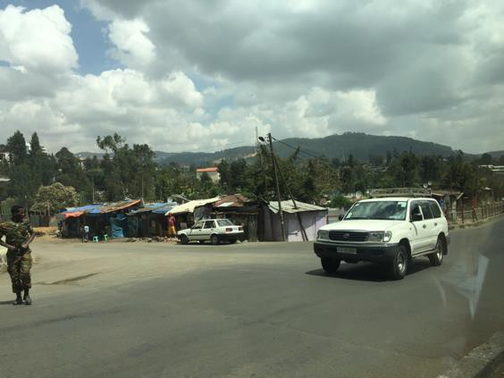
However, as a student of Political Violence and Terrorism, and a professional in public security (I am a civil policewoman in Brazil), it was a golden opportunity to be able to observe closely the paradoxes lived by this country in comparison to my homeland. Despite being an admittedly poor country, with questionable democratic openness and a history of internal and international conflicts that persist in time, police continued to patrol the streets of Addis
Ababa unarmed in the State of Emergency. Only public buildings were heavily protected. Meanwhile, I was precariously using my telephone connected to Ethiopia's monopolized state internet service (between one blackout and another, daily), and I read that Brazil decreed, for the first time after the democratic opening, a Federal Intervention (why not say, “military intervention”) in the state of Rio de Janeiro.

Undoubtedly, Ethiopia is a Police State par excellence, "semi-authoritarian" in the general classification, with an outrageous history of violence. Even in the current government, problems with political opposition, often confused with "terrorist acts" due to intentionally broad legislation, not to mention the conflicts in almost every country with which it borders (with threats such as Al-Shabab and Al- Qaeda knocking at the gates), makes Ethiopia a peculiar state in security matters, and the establishment of a State of Emergency is not something unthinkable in this context. In fact, the guarantee of stability in this country must be recognized (and studied) internationally

Hawassa Industrial Park
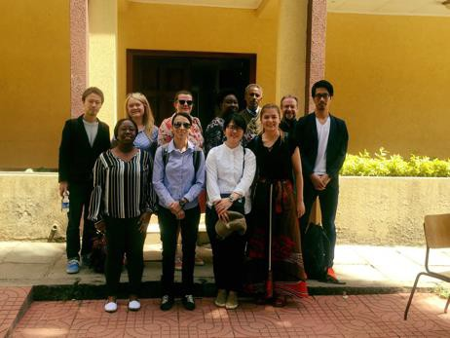
A post by Lydia Kröger – Bradford Rotary Peace Fellow, class XVI Industrial parks have become some kind of
theme throughout the 2-week study trip to Ethiopia in our small but diverse and humorous group of 10 University of Bradford students. It all began one night in the first week of the trip with a Japanese fellow student carefully voicing his reservations about the planned trip to the Hawassa Iindustrial Park that weekend. This reservation aligned with our African politics professor, who hasn’t been shy about his
utter disinterest in visiting industrial parks. Yet, it was the same professor who asked him why he didn’t want to go. The answer would not be forgotten for the rest of the trip – my Japanese fellow student had imagined an industrial park to be a park, with trees and plants and with old historic industrial engines exhibited. “Just like that one I visited in York.” After everybody had a good laugh, we clarified the meaning of an industrial park and agreed that we’d all be interested in going.

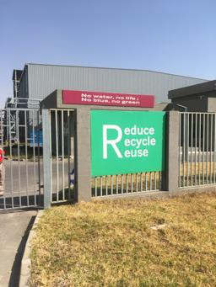
So, two days later we went. And the pre-industrial park horseplay came to a sudden halt. The industrial park, supposedly the biggest on the African continent, currently houses about 14 international, mainly Asian, garment companies and gives jobs to about 12,500 Ethiopians, largely women. The huge area could be located anywhere, the roads are flawless and a number of road sweepers ensure that it stays that way. The 52 hangars sparkle in the Ethiopian sun and a water recycling management system makes all the environmentally considerate Western aid workers happy.

After a short introduction by the park manager, we visit TAL Apparel, a garment manufacturer from Hong Kong who recently opened this plant in Ethiopia. A local with a perfect American accent welcomes us and leads us to the showroom full of collared shirts TAL produces for JC Penney. We then take a tour around the hangar where a small group of people, some Ethiopian, some clearly expats, do the administrative work on fancy desks while the majority of employees - local women - operate the sewing machines.

Although the hangar seems bright, modern and friendly, I can’t help but feel like I am in one of the Bangladeshi, Indian, Pakistani or Chinese sweatshops I have read and watched so much about. I can’t help but feel that I am standing in a place that represents what gave reason for me to start drastically changing my way of living a few years ago, when I decided to stop buying all this stuff that Western generation Ys grow up believing they need. I started with clothes, continued with meat and fish and went on to plastics and waste. I started seeing products as the results of tremendously complex and internationalized manufacturing processes, often directly linked to unethical labor conditions and environmental degradation, which I, whose primary paradigm in life is to contribute to making this world a tiny bit better, can’t consume anymore.

But back to Hawassa. The perfect American accent now tells us about the 40USD monthly salaries they pay to their seamstresses and how for them this is really an improvement of their living conditions. Of course, first they have to be taught discipline “which they lack here” but after that they can benefit from the shiny interior of their new workplace, a salary that’ll be sufficient for a room and food and roads that one could eat from. After the 15- minute visit we leave TAL and the industrial park feeling uneasy. I am sure that there won’t be any more jokes about the industrial park. From now on, all of us, even our African politics professor with little interest in business, think about the sewing machines and the women operating them on a salary the amount of five hours minimum wage in the United Kingdom.

I would have liked to give this story a more positive ending, one that puts emphasis on the impact the newly created jobs in Hawassa have brought to the women working in the industrial park, or one about children of illiterate parents who now go to school, or even one about the positive developmental implications this industrial park can have on lifting Ethiopia out of poverty. But so many manufacturing sectors before have been the hopes of nations to reach higher income status, India, Pakistan, Bangladesh, the Philippines, Vietnam, Cambodia, and the list goes on and on. Under the perception that jobs, no matter how badly paid, will bring development in the long run – called the trickling down effect, governments of poor nations have welcomed the foreign companies, often very labor-intensive ones, such as the garment industry. And it has since moved from country to country, seeking the longest working hours, the cheapest wages, the freest interpretations of decent labor conditions.

Wages paid in Ethiopia are almost 50% lower than the hitherto lowest paid wages in the garment industry – 70USD per month in Bangladesh. It follows the old pattern – cheaper, longer, freer. We will see what it will take to disrupt this endless cycle – I, for my part, will continue discovering alternative consuming routes in the West, and how more people can follow those in the future. So that maybe one day workers in Ethiopia, or anywhere else in

the developing world, will get paid a decent salary and work under decent labor conditions, just like we in the West.

Distinct and Identical: A Reflection on the WWI Centenary
Will McInerney - Bradford Rotary Peace Fellow 2016-17, class XV and Rotary Liaison Officer 2018.

In the midst of the WWI Centenary, Bradford Rotary Peace Fellows embarked on a journey to France and Belgium this past week to learn about the impact of The Great War and to examine the many ways the conflict is memorialized. This post, originally published by Rotary Great Britain and Ireland in 2017, was written by Class XV Peace Fellow Will McInerney based on his reflections from the same trip last year.

It is a bright and soft spring day in the north of France. The rolling countryside is blanketed in thick shin-high grass that ebbs and flows in the wind. Manicured canola crop plots birth endless streams of golden flowers. It is a sight to be seen. But there are stories buried below the surface here. Looking closely, the scars of snarling trenches splinter the countryside and massive craters lurk between the valleys. From a hilltop, you can spot a peppering of thick iron gated walls in all directions. Fields of graves rest beyond those gates. For every golden canola flower in the wind, there must be at least ten tombstones in the ground. A hundred years ago, this serene setting was the Western Front of World War I. There are perhaps a million or more men buried along this line.I am with a group of a dozen or so foreigners to this land. We are Rotarians and Rotary Peace Fellows from across Europe and North America. Our group is here to learn about what happened and to reflect upon the sacrifices that were made. We tread with reverence along the journey. Over three days, we visit a dozen cemeteries and memorials honoring French, Belgian, British, Canadian, West Indian, Australian, American, and German soldiers. The cemeteries are typically organized by country. Each nation’s section is enshrined in flags and solemn reminders carved into stone. We are physically in France, but the cemeteries take you to another place. For a moment, Vimmy Ridge feels like Canada, and the Arras Memorial is England. The feeling is somber and enveloping.
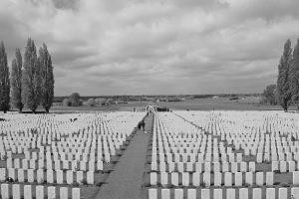

The segregation of cemeteries by country, or by Entente and Central powers, is standard practice. But there is one place along the Western Front that is different. There is one place that it is hard to decipher where you are, or how you feel. At the Notre Dame de Lorette International Memorial, there is a monument to those who died in the Nord-Pas de Calais region; to all those who died, regardless of side or nationality. The Ring of Remembrance is a massive elliptical wall with nearly 600,000 names from 40 nations etched into steel plates. The wall is organized alphabetically. Nation and allegiance are removed; all that is left are names. Enemy soldiers are listed side by side encircling each other.

As I walk around the ring, I notice patterns in the steel plates. There are hundreds of Martins, and Müellers, and Murphys. The name William Brown is written 136 consecutive times. Each
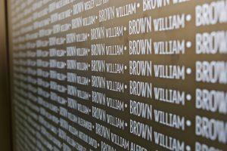

one is a different man of the exact name. All of them died here. The volume of names is overwhelming. I run my fingertips across the etched walls and try to let the names sink in. My hands stumble upon a familiar pattern of letters about halfway around the ring. My surname is McInerney. It is of Irish origin. There are a dozen or so McInerneys listed here. A few rows down I spot William McInerney. I press my hand against my own name. The steel plates have a polished finish. My fingerprints are left adorning the letters. As I slowly walk further, the ring eventually comes to a close. But, there is one more spot I want to check. My full name is William Wedel McInerney. Wedel is my mother’s last name. It is of German origin. It too is etched in the wall at the Ring of Remembrance.

I do not know the details of my family history beyond a few generations. I do not know my relation, if any, to the William McInerney or the handful of Wedels on the wall. I exit the memorial with a sensation of connection and confusion lodged tightly in my chest. I walk away for a brief moment forgetting who was who, and only remembering that all were human. I walk away remembering the physical and emotional sensation of feeling of my own name, split amongst two warring sides, resting under my fingertips. Each name was cut into the steel exactly the same on the wall. Each name was both distinct and identical. That is a feeling I will never forget.

The great Sufi poet Rumi says, “The wound is where the light enters you.” The wounds of the Western Front are still visible. They are scars of history embedded into the French countryside. But as I look around the world today, I wonder if their meaning has been lost in translation. These memorials and cemeteries are not meant to haunt us. Instead, they seek to resurrect history and place it before our eyes so that maybe we can find a new path forward. They try to bring light into our world through the wounds of the past. They ask; how could we, who are both distinct and identical, do this to each other?
A question lingers in the air as the golden canola flowers release into the French breeze. World War I, The Great War, the war to end all wars, asks us; what have we learned?

Study Trip: Northern Ireland – 2018
Professor Donna Pankhurst

With eighteen postgraduate students hailing from seventeen countries, our group made quite an impression on some of our hosts. All had an interest in, if not actual experience of, what happens to societies after the official ending of a conflict. Ably organised and led by our Student Liaison Officer, Sanna Tukiainen, we spent several days in Belfast and Derry/Londonderry, in atypically warm and sunny weather, with an ambition to learn lessons from Northern Ireland. We had a varied itinerary, including community and official organisations, the University of Ulster, and a dinner talk from the inspiring long- standing peace activist Ann Patterson.

We took three walking tours led by an academic/community activist, and two former IRA prisoners. Our guides were well-known characters, greeted by many as they presented their narratives in the urban landscape. Such ‘peace tourism’ tours feature in other post-conflict countries and are not without their challenges – how do we contextualise the selective narratives presented to us (especially with the added complication of very strong accents that some find hard to understand)?
Other practices of memorialisation seemed to reinforce what one member called a ‘cult of armed violence’. We saw plenty of recently-painted wall murals which glorified armed men and weapons, from both communities, which would not be tolerated in many parts of the world (and in spite of Belfast City Council removing 40). Similarly, the maintenance of ‘peace-walls’, which divide the areas of residence in parts of Belfast, shocked the group.

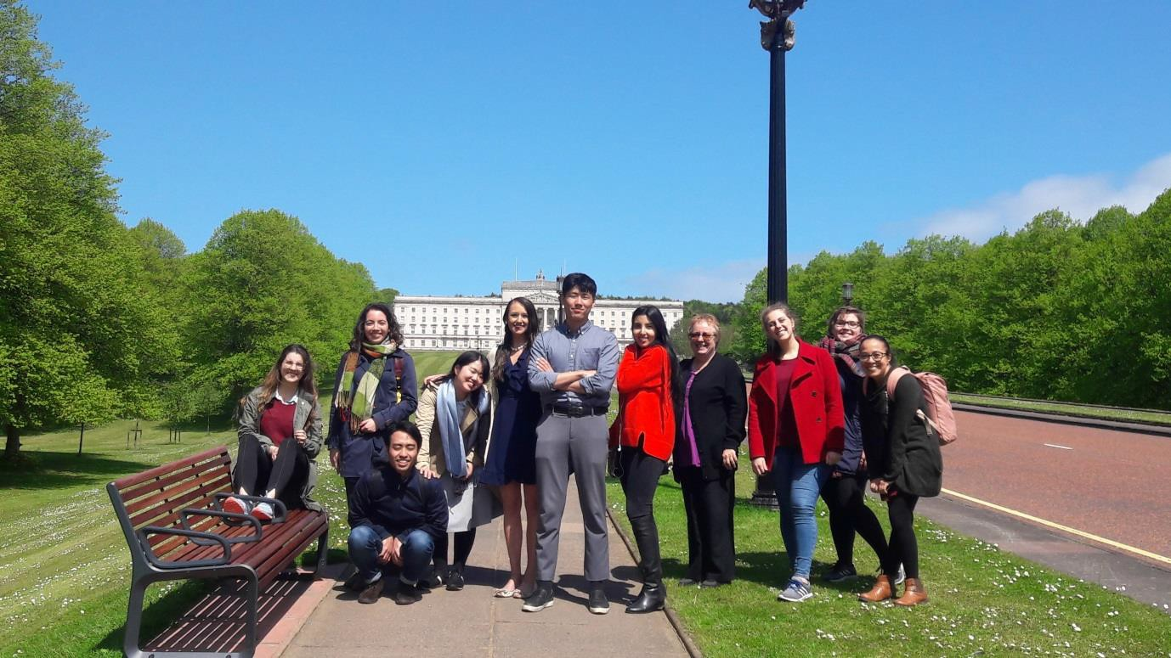
Students outside Stormont

All our hosts highlighted the importance of European funding for positive change, which has been guaranteed by the UK government until the end of 2022. In poor countries emerging from conflict funding is not always so forthcoming. Some expressed concern that much of the funding has gone to people who committed violence rather than victims, but debate on this issue has been much more limited than in other countries. Our hosts were uniformly exasperated and bewildered by the implications of Brexit – several of them live in Ireland / ‘the Republic’ / ‘the South’ and commute to work in ‘the North’ / ‘Northern Ireland’, and cannot see how a post-Brexit border will work.

At our visit to the seat of the NI Assembly, Stormont (on an almost surreal sunny Spring day), we were lucky enough to meet a member of the Alliance Party who generously took the time to tell her own story but also very engagingly described how she had managed to bring politicians from Sinn Fein and DUP to reach compromises, and how the Women’s Coalition brought women from all parties together. She and others made it very clear to us that the coalition power-sharing principles of the peace agreement (which we learned goes by both names of the Good Friday Agreement and the Belfast Agreement) had been useful but now are responsible for the stalemate in politics resulting in the suspension of the Assembly since January 2017.

The NI Policing Board in Belfast is the civilian organisation that holds the police-force to account. It normally includes elected politicians, but not in the last 16 months due to the Assembly’s suspension. Police reform, following the Patten Report, includes positive discrimination in the recruitment of those ‘perceived to be’ Catholics (even if they are ‘Catholic atheists’) up to 50%, and currently at 31%. Overall it is officially regarded as a success, with very high monitoring by global standards. Investigations into historic cases of deaths involving the police are increasing in number. There are daily attacks on the police and weekly bomb threats. Suicide rates are one of the highest in the world and higher than the total killed 1969-97.

We heard about ’punishment attacks’ from several hosts. These are committed by paramilitary groups, from both communities, against ‘anti-social elements’, allegedly with community approval. In Derry/Londonderry at a conference on ‘Alternative Punishment’, a speaker from a pensioners’ residents’ organisation gave a moving

account about children and young people partying in her neighbourhood streets and gardens late into the night. She had talked with them, rescued some from enforced drug- taking and had returned naked, abandoned victims of sexual assault to their parents’ homes. She argued against a common view in her community that they should be subject to violent punishment, and that instead they needed help, ‘shooting them is not showing them respect’. We heard more about inter-generational trauma and very high rates of suicide amongst young people.
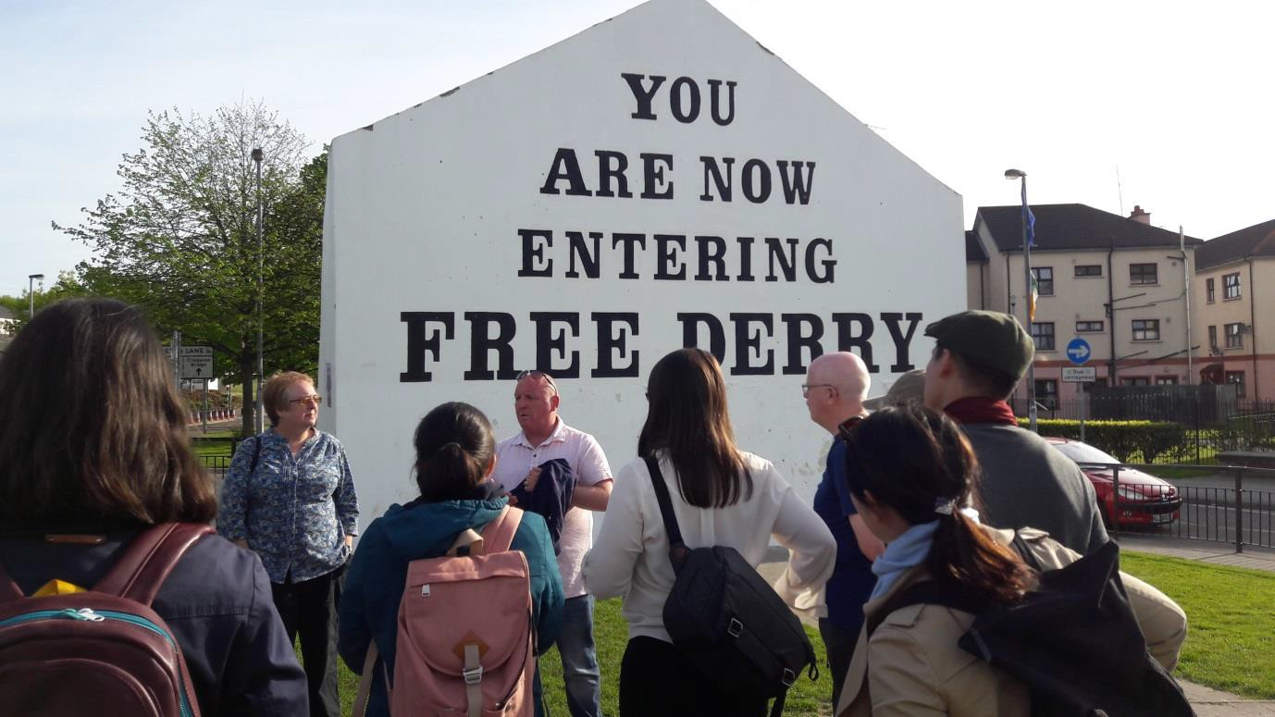
Students in Free Derry

Finally we were honoured not only to hear about the different activities of a community organisation called The Junction in Derry/Londonderry, but also to meet and hear the personal life histories of two former ex-combatants who had been recruited to paramilitaries (UDA/UFF and IRA) as teenagers. They were both impressive speakers who described how their lives had been changed by their experience of story-telling and performance with the organisation Theatre of Witness. As a result they had actually become friends, which was truly an inspiration. We left with new networks, new questions and lots of food for thought.

Invited Speakers at Peace Studies and International Development (2016/17):
The following policy practitioners and scholars presented papers on diverse topical issues in a highly stimulating seminar series 2017/18:

Professor Roger Mac Ginty (Special Guest Speaker) Everyday Indicators, connecting the Home and International: Circuitry as an Analytical Tool in Peace and Conflict Studies, University of Durham.
- Sarri Bater, Personal Stories Workshop: Examining the Roles Personal Stories Play in what We do as Practitioners in the Field of Peace and Conflict, Sarri Bater is Director of Open Edge – Transforming Conflict.
- Irving, Luke, Practitioner Engagement Session: Training The White Helmets in Syria: Dilemmas of Humanitarian Responses in a War Environment’, Luke is a British Army Veteran. He is currently working COO of the NGO Mayday Rescue.
- Yolanda Antin, ‘Mes Que un Club? Sport and Conflict Resolution. The Work of Football Club Barcelona. Speaker is Partnerships Coordinator of Fundacio Barca, chaired by Professor Tom Woodhouse.
- Dr Alex Vines (OBE), “Emerging Powers in Africa Today: Beauty Contest or Horror Show?” Alex Vines is the Head of the Africa Programme at Chatham House London and Co-Director of the African Studies Centre, Coventry University.
- Dr Jutta Bakonyi, “Narratives and Violence: What Narratives do Violent Actors use to Attract Followers and What Does that Tell us.” Jutta Bakonyi is the Director for two Master programmes at Durham University.
- Dr Julia Gallagher: “How States become States: International Relations in the Creation of Zimbabwe.” Julia Gallagher is a Senior Lecturer in Politics & International Relations at the Royal Holloway, University of London.
- Dr Yusuf Sheikh Omar & Dr Khadijo Osman: “Peace Education, Stories and Living Experiences from Somalia.” Yusuf Sheikh Omar is a writer, a poet, peace activist.
- Dr Devon Curtis: “The Interest in Inclusivity in Peace Negotiations.” Devon Curtis is a Senior Lecturer in the Department of Politics and International Studies at the University of Cambridge.
- Judy El-Bushra: State Fragility, Violence and Gender: Where do men fit?” Judy El-Bushra is a Research Associate at the Department of Development Studies in SOAS.
- Prof Peter Woodward: “Sudan: still an 'Unstable State'?” Peter Woodward is a Professor in the
- Simon Yazgi: “Approaches and Challenges for De-mobilising and Re- integrating Ex-combatants from Organisations with Associations with Terrorist Networks Operations”. Simon Yazgi is an expert in peacekeeping, political affairs and international security at UNDPKO.

The Journal of Peace and Conflict Research

The Journal of Peace and Conflict Research will be managed and edited by an editorial team principally based in Peace Studies and International Development (PSID) at the University of Bradford. The editorial team has extensive experience of publishing and editing academic publications. Cooper, Macaulay and Anand will act as co-editors of the journal. Cooper has previously acted as editor of the journal International Peacekeeping and Macaulay has acted as editor of the Journal of Latin American Studies. Cooper and Anand also have experience as guest-editors for special issues of various other journals. All three editors have extensive experiencing of reviewing papers for other refereed journals. The broader editorial team at Bradford includes specialists on peace, peace education, participation, gender, peacekeeping and peacebuilding, development, the environment and the arms trade and arms control. The team also includes specialists on Africa, the Middle East, Latin America, South Asia and South-East Asia.

To publish both policy-related publications and theoretically informed and rigorous research on current or past questions of peace and conflict broadly defined, whether focussed on the global, regional, state, sub-state or inter-personal dimensions of peace and conflict. The journal will be multidisciplinary in orientation and will adopt a broad definition of the field of peace and conflict research. As such we will aim to publish contributions that reflect the diversity of theoretical and methodological approaches that characterise the field of peace and conflict studies including (but by no means limited to) research informed by less mainstream theoretical perspectives such as postcolonialism, critical theory and feminism. The journal will aim to publish contributions that analyse past or present policies aimed at fostering peace and preventing conflict across a wide range of issue areas including but not limited to the following:
- The meaning and practices of peace conflict prevention, conflict resolution and peacebuilding
- How local, national and global political economies (licit and illicit) shape and are shaped by peace and conflict
- The role of states, business and/or civil society in preventing or fuelling peace and conflict.
- How local, regional and global forms of governance influence the nature of peace and conflict
- The relationship between peace, conflict and the environment
- The relationship between peace and conflict on the one hand and culture and identity on the other hand
- Intrapersonal aspects of peace
- How relationships of power (e.g. class, gender, race) influence the dynamics of peace and conflict
- How technology, whether military, civilian or dual-use shapes the prospects for peace and conflict.
- The relationship of the visual arts to processes of peace and conflict and as a vehicle for the study and understanding of such processes.

Visitors from Rotary Foundation

Two visits took place in 2017/18. Simona Pinton, Rotary Cadre Technical Coordinator visit, served to evaluate the program thoroughly. The assignment includes 2 days of interviews and focus groups with key stakeholders at the Center – staff, fellows, administrators, host area Rotarians, and faculty.

In addition Peter Kyle, Chair of Rotary Peace Center Board, and Jill Gunter, Manager of Rotary Peace Centers, visited the division of Peace and International Development May 2018. The objective of this visit was to strengthen the relationship between the Foundation and the Center. The goal of the relationship building visit was to provide the Foundation with a better understanding of what it means to be a current peace fellow at Bradford, how the Center functions, and how Evanston staff can enhance their support to both the fellows and Center Staff.

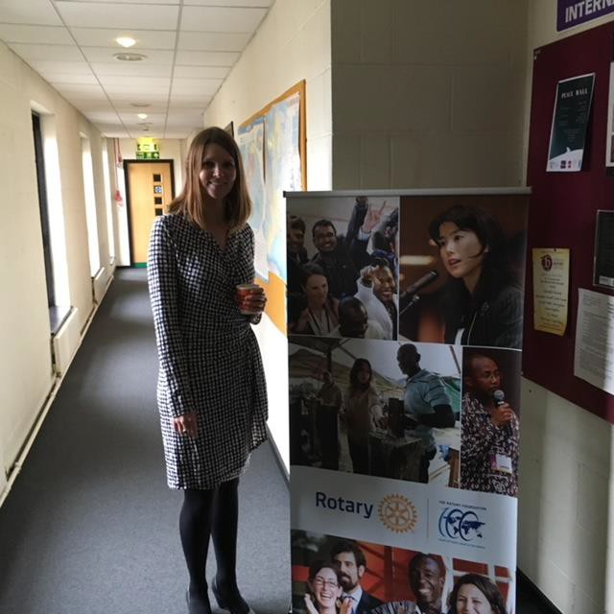
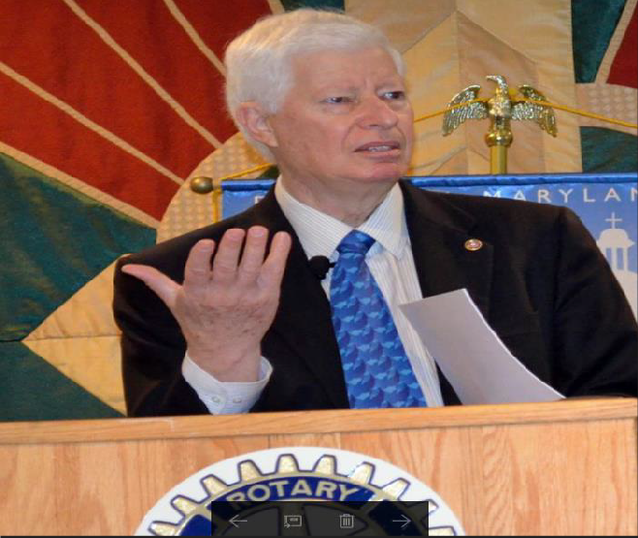
Jll Gunter Peter Kyle
Rotary Peace Centres Programme Manage Chair of Rotary Peace Centres Committee

Area Host Rotarian
We would like to thank the Host Rotarian, Ken Robertshaw (2015-2018) for his support, enthusiasm and dedication to the Bradford Rotary Peace Centre and Peace Fellows. We wish him the very best for the future.
We now welcome the new Host Rotarian, Keith Davison. We have already established a number of activities that we hope to implement this year. Here is Keith’s profile (in his own words):

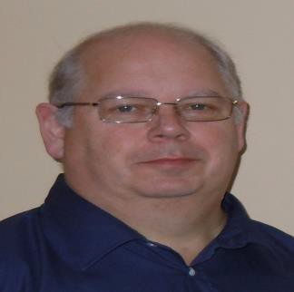Rotarian PDG Keith J Davison: Rotary Club of Birstall Luddites

Since joining Rotary I have been an active member at Club and subsequently District, RIBI and RI level, firmly believing that you only get out of anything as much as you put in. I have been a member of Rotary in the Rotary Club of Birstall Luddites since January 2000. I was President of the Club in 2002-03. I served for 3 years from 2004 – 2007 as the District Training Officer arranging and running all the District training events. In 2013 following my Year as District Governor I took this role on again to date. I have been a member of the District Conference Committee for the past 13 years responsible for the IT and Stage Management. In 2010-2011 I was the Conference Chairman. For 3 years from 2007 – 2010 I was the Assistant Governor for the Inner 9 Group of Clubs within the District. I served as District Governor for District 1040 in the Rotary year 2012-2013. On an International front, I have been a member of the District Healthcare and Literacy Ukraine Convoy team since it started in 2001, having been on all the Convoys since 2001, 12 in total as well as making 2 private visits to monitor the on-going progress of Projects. In 2004 I was appointed as the Chairman of the Project Team and as such, I report back to the District International Committee as the Chair of one of its Sub-Committees.

From 2013-2016 I was a member of the RIBI Leadership Development and Training Committee. In 2016 I was appointed as the Training Facilitator for the District Governor Group 2018-2019. I took this team through their training programme until they took office on the 1st July 2018. In 2013 I was appointed as one of the Assistant Rotary Co-ordinators for Zone 17. I held this office for 3 years through to the end of the 2016 Rotary Year.
Currently I am my first year as Rotary Host Co-ordinator for the Rotary Peace Centre in Bradford. I am very proud to be undertaking this new role and have been a supporter of the Peace Centre for many years through helping with the Technical side of the annual Seminar in October each year.

Curriculum by Degree Programme
Peace Fellows at the Bradford Centre choose from a range of Masters programmes offered within the Division of Peace Studies.

MA in Advanced Practice in Peacebuilding and Conflict Resolution

This programme will develop your understanding of the causes and dynamics of social conflict, with a strong focus on case-study analysis. It will allow you to develop informed judgements about when and how to engage constructively with conflict, recognising the strengths and limitations of different approaches to intervention. And you will consider critical questions surrounding and problematising efforts to build peace in different contexts, and in the light of contemporary trends, including converging environmental, economic and political developments. Through a diverse programme of study, including a significant applied, practical element, you will build a portfolio of work that demonstrates your knowledge and achievement of a set of professional competencies essential to effective, ethically-aware practice within conflict engagement and peace practice - locally, nationally or internationally - relevant to employment in the peace, conflict and development fields.

SEMESTER ONE
Applied Conflict Research (core)
Designing and Assessing Conflict Intervention Processes (core)
African Politics and Security Dynamics
OR Studying Peace in a Changing World
OR Elective
SEMESTER TWO
Skills for Constructive Conflict Engagement (core)
Natural Resource Governance
Movements for Social and Ecological Justice
Transnational Challenges: Problems and Responses
Creative Conflict Transformation
Peacekeeping and Peacebuilding
Gender, Conflict and Development
Africa Study Visit
Terrorism and Political Violence
Sustainable Cities
Middle East Politics and Security Dynamics
SEMESTER THREE
Dissertation

MA International Relations and Security Studies

The new MA in International Relations and Security Studies explores themes of peace and conflict studies, including:

  - war, violence and security-building between and within states and regions
  - tackling weapons of mass destruction, conventional arms proliferation, political violence and terrorism
  - development and operation of international and regional institutions
  - past and present transnational challenges in international and regional diplomacy
  - contemporary global challenges such as environmental degradation, trafficking/crime and migration

You will develop an advanced academic and policy-relevant understanding of international relations and security, along with analytical skills that are in high demand within institutional politics, NGOs and lobbying organisations.
You will have the opportunity to take specialist pathways, including a focus on selected regions (Europe, Africa, Middle East and North Africa, Asia, or Latin America and the Caribbean), with opportunities for study visits, or on thematic specialisms such as international governance, modern diplomacy, security studies, or political violence and terrorism.

SEMESTER ONE
The International System in Theory and Context (core)
Contemporary Security Challenges (core)
African Politics and Security Dynamics
OR Elective
SEMESTER TWO
Transnational Challenges: Problems and Responses (core)
Natural Resource Governance
Africa Study Visit
Middle East Politics and Security Dynamics
Gender, Conflict and Development
International Environmental Governance
Peacekeeping and Peacebuilding
Terrorism and Political Violence
Assessing Development Needs and Outcomes
SEMESTER THREE
Dissertation

MA Peace, Conflict and Development

This degree will provide you with an advanced understanding of the inter-relationships between conflict, development, security, and governance in developing, fragile, transitional and/or conflict-affected regions and countries. You will gain the understanding and skills you need to pursue or develop a career in what is now a major area for international, national and local policy and practitioner communities. You will be equipped to work across many sectors including:

  - international development
  - conflict prevention and peace building
  - post-conflict recovery
  - humanitarian aid
  - natural resource management

You will have the opportunity to take specialist pathways, including a focus on selected regions (Europe, Africa, Middle East and North Africa, Asia, or Latin America and the Caribbean), with opportunities for selected study visits. The programme will provide enhanced training and engagement with widely used policy and practitioner analytical tools and models, enabling you to develop your skills and employability.

SEMESTER ONE
Applied Conflict Research (core)
Security and Development in Fragile and Conflict-Affected Areas (core)
African Politics and Security Dynamics
OR Elective
SEMESTER TWO
Natural Resource Governance (core)
Gender, Conflict and Development
Terrorism and Political Violence
Transnational Challenges: Problems and Responses
Middle East Politics and Security Dynamics
Assessing Development Needs and Outcomes
International Environmental Governance
Peacekeeping and Peacebuilding
Sustainable Cities
Africa Study Visit
SEMESTER THREE
Dissertation

MA Peace, Resilience and Social Justice

This new MA is designed for those seeking an advanced understanding of the major contemporary trends shaping our world, such as environmental crisis, widening inequality and social division, resource scarcity, and violent conflict.
The programme critically examines how society is responding to these challenges, from contentious collective action and political resistance through to efforts to design and create more resilient, sustainable communities.
You will explore topics such as:

  - the implications of climate change for peace and social justice
  - the role of resource limits and land-grabbing in the promotion of conflict
  - the emergence of movements for indigenous rights and food sovereignty
  - the crisis of democratic institutions and the rise of political populism
  - the increase in contentious collective action – in both the real and virtual realms

SEMESTER ONE
Studying Peace in a Changing World (core)
Social-Ecological Resilience: Discourses and Practices (core)
Applied Conflict Research
OR African Politics and Security Dynamics
OR Elective
SEMESTER TWO
Movements for Social and Ecological Justice (core)
Natural Resource Governance
Sustainable Cities
Skills for Constructive Conflict Engagement
Creative Conflict Transformation
Gender, Conflict and Development
Assessing Development Needs and Outcomes
Middle East Politics and Security Dynamics
International Environmental Governance
Transnational Challenges: Problems and Responses
Peacekeeping and Peacebuilding
Africa Study Visit
SEMESTER THREE
Dissertation

MSc Sustainable Development

Sustainability is an important national and international concept and policy issue. Yet, there are serious challenges facing any society, country or city aspiring to adopt a sustainable path. This programme critically examines how sustainable development shapes policy and strategy on a range of issues at different levels - global, national, regional and local community. It takes a multi-disciplinary approach to sustainability and looks at the three traditional pillars -- economic, social and environmental -- as well as historical, cultural, political, institutional and gender dimensions to understand the issues and challenges of vulnerability, powerlessness, agency, responsibility and resilience. The programme aims to develop comprehensive and systematic understanding of the various dimensions of sustainable development and the complexities of shaping, influencing and informing policy analysis and achieving impact in the world.

SEMESTER ONE
Critical Perspectives on Sustainable Development (core)
Governance for Development (core)
African Politics and Security Dynamics
OR Issues in Development Theory
OR Elective
SEMESTER TWO
International Environmental Governance (core)
Sustainable Cities (core)
Gender, Conflict and Development
Natural Resource Governance
Movements for Social and Ecological Justice
Assessing Development Needs and Outcomes
Finance for Development
Africa Study Visit
Peacekeeping and Peacebuilding
Middle East Politics and Security Dynamics
SEMESTER THREE
Dissertation

MA International Development Management

Human development processes and practices continue to be at the forefront of most governmental and societal concerns, particularly for developing countries or countries in political transition. There are keen debates about principles, policies and practices of international development co-operation assistance and investment, and their links with humanitarian challenges and wider processes of globalisation. Issues of international development management need to addressed in the full complexity of political, institutional, economic, social and cultural contexts. This requires a multi-disciplinary approach that brings together research, policy and practitioner communities.
This degree will provide you with the critical and analytical skills to operate effectively in international development environments. It covers macro and micro level perspectives and draws on cutting edge debates around development theory, policy and management to provide an integrated, cross-disciplinary framework for the postgraduate study of development. The unifying focus is the analysis of strategies for overcoming poverty. You will gain knowledge of different development paradigms and their evolution and be encouraged to develop comparative perspectives (between different regions/countries, disciplinary approaches, schools of thought).

SEMESTER ONE
Issues in Development Theory (core)
Issues in Development Practice (core)
Governance for Development
OR African Politics and Security Dynamics
OR Elective
SEMESTER TWO
Assessing Development Needs and Outcomes (core)
Natural Resource Governance
Sustainable Cities
Gender, Conflict & Development
Peacekeeping & Peace-Building
International Environmental Governance
Africa Study Visit
Project Implementation and Management
Middle East Politics and Security Dynamics
Transnational Challenges: Problems and Responses
SEMESTER THREE
Dissertation

MSc Project Planning and Management

This course builds knowledge and skills in the planning and management of development projects and programmes. It is designed to deepen critical understanding of the strategies, processes, techniques and issues involved in taking ideas for international development and turning them into practical realities with identifiable outcomes and benefits. The degree provides an excellent basis for career enhancement or conversion. The focus is on international development projects in the public or third (voluntary or community) sectors, but the underlying principles are applicable to all types of project, including those for commercial benefit.
The course covers

  - The discipline of project and programme management, within an overall appreciation of the nature and purpose of projects
  - The principles and practice of project planning, design, preparation, and appraisal techniques for projects in an international development context
  - The theory and practice of management skills for project and programme management, focusing particularly on 'hard' and 'soft' skills for successful project implementation

SEMESTER ONE
Project Planning and Design (core)
Project Appraisal (core)
Issues in Development Theory
OR Economic Growth for Development
OR Elective
SEMESTER TWO
Project Implementation and Management (core)
Assessing Development Needs and Outcomes
Natural Resource Governance
Sustainable Cities
Finance for Development
Gender, Conflict & Development
International Environmental Governance
Africa Study Visit
Middle East Politics and Security Dynamics
SEMESTER THREE
Dissertation

MSc Economics and Finance for Development

This course will provide you with a systematic and advanced understanding of economic approaches to development and in particular the role of finance and financial institutions. This is a fascinating time to study such questions and you will engage with current debates in economic and financial development, and be able to evaluate the merits of the various mechanisms of financing development. You will develop the skills required for the analysis of development issues using relevant software packages and to understand the bases for financial policy and the interlinkages between statistics and econometrics, and develop expertise on international trade and exchange rate policies and related economic matters. You can also develop particular specialist interests through a range of options, including project and programme management, public policy, and development policy.

SEMESTER ONE
Economic Growth for Development (core)
Applied Econometrics (core)
Project Planning and Design
OR Project Appraisal
OR Elective
SEMESTER TWO
International Economics (core)
Finance for Development (core)
Assessing Development Needs and Outcomes
Natural Resource Governance
Project Implementation and Management
Sustainable Cities
Gender, Conflict & Development
International Environmental Governance
Africa Study Visit
Middle East Politics and Security Dynamics
SEMESTER THREE
Dissertation

Module Details (in Alphabetical Order)

Africa Study Visit
The centrepiece of this module is an intensive two-week study visit in an African country. Students develop theoretical and historical knowledge of African politics and security in other modules (African Politics and Security Dynamics – see below – is particularly recommended) and are then intensively prepared on the environment, security, politics and society of the country to be visited. During the visit you will be able to use your knowledge in interview settings to formulate and ask questions of key players, supported by the academic leader. You will visit important sites and institutions, and meet with state and local government ministers, politicians, civil servants, members of the security forces, national and international NGO staff and activists, the media, academics and other students.. There are very few modules offered anywhere that combine theory, knowledge and primary research in this way. Please note that there is an additional cost for participation in this module.

African Politics and Security Dynamics
The discourse on Africa is now replete with notions of so-called Afro-optimism and Afro- pessimism in equal measure. In light of this, students on the African Politics and Security Dynamics module will develop knowledge of historical and theoretical contexts for a better and more nuanced understanding of the social, religious and political complexities of Sub- Saharan Africa in the twenty-first century. You will critically examine important turning points such as decolonisation, the end of the Cold War, democratisation, the outbreak of conflicts and the onset of greater levels of international intervention, and analyse key issues such as colonialism, fragility, governance, democracy, gender, development, conflict, security and terrorism. This module is strongly recommended for those wishing to participate in the African Study Visit.

Applied Conflict Research
Applied Conflict Research develops core knowledge and competencies for conflict analysis, with a focus on the practice of conflict research in professional and policy settings. The module will develop your capacity for critical inquiry into contexts where conflict occurs, the causal mechanisms driving or sustaining conflict, the conflict sensitivity of programmes or activities in fragile or conflict affected areas, and the nature and impacts of conflict experience. It emphasises practical and applied learning, through exercises and activities that build understanding of conflict research processes in relation to real cases.

Applied Econometrics
This module introduces you to the quantitative methods relevant to the field of applied econometrics. You will study the relevant theories, concepts and techniques in this area. Through the use of computer practical sessions you will also gain hands-on experience of using relevant software packages and an understanding of key concepts and regression techniques as well as an understanding of the debates about their relative merits. You will study the application of applied econometrics and critically assess its use and limitations, undertake quantitative data analysis including bivariate and multiple regression analysis and be able to interpret and explain statistical results and their implications for policy.

Assessing Development Needs and Outcomes
Debates on whether spending on aid is 'effective' or constitutes ‘value for money’ and how we should measure the results of development programmes and projects have become particularly central to aid policy in the past decade. Similarly, methods for assessing needs, monitoring and reviewing progress in implementation, and evaluating outcomes have been intensely scrutinised. This module examines some of the most important ways in which national and international development institutions and the 'aid industry' measures needs, progress and outcomes and the implications of this for policy and programming. You will learn to use different approaches for assessing needs and measuring results, and you will develop a critical awareness of the limitations and uses of different techniques and approaches.

Contemporary Security Challenges
This module offers an exciting and advanced examination of contemporary security challenges and responses to such challenges. It provides an advanced knowledge of key concepts, perspectives and analytical frameworks of security studies, particularly as these relate to transnational and international security agendas and processes; and opportunities to learn how to apply these in order to engage with contemporary security policy debates. The module examines in detail selected international security issues in which shifts in relative power, interstate tensions, and risks of inter-state war are a major concern. These include: global security governance in light of the rise of China, India, Russia, and other key developing powers; the challenge to the post-Cold War European security order by Russia and others; inter-state tensions and conflicts in the Korean Peninsula, East Asia; South Asia and the Middle East (including the risks associated with the development of nuclear weapons); the relevance and effectiveness of the UN and other multilateral security institutions; and multilateral conflict prevention and crisis response mechanisms.

Creative Conflict Transformation
This module explores some intriguing questions posed by John Paul Lederach in his book 'The Moral Imagination': What happens to peacebuilding practice if we shift from a guiding metaphor that we are providing professional services to one where we are engaged in a vocation to nurture constructive social change? What happens to process design if we think of ourselves as artists [as well as] professional specialists with technical expertise? If building intuition and art are included in conflict resolution, mediation, and peacebuilding training? This module looks beyond the most familiar peacemaking processes to include the arts (e.g. music, applied theatre, literature), memory work, and critical/peace education because much work to address conflict and its legacies requires a capacity to both envision and act for change. How might we cultivate this capacity in ourselves and others? It will draw inspiration from existing experiences and experiments and encourage you to reflect both creatively and critically on how they might help you shape your own approach to conflict engagement.

Critical Perspectives on Sustainable Development
This module will help you develop an advanced understanding of the economic, social and environmental dimensions of sustainable development, of the global and national policy

discourses on measurement and indicators, and of the implementation challenges and the roles of state and non-state actors and corporate social responsibility. The syllabus covers the evolution of the idea of sustainable development; sustainability as inter-temporal fairness; and critical perspectives on alternative theories. We will have thematic discussions on topics such as: the green economy; human rights perspectives and protecting the rights of future generations; social dimensions - inclusion, inequalities, indigenous people, displacement, gender; global commons, climate change, the principle of equal but differentiated responsibilities; Sustainable Development Goals; ethics of sustainability; challenge of responsibility - who should act, and why; the potential and limitations of corporate social responsibility; ideological and ethical critiques of sustainability; science and sceptics of sustainability; the role of innovation and how to harness new approaches for behavioural and social change; sustainable cities; challenges and future directions.

Designing and Assessing Conflict Intervention Processes
This module provides opportunities to learn about options and methods for intervening constructively in conflict situations, and about the ethical, political and practical questions that surround conflict interventions of different types. This module will develop your ability to make informed judgements about the timing and nature of appropriate conflict intervention processes. Through practical engagement in designing responses to a range of conflict situations, you will develop insight into the needs of people in conflict and the strengths and limitations of different processes/methods. The module relates closely to the Applied Conflict Reseach module, linking the process of conflict analysis to the design and assessment of conflict intervention processes.

Dissertation
In semester three (from May to August), you will be writing a dissertation of up to 15,000 words. The dissertation is worth one third of your final degree classification. This is an opportunity to apply what you have learned during your coursework and pursue and develop your own interests by designing and carrying out a bespoke research project on a topic related to your degree programme. You will be given guidance in the form of lectures and seminars, as well as individual support from a member of academic staff who will supervise you in defining a topic, devising an appropriate methodological approach and structuring and writing up your work.

Economic Growth and Development
This module will develop your understanding of the determinants and the policy frameworks of growth prospects, particularly for developing and transition economies. It will help you develop a critical analysis of the role that growth plays in economic development. The course covers: macro- economic frameworks; growth comparison in historical context; theories and models of economic growth, and their relationship to development; the role of macro-economic policies and institutions in growth; growth diagnostics; economic growth, income distribution and poverty; and the relevance of a gendered analysis.

Elective (Semester One)
Alongside your core and optional modules in semester one, you can also choose any module offered within or outside the Division of Peace Studies and International Development.

Finance for Development
This module critically analyses the role of finance, both domestic and external, in developing countries. You will examine theories of finance and the problems of financing economic development as well as policy problems relating to the financial sector. The course also examines monetary and fiscal policy, the international financial architecture, the impact of the financial crisis and the debates over the best approach to financial regulation. It will cover: the role of financial intermediation in development; the structure of financial systems; differences between market-based and bank-based financial systems; differences between developing and developed countries’ financial structures; public and private banks; the IS-LM Model; financial repression and liberalisation; financial crises, capital flows and financial regulation; foreign investment; foreign aid; and microfinance and financial inclusion including digital finance.

Gender, Conflict and Development
Gender matters in understanding the social roots of violent conflict, how that violence is conducted, and how societies recover. Gender relations and identities are, arguably, the deepest rooted and most personal that we experience. So, understanding violent conflict requires an analysis of gender and how this intersects with culture, religion, ethnicity, class and other variables) This module explores how gender roles (masculinities and femininities constructed through identity, ideology, behaviours, attitudes, cultural practices) in different societies at different times have contributed to either the breakdown of social relations into violent conflict, or the construction of stable and peaceful societies. We look at men as well as women in order to move from a ‘women in conflict/development’ lens to a ‘gender and conflict/development’ perspective. We also consider how gender as an idea of masculine/feminine values is deployed discursively and strategically in the roots, conduct and resolution of violent conflict, and in post-conflict development policy.

Governance for Development
Good governance has become a buzzword for international development agencies since the 1990s, but has been difficult to put in practice. This module will explore the difficulties of reforming governance and pursuing the public good through effective policy making in the Global South under conditions of globalization in which the role of the state is rapidly changing in relation to the market. You will explore different theoretical approaches to governance and development, such as the new institutionalism and its critics, rationalism and collective action, and principal-agent problems. The module explores the role of the state in development; central and local government relations and decentralization; the shift from government to governance, quality of governance indicators, and governance failures including anarchy, state-capture, and corruption; global-national relations, sovereignty, conditionality and development partnerships; and the principles and methods underlying conflict sensitivity.

International Economics
In this module you will critically analyse the role of international trade in economic development and develop an understanding of the links between international economics and domestic economic development. The course will examine the different theoretical frameworks and policy debates relevant to the study of international trade: theories of

international trade, international competitiveness, instruments of trade policy, free trade areas, trade policy for development, theory of protection, balance of payments, regional integration, and exchange rate policy. You will also learn how to apply micro and macro- economic analysis to the functioning of open economies in a globalised context.

International Environmental Governance
This module will enable you to gain an advanced knowledge and understanding of the international responses to transnational and global environmental challenges, including climate change, the governance of oceans and seas, biodiversity and pollution, and selected specific environmental issue areas. It particularly focusses on the development, implementation and effectiveness of multilateral environmental agreements and the operation and significance of contemporary systems for global environmental governance – and challenges to them. The module reviews the historical development of international co- operation, agreements and institutions to address transnational or global environmental problems. It then focusses on the politics, institutions, and systems for international environmental governance since the early 2000s and the complex of overlapping norms and programmes, examining the notion of ‘regime clusters’ and ‘architectures’ for environmental governance.

Issues in Development Practice
This Module critically analyses development practice in different locales and contexts. You will gain knowledge of different policy paradigms and an understanding of the challenges to delivering development effectively. You will be exposed to different conceptions of development and the range of policy responses pursued by international development agencies, public and civil society institutions. The course will cover: a multidimensional understanding of poverty and inequality; policies of social protection; multilateral and bilateral aid and development policy; rural and urban livelihoods; participation and empowerment; Sustainable Development Goals; the role of NGOs; impact assessment; forced migration, displacement and resettlement; gender and development; and conflict sensitivity.

Issues in Development Theory
In this module, students will use an integrated, cross-disciplinary framework to critically investigate the different mainstream and alternative development paradigms of development (such as modernisation and dependency theories, neo-liberalism, global governance) and how they evolved. You will analyse the links between theory and practice at the global, national and the local level, and cover issues such as global development institutions (the World Bank/IMF, World Trade Organisation, UNDP); globalisation; aid policy, non-state actors and philanthropy; international migration, diasporas and remittances; alternative development, social justice, and the capability and rights-based approaches; gender relations; state-civil society relations; and sustainable development.

Middle East Politics and Security Dynamics
This module provides advanced knowledge and understanding of the different drivers and key aspects of the politics and security dynamics of the contemporary Middle East region (including North Africa and the Persian Gulf), which has been undergoing profound political

upheavals in recent years. These vary significantly within the region and are also complex, given the changing configurations of power, and the influence of external powers such as the USA and Russia. You will examine regional and sub-regional security complexes in the region, and their inter-relationships with societal political movements and international and global actors and factors, focussing particularly on developments since 2005 while placing these in historical context. In terms of political structures and processes, we will examine political Islam in the region and its relationship with transnational 'jihadi' terrorist networks; civil wars and conflicts and their aftermath; the relationship between religious/ethnic identity, democratisation, gender, and state building; the relationship between conflict, security and development; the politics and security of oil, gas and other natural resources in the region; and the regionally-specific challenges of arms control, disarmament and confidence-building.
Movements for Social and Ecological Justice examines the role of social movements in defining, challenging and transforming injustice in a variety of socio-cultural, political and economic domains. A particular emphasis will be on how contemporary movements are tackling the intersections between these domains in a period of ecological crises: What does social justice mean in a context in which economic growth has become deeply problematic and thus can no longer be considered a sustainable route to addressing shortfalls in provision for human needs? How are social and environmental justice issues being framed in contemporary movements for change? What is the potential of ideas and initiatives that are trying to tackle social and ecological issues simultaneously, and what might be the trade-offs involved?

Natural Resource Governance will enable you to gain an advanced knowledge and understanding of the key concepts, theories, characteristics, challenges, and strategies and programmes for reform of natural resource governance in developing countries, and particularly in fragile or conflict-affected contexts. This module also introduces professional guidelines and methods and their application to help ensure conflict sensitivity, gender sensitivity or consistency with wider sustainable development goals. The module examines issues and challenges for natural resources governance, generically and through a wide range of experiences and case studies from across the world. It focuses systematically on different sectors, particularly land, water, forests, river basins, fisheries, seas and mineral resources (including oil, gas, gems and metals). It also examines their relationship with governance, conflict risks and processes, state fragility and societal resilience and gender relations. We also look at the roles of state regulation, community initiatives and governance; and international aid, trade, or environmental agreements.

Peacekeeping and Peacebuilding focuses on countries of the Global South that have experienced conflict. You will explore the changes that have taken place in peacekeeping on the ground, and analyse the different evaluations that have been made by academics, practitioners, campaigners and politicians. You will interrogate the concept of peacebuilding and analyse the ways in which its varying objectives have been addressed by different actors over time in different parts of the Global South. You will explore these themes in the context of country case studies. You will undertake research, using both academic sources and

accounts from international organisations, ranging from the United Nations to international Non-Governmental Organisations.

Project Appraisal
This module aims to develop an advanced understanding of the principles and practice of project appraisal within the overall context of an appreciation of the nature and purpose of development projects, and of working in fragile or transitional contexts where so many humanitarian and development projects are currently carried out. The course covers the following: estimating project costs and benefits; measures of project worth; project financing and appraisal; introduction to economic analysis; linkages and externalitiies; opportunity cost and shadow pricing; cost-effectiveness analysis; risk and uncertainty; and conflict sensitivity principles and methods.

Project Implementation and Management
This module will provide you with an advanced understanding of the theory and practice of project implementation and management skills. It will cover an introduction to project planning and management; project organisations and structures; the role of the project manager; contracting and procurement; project monitoring and control; leadership and management styles; teambuilding; project closure, sustainability and evaluation. The module will be taught through teamwork, workshop exercise and individual assignments.
Project Planning and Design
This module will enable you to develop an advanced understanding of the principles and practice of project planning and design. The course covers project cycle management; identifying new project concepts and ideas; understanding the project environment and how to create a problem tree and conduct a stakeholder analysis; project scheduling, the use of gantt charts and critical path analysis; estimating project costs; preparing
project budgets and financing plans; resource allocation and resource smoothing; understanding the project environment and identifing and managing risks; the use of logical frameworks; and an examination of the relevance of gender issues.

Security and Development in Fragile and Conflict-affected States
This module examines the complex interrelationships between conflict, security, poverty and development in developing countries, and particularly in fragile and conflict-affected areas where the great majority of very poor people live. It examines the development of debates, policies and programmes for effective work in, and engagement with, fragile and conflict-affected areas or states, in relation to aid, trade, investment, governance, security and justice provision. We look at the risks and opportunities of linking security and development policy issues in such contexts. The module develops familiarity and skills in using concepts and methods for assessing key issues including fragility, resilience, conflict- and gender-sensitivity, peace-building and state building, and specific topics such as: the ‘resource curse’; ‘conflict trade’ and war economies; transnational crime in fragile and conflict-affected regions; security and justice sector provision; armed violence reduction; community security; and gender-based violence.

Skills for Constructive Conflict Engagement provides opportunities to develop and demonstrate competence in core skills and qualities needed in peace and humanitarian work. Building on the semester one core modules, it continues to develop insight into conflict situations and intervention processes, but with a focus on the direct practice of negotiation, facilitation and mediation in different conflict situations. The module will combine training methodologies with critical insight into the application and limits of peacemaking skills, developing a basis for informed, reflective practice.

Social and Ecological Resilience: Discourses and Practices
Located at the intersections between different disciplines in the natural and social sciences, and between theory and practice, 'resilience' has become a buzzword among academics, policy-makers and practitioners trying to work within complex social-ecological systems. It has stimulated critical debate, ongoing conceptual development, and practical experimentation, which this module explores. How might ideas and practices of resilience, adaptation, and transformation inform attempts to grapple with some of the key challenges we face in a context in which 'business as usual' becomes increasingly unsustainable? Which aspects of current social-ecological systems can and should we try to sustain? What adaptations might be needed along the way? When might transformation be a more desirable and more viable option? Where do issues of power, equity and justice fit in?

Studying Peace in a Changing World introduces you to the field of Peace Studies and explores its relevance to the contemporary period using case studies from around the world and at a number of scales from the local to the global. You will examine core concepts in the study of peaceful and unpeaceful relations and use them to critically analyse situations of conflict, injustice and violence. We will explore and evaluate a range of practices of peace- making and peace-building in the world today and and analyse the practical and symbolic use of peace discourses within the context of political, economic and ecological crises.

Sustainable Cities will help you to develop an advanced understanding of the concepts, ideas, approaches, policies, and limitations of sustainable cities. This module looks at a range of challenges facing contemporary cities, including: the urban millennium and the nature of cities; the urban economy and its spatial and social manifestations; city growth, productivity, prosperity and poverty as ‘engines of growth’ or ‘dark satanic mills’; ecological footprint and the basis of sustainable cities and implications for Sustainable Development Goal 11; strategic and city-wide challenges; sector based approaches including transport, energy, water, pollution and waste management; smart cities, big data and digital innovations; urban governance; the new urban ecologies and citizen centred approaches, health issues and healthy cities; urban violence; the gendered nature of urban systems and issues for inclusive cities; urban space as a means of liberties; cities, speculation and money- laundering issues.

Terrorism and Political Violence
Terrorism has emerged as one of the defining political and security issues of the post-9/11 era, yet debate still rages over the causes of terrorism, the political and security effects of terrorist acts and over how best to respond to terrorist movements. How can we explain the

phenomenon of terrorism? How effective is terrorism as a political strategy? What is the most effective reponse to the phenemenon of terrorism and political violence? The module begins by locating the contemporary problem of terrorism and political violence in the much longer history of terrorism and debates over how to define it and understand its causes and consequences, including its effectiveness as a political strategy. You will then study how terrorism and political violence were used by radical groups and national liberation movements in the Cold War; the Arab-Israeli conflict and terrorism in the Middle East, urban terror in Western Europe and radical Islam. The emergence of Al Qaeda, global terror networks and the threat of weapons of mass destruction are rigorously examined alongside the efforts to counter terrorism, including the US-led ‘war against terror’.

The International System in Theory and Context
This module offers a sophisticated examination of key concepts, academic perspectives and debates, relevant to the field of international relations. The module examines the historical evolution of the international system, and then examines in detail the liberal post-cold war order and its challenges. It will engage closely with the theoretical frameworks of Realism, Constructivism, Liberal Institutionalism and Post-colonialism, and the ways in which these can help us to make sense of the international system. The module also examines non-state actors, international and regional organisations and transnational networks, and the ways in which they shape the international system.

Transnational Challenges: Problems and Responses offers an advanced examination of contemporary transnational challenges including: refugees and international migrant flows; transnational trafficking and crime; international spread of sensitive technologies; weapons proliferation; international terrorist networks; global or regional environmental problems such as climate change or air and sea pollution; and major sub-regional humanitarian crises. You will develop advanced knowledge of key concepts, theories and approaches to understanding such transnational processes and problems and look at the development, implementation and effectiveness of international responses.

The Applied Field Experience
The Applied Field Experience is supervised by the Rotary Director who advises Fellows on their choice of placement and maintains contact with Fellows throughout their period away from the university. Fellows have historically chosen placements with a wide variety of organisations, including multilateral organisations such as the United Nations High Commission for Refugees and the United Nations Children’s Fund; international NGOs, such as the Carter Centre and Save the Children; university departments, such as the International Development Department at the University of Sussex; and various local NGOs, including community groups in Bradford.

The Dissertation
The MA dissertation comprises 60 credits and is the capstone project of the MA programme. Fellows are invited to submit their chosen topics for consideration in early February and then allocated a supervisor. Supervisory meetings begin in March. Fellows will receive a total of eight supervisory meetings throughout the dissertation process; four of these are generally group meetings with other Masters students working on similar topics, and four

are individual meetings. The timing of these meetings is arranged between the Fellow and the supervisor, and Fellows may elect to take their individual supervisory sessions before or after their AFE as appropriate.

Admission Requirements
Peace Studies and International Development admits about 120 postgraduate students a year. The Master student body is diverse: some 55 nationalities are represented by men and women of all ages and with a wide range of backgrounds and experience. The University welcomes applications from all potential students regardless of their previous academic experience; offers are made following detailed consideration of each individual application. Most important in the decision to offer a place is our assessment of a candidate’s potential to benefit from their studies and of their ability to succeed on this particular programme. Entrance requirements for each programme will vary but consideration of your application will be based on a combination of your formal academic qualifications and other relevant experience.

The University of Bradford has always welcomed applications from disabled students, and these will be considered on the same academic grounds as are applied to all applicants. If you have some form of disability you may wish to contact the programme leader before you apply.

Learning Resources
The JB Priestley Library on the city campus and our specialist library in the School of Management provide a wide range of printed and electronic resources to support your studies. We offer quiet study space if you want to work on your own, and group study areas for the times when you need to discuss work with fellow students. Subject librarians for each the faculty provide training sessions and individual guidance in finding the information you need for your assignment, and will help you organise your references properly.

Student PC clusters can be found in all our libraries and elsewhere on the campus. Many of these are open 24/7. You can also use the University's wireless network to access the internet from your own laptop. Most of our journals are available (both on and off campus), and you can also access your University email account, personal information and course-related materials this way. Staff are on hand during the daytime to help you if you get stuck, and there is a 24/7 IT helpline available.

Student Support and Guidance Programme Team
Support for you personally and in your course of study, will be provided both by the University and the Programme Team. You will be allocated a personal tutor who is someone with whom you will be able to talk about any academic or personal concerns. The School will ensure that there is someone available with whom you feel comfortable to help and support you. You will be provided with a comprehensive series of handbooks that you can consult on a range of learning issues and your course tutors will be available to consult on subject specific queries.

Students’ Union
We value the feedback provided by students and collaborate with the Students’ Union, through a system of course representatives and formal staff student liaison committees, so that any issues you wish to raise are addressed rapidly. The Students Union provide professional academic representation and advice. The Students’ Union and the University of Bradford work in partnership to provide confidential counselling and welfare services where you can get help with any aspect of your personal or academic life. Student Financial and Information Services (part of the Hub) will provide you with information about a diverse range of issues such as council tax, personal safety and tourist information. International Students can access a range of additional advice and support services through the Student’s Union.

Careers and Employability
The University is committed to helping students develop and enhance employability and this is an integral part of many programmes. Specialist support is available throughout the course from Career Development Services including help to find part- time work while studying, placements, vacation work and graduate vacancies. Students are encouraged to access this support at an early stage and to use the extensive resources on the web site www.careers.brad.ac.uk.

Discussing options with specialist advisers helps to clarify plans through exploring options and refining skills of job-hunting. In most of programmes there is direct input by Career Development Advisers into the curriculum or through specially arranged workshops.

The specific provision on this programme is intended to meet the employability expectations of Peace Studies graduates. These are typically focused on careers in conflict management, international organisations, non-governmental organisations, civil service, local government, police, journalism, diplomacy, research and education. Teaching on the program is research informed and delivered by an academic team that is engaged in knowledge transfer activities with employers and practitioners, enabling us to constantly review our employer engagement capability. The MAs provide a mix of both discipline and personal transferable skills. Graduates develop an independent and critical ability to gather, organise and analyse relevant primary and secondary evidence or data, to use communication and information technology for the retrieval of and presentation of information, to demonstrate initiative, and to collaborate with others to achieve common goals. The caliber and diversity of our student body adds value to our programme in terms of the networking opportunities provided.

Academic Skills Advice Service
For students who are looking to improve their marks during their time at university, study skills and maths advice is available to all regardless of degree discipline or level of study. Students can access a programme of interactive workshops and clinics which is delivered throughout the year. This is in addition to our extremely popular face-to-face guidance from our advisers, who also offer a wide range of online and paper based materials for self-study. http://www.bradford.ac.uk/academic-skills

Disability
Disabled students will find a supportive environment at Bradford where we are committed to ensuring that all aspects of student life are accessible to everyone. The Disability Service can help by providing equipment and advice to help you get the most out of your time at Bradford and is a place where you can discuss any concerns you may have about adjustments that you may need, whether these relate to study, personal care or other issues.
For more information contact the Disability Service by phoning: 01274 233739 or via email: disabilities@bradford.ac.uk

Ecoversity
Ecoversity is a strategic project of the University which aims to embed the principles of sustainable development into our decision-making, learning and teaching, research activities campus operations and lives of our staff and students. We do not claim to be a beacon for sustainable development but we aspire to become a leading University in this area. The facilities we create for teaching and learning, including teaching spaces, laboratories, IT labs and social spaces, will increasingly reflect our commitments to sustainable development. Staff and student participation in this initiative is crucial to its success and its inclusion in the programme specification is a clear signal that it is at the forefront of our thinking in programme development, delivery, monitoring and review. For more details see www.bradford.ac.uk/ecoversity/

Student Facilities
Our award winning sustainable campus is modern, compact, and just five minutes from the city centre. The campus is a green oasis in the urban centre of Bradford. We have some of world’s most environmentally friendly buildings, loads of edible planting and prime places for relaxing and learning informally about social and ecological sustainability, at the heart of the University of Bradford’s philosophy and your degree. You can even learn to be a beekeeper whilst you are here!

The centrepiece of our bustling City campus is the three-storey Student Central building – the heart of student activity and home to University of Bradford Students’ Union. The Union Mall has open spaces for group study, student advice centres, socializing, eating and a well- stocked shop. There are also teaching rooms, student services and a computer cluster.

Our Fitness and Lifestyle sports centre has a range of top facilities including a gym, swimming pool and climbing wall, with a packed programme of classes at hugely competitive prices (visit www.bradford.ac.uk/unique for more details). There are also multisport hard courts right in the centre of campus, by the library. There’s also plenty of open green space for you to enjoy on campus, including the grass amphitheatre outside Student Central which plays host to barbecues and the end-of-year Party in summer and sledging in winter.

For food you can choose from a wide range of places to eat and drink, including the Atrium Restaurant, which offers vegan and halal options, and several bars and cafés where you can catch up with your coursemates over a cappuccino or celebrate with friends on a night out.

The campus has its own theatre, art gallery and music centre. The University’s Theatre in the Mill is an intimate space that hosts some ground-breaking and thought-provoking pieces, often by global artists. Many of the shows speak directly to issues related to your PSID degree.

Accommodation
Many Masters students live in our new £40m award-winning eco-friendly student village, The Green. The buildings meet the highest standards of sustainability, costing very little to heat and light, and are arranged as a small village, with rooms available in apartments or townhouses. The Green has a real community feel. It is set in beautiful landscaped gardens, with places to relax and socialise. For more details about what’s available for our students, and for costs, visit www.bradford.ac.uk/accommodation

Others choose to live in privately rented accommodation which is cheaper, easier to find and more conveniently located in Bradford than in most other university cities. Unipol Student Homes offers a free advice service to students (www.unipol.org.uk/bradford), and is a good way of finding a good-quality, safe place to live at a reasonable cost.

Bradford: A Global City

Bradford is a vibrant, friendly, creative and cosmopolitan city with a population of over half a million people speaking around 70 different languages. This diverse community hosts a diverse range of dazzling street events and festivals such as the annual Mela, a colourful celebration of Asian culture attracting 100,000 revellers. The city’s restaurants serve up a delicious menu of world cuisine including Russian, Chinese, Ukrainian, Polish, Iranian and Middle Eastern, while our famous curry houses earned Bradford the title of Curry Capital of Britain in 2011, 2012 and 2013.

It is the perfect multicultural setting for the Peace Studies and International Development department. The city has even had its own Nobel Peace Prize winner and Peace Museum, Bradford was at the heart of the Industrial Revolution and the appalling social conditions of the nineteenth century ensured that it became the cradle of a lot of important movements for social justice in the past, such as the Methodist movement and the Labour party. It introduced the first municipal schools and nurseries in the country. This rich Victorian heritage is also evident in the city’s abundance of handsome architecture. More recent introductions include City Park, an award-winning landscaped space in the city centre. The mirror pool, spectacular laser light projections and over 100 fountains attract the widest range of people and it is also the setting for many open-air cultural events.

Almost three-quarters of the City of Bradford district is green open space. The beautifully landscaped Lister Park, next to the University’s School of Management, is within walking distance of the city centre. The surrounding countryside is equally breathtaking. The towns and villages of Saltaire, Ilkley, Haworth and Skipton are all popular tourist attractions, and all host seasonal cultural festivals. They are easily accessible by train or bus services that will also take you into the Yorkshire Dales and spectacular walking and hiking country.

It’s also one of the least expensive student cities in the UK – offering great value for money

for housing, food and nightlife. Social life in Bradford thrives in small, quirky independent bars, including the extraordinary Sunbridge Wells, a rabbit-warren of bars and eateries in old Victorian tunnels beneath the city centre. There are plenty of cinemas, sporting venues, theatres, all within a few minutes’ walk of the City Campus. The National Science and Media Museum is the most visited museum attraction outside London, the Alhambra Theatre is a major touring venue offering top West End shows, contemporary dance and ballet and St George’s Hall hosts top class classical concerts. There is also a wealth of grassroots culture to explore, from artist sound walks around historic Manningham to the flourishing poetry and local music scenes, and literature festivals in Ilkley and in Bradford. Indeed, Bradford was voted ‘Emerging destination of the year’ by tourist bible, The Luxury Travel Guide.

Academic Staff
For a detailed profile of academic staff in the Peace Studies and International Development division visit:
https://www.bradford.ac.uk/social-sciences/staff-profiles/peace-studies/
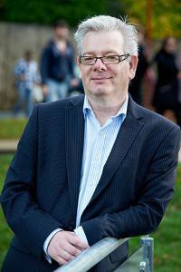
Professor Neil Cooper is Head of Peace Studies and International Development. His research focuses on the arms trade and arms control including the history of arms trade regulation. His recent work includes research on the history of arms trade regulation. Future planned research includes work examining the genealogy of military precision, focussing on the shift from late nineteeth century discussions of modern small arms as ‘arms of precision’ to more recent debates about precision guided weapons.

Dr Karen Abi-Ezzi’s research interests lie in the areas of social constructionism and discourse analysis and their application to conflict resolution processes. Her research also focuses on the Middle East, specifically on the Israeli-Palestinian conflict and also on Lebanon.

Dr PB Anand current research is focused on three main strands. The first one is on Inclusive, Smart and Sustainable Cities as part of a three-year British Academy grant project in collaboration with Prof Sudhir Rajan of the Indian Institute of Technology, Madras (IITM) Chennai, India. The second strand of his research is focused on completing a large edited volume on the BRICS and Emerging Economies, a four-year project involving 40 chapters written by 49 experts from all continents. The third strand focuses on human development challenges in natural resource-rich societies.

Dr Gábor Bátonyi’s research encompasses various aspects of twentieth century Central and Eastern European history, such as the legacies of authoritarian and totalitarian regimes; the memory of Soviet occupation and anti-communist resistance; and the pursuit of foreign policy objectives by small states under conditions of limited sovereignty.

Professor Christoph Bluth is a specialist in nuclear weapons policy and his research is concerned with the prevention of nuclear proliferation, the role of nuclear weapons in crisis regions and trajectories towards nuclear disarmament. Professor Bluth’s work on crisis regions also includes work on South Asia and the role of nuclear weapons in strategic relations between India and Pakistan as another case study of a conflict region where there is a serious risk of escalation to a nuclear conflict.

Dr Graeme Chesters is a political sociologist by training and his work includes researching, teaching and writing about social movements and collective action and their role in transformative change processes, as well as in shaping ideas of the good society. Central to all his work is a focus on the relationship between agency, participation and change in a complex global society.

Owen Greene is Professor of International Security and Development, and Director of Research and Knowledge Transfer at PSID. He is an internationally recognised researcher and policy expert, working mainly on the following areas: international and regional security; conflict, security and development inter-relationships and conflict sensitive development; conflict analysis and prevention and community security; post-conflict peace and security building (including DDR); development and effectiveness of international agreements (on arms, security; environment and development); security and justice sector reform, arms management, and armed violence reduction; and preventing and combating arms proliferation and illicit trafficking.

Dr David Harris continues to research and write on two broad strands of the study of African politics. The first concerns elections in Africa, and 2016-17 was a very busy period. A pre-election briefing, ‘Liberia’s run-up to 2017: continuity and change in a long history of electoral politics’, co-authored with R. N. Pailey, came out in early 2017 in Review of African Political Economy 44:152, and a post-election article is planned for 2018.

Dr Hossein Jalilian is Reader in Economic Development and is a development economist (with research interests and publications in various aspects of economic growth and development, with emphasis on quantitative data analysis. More recent research relates to the role that manufacturing and financial development have on growth in developing countries,

Professor Farhad Analoui’s research interests are in strategic management and

human resource management, leading work on managerial effectiveness and capacity building and development.

Dr Rashmi Arora’s main research interests are finance and development, inequality, economic growth and development and her areas of study are South Asia, Asia and developing economies in general.

Dr Rhys Kelly’s recent research has been driven by a desire to understand the nature and implications of an emerging ecological crisis – including, but not limited to climate change – with a critical interest in the intersections between environmental issues and peace research. Working closely with Dr Ute Kelly, he has been engaging with emerging scholarship and practice around the concept of ‘resilience’. More recently, he has been developing research into the nature and management of conflict within climate adaptation processes, recognising that communities/societies face difficult choices and trade-offs in the process of responding or adapting to climate change.

Dr Ute Kelly Over the last few years, Ute’s research interests have been centred on the complex challenges facing social-ecological systems now and into the future, and on a range of different ways of framing, exploring and responding to these challenges. This has included a survey of different discourses and practices of ‘resilience’ on the ground, which led to the publication (with Rhys Kelly) of ‘Resilience, solidarity, agency – grounded reflections on challenges and synergies’ in the journal Resilience: International Policies, Practices and Discourses 5 (1) in 2017.

Dr Fiona Macaulay’s main areas of research continue to be Latin America, specifically Brazil, criminal justice reform, especially prisons, and gender relations, giving presentations on her work at a number of academic centres – Cornell and Cambridge universities, Johns Hopkins (SAIS Bologna), Central European University in Budapest, University of São Paulo, and King’s College London.

Professor Behooz Morvaridi’s research is focused on developing a critical understanding of the political transformations in modes of aid and development, conceived as intentional practice in countries of the Global South, from a perspective of social justice. He has examined this in the context of rural transformation in the Middle East and Africa, and in the context of Refugees or forced migration. He is currently writing a book on Peace and Development Jointly with Professor Caroline Hughes, Chair of CSC, Kroc Institute of International Peace Studies, University of Notre Dame.

Professor Donna Pankhurst’s research has focussed for the past couple of years on Soldiers After Wars. The first stage of this project has looked at Ex-Army Servicemen in the UK, ‘best practice’ in the care of veterans, and its limitations. She continues to research and teach on wider gender issues in peacebuilding and conflict, as well as in countries of the Global South not affected by recent war. She is currently working on a gender-focussed chapter in a series of volumes about the Cultural History of Peace, edited by Ronald Edsforth in the USA.

Dr David Potts’ main areas of research are in the fields of project appraisal and economic development with particular reference to Sub-Saharan Africa. He has contributed to the on-going training programme for the young professionals of the African Development Bank and published with K Wondemu ‘The Impact of the Real Exchange Rate Changes on Export Performance in Tanzania and Ethiopia’ as an African Development Bank Group Working Paper (no. 240).

Professor Munro Price has continued working on his main research area, the history of international relations since the French Revolution. Over the last year, Professor Price has also undertaken several wider impact-related activities connected to his last book, Napoleon: the End of Glory (Oxford University Press, 2014). As in previous years, Professor Price is a member of the judging panel for two national book prizes, the Franco-British Society Literary Prize and the Elizabeth Longford Prize for Historical Biography. In July 2017 he was elected a Trustee of the Society for the Study of French History, the main learned society for British historians of France.

Dr Afshin Shahi Over the last two years, Afshin Shahi continued working on a number of research projects. One of his substantial journal articles, with H. Forozan, ‘The Military and the State in Post-Revolutionary Iran: The Economic Rise of the Revolutionary Guards’, was published in 2017 in The Middle East Journal 71
- which is considered as a high impact outlet in his area. Since 2016 he has conducted over 200 press, radio and TV interviews. He has been a regular commentator for various BBC programmes and has contributed to Al Jazeera, France 24, Sky News, ITV News, Bloomberg Business and Forbes Magazine.

Dr Simon Whitby has continued his academic and policy work at the interface between the life-science, international security, ethics and law discourses, and has expanded his research and teaching profile with work he (with others) have pioneered on transformative research and teaching on dual-use bioethics and biological security. In an article written with former PhD student Giulio Mancini ‘The Securitisation of Life Science: Alongside his acceptance to the Higher Education Academy as Senior Fellow, Simon has further developed pioneering work on dual-use biological security awareness-raising, education and (CPD) training through team-based learning. This builds on the experience of delivering team- based biological security training (July 2017) for the EU’s Human Brain Project for neuroscience experts at the Karolinksa Institute, Stockholm, Sweden.

PSID Support Staff
Sanna Tukiainen, Student Liaison Officer

Sanna is our current Student Liaison Assistant (SLA), following her predecessor Aleksandra Czech. Together they gave superb administrative support to the Adam Curle Symposium. PSID is very fortunate to have this post funded by the Quaker Peace Studies Trust, as it enables us to provide unique support to all our students, enriching their learning experience and helping them through their university studies, signposting help where needed, and organising social and extra-curricular academic activities to enhance

their classroom studies. In collaboration with the academic staff, she is also responsible for organising many of the activities that you have read about in this Report: our annual study visits to The Hague and to Northern Ireland, the Crisis Game, and several smaller events including the Peace and Development Breakfasts, various guest lectures and workshops, and the annual Peace and Development Ball. Sanna, like all our SLAs, is a graduate of PSID, and completed her MA in International Politics and Security Studies with a focus on Baltic Sea regional security in 2017. She previously studied and worked mainly in Finland and Austria and she is just about to embark on a doctorate.

Will Mcinerney, Rotary Liaison Officer

Will McInerney served as the Rotary Liaison Officer at The University of Bradford Rotary Peace Centre, January 2018 – May 2018. In this capacity, Will helped organize, develop, and raise awareness about the Rotary Peace Centre and supports the Rotary Fellows through promotion of their activities on Social Media, writing blog pieces about their time at Bradford and their Applied Field Experiences and giving advice and guidance about any other Rotary based issues. Will is himself a proud Bradford Rotary Peace Fellow alumnus. He graduated from The University of Bradford in 2018 with an MA in Conflict Resolution with distinction. Will’s research focused on creative approaches to men’s violence prevention education and the establishment of a moral imagination of masculinities educational framework. Will served as the executive director of an arts and peace education non-profit, taught violence prevention and gender equality programs on university campuses, and worked as a reporter, producer, and host for public media organizations.

Oliver Denton, Careers and Alumni Officer

Oliver Denton holds our newly re-established post of Careers and Alumni Officer, made possible by the generous support of the Quaker Peace Studies Trust. The department is proud to have thousands of alumni, working around the world in government, in NGOs, in international organisations, running their own social enterprises, innovating, advocating for social justice and generally trying to make the world a better place! Our alumni are an amazing resource for each other, for our students, and for the department. So, we have begun to invite alumni back to the department to talk about their work in our new ‘Practitioner Engagement Programme’. Oliver is also a PhD student in PSID, working on a thesis entitled The role of The Times newspaper and its editor, Geoffrey Dawson in the policy of appeasement from March 1935 to December 1940. Oliver also holds an MA in International Politics and Security Studies from PSID, as well as this Oliver has a number of research interests including: European security and politics; US politics; Media and journalism; Veterans and PTSD; Social Justice. Prior to PSID Oliver worked and volunteered in a range of industries including party politics, higher education and executive search.

If you are an alumnus, we would love you to

- Join our Facebook group ‘Peace-Studies Bradford’
- Join our LinkedIn group ‘Alumni of Peace Studies and International Development,
The University of Bradford’
- Follow us on Twitter @BDPeaceAndDev

Tell us what you are up to and follow events in the Department!

Rotary Peace Fellows 2017-18, class XVI


Jessica Tissell
Academic background: BA in Global Politics, Minor in Music Areas of interest: Middle East History and Politics, Disaster Relief and Development, Cross-Sector Collaboration, Religious Studies, Peacebuilding. Jessica Tissell is currently working toward a Masters in Middle East Politics and Security at the University of Bradford. Through the Rotary Peace Fellowship, Jessica aims to gain new perspectives on how NGOs can support reconciliation and long-term peacemaking goals in the Middle East while meeting the urgent needs of the region’s most vulnerable people. Jessica worked for several years with disaster relief agency, Medical Teams International. She travelled with Medical Teams to Guatemala, Lebanon, South Sudan and Uganda to raise awareness and support for people facing disaster, conflict and poverty. She also visited Israel-Palestine with World Vision and spent a year working with the Washington Global Health Alliance to advance global health equity. Jessica began her career facilitating collaboration among Fortune 1000 corporate officers with leadership development company, Evanta. Prior to that, she earned a Bachelors in Global Politics, Minor in Vocal Performance, from Willamette University. Her undergraduate research focused on political modernization in the Gulf region of the Middle East, particularly in the Sultanate of Oman where she lived for several months.

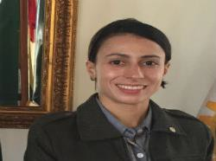
Cinthia Gonçalez da Silva
Academic and Work Background: Bachelor of History. Police Investigator at Parana State Civil Police - Brazil. Language Proficiency: Portuguese, English, some French, Spanish, Italian and currently learning Arabic. Interests: Public Safety, National Defence, Law Enforcement, Intelligence Network, Peace Culture, Conflict Prevention and Resolution. After graduating in History, when she studied the evolution of gender discussion and the violence against women in the decades before the Feminist Revolution, Cinthia felt she needed to do something more pragmatic in the conflict resolution area. So, after teaching for teenagers for a few years, she decided to become a policewoman. As a police investigator, member of the so called “ rupo Tigre" — a police group specialised in extortion by kidnapping, high risk and counterterrorism situations, in the State of Parana, Brazil - she worked on the border with Paraguay, where her unit was responsible for the monitoring of what is known as one of the entrance route of illegal weapons and drugs in Brazil. Recently, Cinthia worked on the prevention and the repression of terrorists threats on the 2014 Fifa World Cup and on the 2016 Olympic and Paralympic Games.

Through the Rotary Peace Fellowship, she hopes to develop new skills on the prevention of crises situations, especially the ones regarding to Political Violence and Terrorism. Although Brazil has a historic of peace when it comes to those issues, she believes her country could be vulnerable to situations that will support these major potential crises, like drugs and weapons trafficking, organised crime and immigration issues. So, she believes that the knowledge acquired through the Bradford Peace Centre will be essential to help her developing prevention and peace strategies in the Law Enforcement area.Yours In Rotary Friendship

55

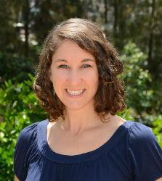
Melody Musser
Academic Background: BA in Peace, Justice and Conflict Studies. Areas of interest: Conflict narratives, trauma response, peace education, development

Melody Musser worked for the past five years as the Communications Specialist for Peacebuilding for Mennonite Central Committee, based in Burundi. In this role, she primarily served as the program coordinator of the Great Lakes Peacebuilding Institute (GLPI), a training institute that provides intensive peacebuilding courses to peace practitioners from Burundi, Rwanda and the Democratic Republic of Congo. At GLPI, she worked in curriculum design, strategic development, impact evaluation, and logistics. In addition to this role, she also collaborated in developing a children’s peace clubs manual and managed a consortium to organize peace clubs reaching over 15,000 children throughout the region. While in the African Great Lakes region, she enjoyed working with other NGOs on several regional peace and reconciliation initiatives. Melody has previous experience in labor rights for immigrant day laborers in Washington DC, girls’ vocation training in Senegal, Special Education in Virginia, USA, peer mediation in Indiana, USA, and teaching English as a New Language in the USA and Burundi. She has facilitated workshops on topics such as grassroots reconciliation, peace and development, children’s peacebuilding, and evaluating peace programs. After completing a Master’s degree in Peace, Conflict and Development at the University of Bradford, she hopes to work on effective project design and implementation for peace and development projects in Africa.

Katherine Keator
Academic Background: Bachelor of Arts in Political Science, Minor in International Humanitarian Assistance Areas of Interest: Conflict Prevention and Mediation, Intercultural Dialogue, GIS Mapping, Information Management, Intersection of Gender, Religion, and Peacebuilding Kate Keator has used her varied interests ranging from cross-cultural communication to gender and peacebuilding to database architecture to support and strengthen the work of peacebuilders and mediators focusing on the Middle East. As the Program Associate with The Syria Conflict Mapping Project at The Carter Center, Kate helped build a database mapping out conflict incidents and armed groups networks across Syria to better inform the work of humanitarians as well as mediators working on the conflict. She also led the Gender Working Group at The Carter Center to encourage discussions around gender in the workplace and foment institutional change to address areas needing improvement. Prior to joining The Carter Center, Kate worked with several nonprofits promoting global citizenship and cross-cultural dialogue while also delving into her interests in marketing and data visualization. She has also worked to promote Muslim- Western understanding through media outreach training, the commissioning of positive, multicultural news articles, and the coordination of social media campaigns with the non-profit Search for Common Ground.

Kate holds a bachelor’s degree from the University of Florida in Political Science and International Humanitarian Assistance. As a Rotary Peace Fellow at the University of Bradford, Kate will be in the Conflict Resolution Program starting Fall 2017. Afterwards, she hopes to be a certified mediator and use her technology and data skills as tools to better address the intersections of gender, religion, peacebuilding, and conflict resolution.


56
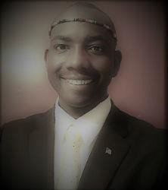
Bol Maywal
Academic Background: Bachelor in Political Science and minor in Military ScienceArea of Interest: Peace, Conflict, and Development Language Proficiency: English, Sudanese Arabic, Dinka dialect, and some Egyptian Arabic In 2013, Bol earned his Bachelor’s degree from North Carolina’s Belmont Abbey College in Political Science and a minor in military science. Previously, Bol worked for a number of years as a Case Coordinator for refugee resettlement through Catholic Charities. He helped refugees become self-sufficient and self- reliant upon arriving to the United States.

In 2015, as an officer in the US Army, he volunteered for a NATO Peace Operation Mission in Kosovo and work to with disadvantaged families, school children, teacher, and community to build partnerships and friendship between the locals and NATO. Upon completion of his deployment, he was awarded a Non-Article 5 NATO Peace Medal in the service of peace and freedom. This was his first opportunity to make a difference in the world.

He understands the importance of peace because of his firsthand experience during the Sudanese Civil War and his recent role as an international peacekeeper. He will start his master’s degree in Peace, Conflict, and Development at the University of Bradford in September 2017.He is convinced that his life calling is to use his education to serve others and contribute as a proactive agent of peace globally. Bol enjoys playing basketball, reading, and spending time with family and friends.

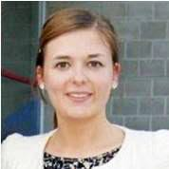
Lydia Kröger
Academic background: Global Business Management Area of interest: fundraising, communications, education, intercultural dialogue Growing up in Eastern Germany, Lydia developed a strong interest in seeing the world and getting to know new cultures, things which her parents had not been able to do until their early 30s. During her studies of Global Business Management she joined the largest international student-run organization AIESEC, holding several leadership roles and facilitating hundreds of intercultural exchanges between German university students and students from all over the world. After finishing her studies, she has worked for NGOs in Brazil, Southeastern Europe and Germany in the areas of education, inclusion of minorities and youth activism as well as volunteered in several refugee camps in Berlin. Lydia is fluent in German, English, Spanish, Portuguese and has advanced knowledge of Arabic.

Shorena Duchidze
Academic background: BA with Honours in Philology Area of interest: include but are not limited to politics, international relations, public diplomacy, conflicts, development and security, communications, education My name is Shorena and I am from Georgia – a tiny country which every now and again shakes and amazes the world. In my 36 years, I have witnessed wars and conflicts in my homeland, causing tens of thousands of casualties, displacement of about 500,000 people and separation of 20% of the country’s territory. Constant lack of peace and stability, I think, was a driving force behind my choices to serve my country in any capacity available to me. Oriental Studies, I graduated from, did greatly contribute to my understanding of today’s world and subsequently, to my professional life. I was working on electoral issues as a member of the NGO “New Generation - New Initiative”, closely cooperating with the Central Electoral Commission of Georgia and International Republican Institute. In 2006, I entered diplomatic service. Throughout this time, I have been contributing to the best performance of my Ministry establishing Georgia’s role as a stable and reliable partner; setting steady, coherent and versatile foreign policy course; building strong bilateral relations and development cooperation; gaining international support for and participation in engagement and non-recognition policies.
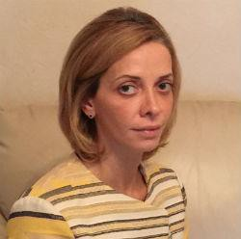

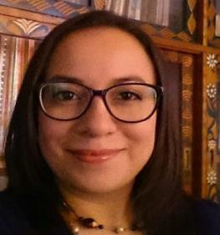
Gabriela Rivera
Guatemalan human rights lawyer. Since 2008 has advised and represented survivors of violence against women. Is one of the founders of an NGO which works to promote human rights of women in prison and their children. Consultant and legal advisor for human rights cases presented both nationally and before the Inter-American human rights system. Between 2014 and 2015 was one of the lawyers representing Mayan women who survived sexual and domestic slavery during the internal armed conflict in Guatemala. Former participant of the Sister-To-Sister Mentorship Program from the Nobel Women’s Initiative, professional intern at the Center for Justice and International Law and invited speaker for various Universities and international organizations on the situation of human rights in Guatemala, women’s rights, access to justice and strategic litigation for gender-based violence cases. Currently working as a consultant for a security and justice reform project focusing on transparency and anticorruption measures.

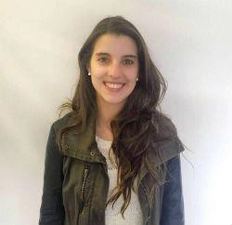
Natalia Gutiérrez
Academic background: Bachelor in Political Science with a minor degree in History, Government and Public Policy from the Andes University (Bogotá, Colombia). Area of interest: Conflict, Security and Development. Natalia Gutiérrez was born in Bogotá Colombia in the year 1991. She is a passionate professional with background in international cooperation and public sector, in the fields of development, conflict resolution and security policies. She has successfully coordinated and managed tasks related to the design, formulation, implementation and evaluation of public policies on citizen security and coexistence in the most vulnerable, marginalize and conflict-affected communities in Colombia. Currently she is working at the Mayor´s Office in the Security Direction, where she coordinates projects for reducing the incidence of crimes such as human traffic, illegal economies, drugs traffic, digital security, theft and homicide. With the leadership of the PHD Professor and researcher Enzo Nussio, she worked as an assistant of an experimental work with vulnerable communities and victims that lived where the ex-combatants of illegal armed groups (paramilitaries and guerrillas), are being reintegrated. She traveled to nine municipalities, leading focal groups in deliberative discussions with members of the Civic Education Program of the Colombian Agency for Reintegration (ACR), victims and civil society. This approach helped her integrate and communicate with vulnerable populations, represent their interests and act as an intermediary between these communities, the academic community and the national and local institutions. Natalia is the Founder and actual Social Director of HELP Foundation, which is the first crowdfunding platform for higher education in Colombia. HELP is a non-profit foundation created her and other 4 interdisciplinary professionals, with the mission of reducing scholar desertion rates and contributing to the construction of a more educated and equitable society. The students supported by the foundation are outstanding young adults, not just for their good grades, but for their life projects and their passion for generating a social impact in their communities. With this initiative, they have demonstrated that with effort young professionals can contribute to reduce inequality and build peace in Colombia. After completing her Master´s Degree in Conflict, Security and Development as a Rotary Fellow, she aspires to become an expert in security public policies and development especially for rural areas affected by armed conflict, where poverty, absence of institutional capacity and lack of basic public services such as health, clean water, education and local job opportunities, enhance conflict attitudes and promote illegal economies.


Zach Cooper Zach Cooper was raised in Avon Lake, OH, a small suburb outside of Cleveland and graduated high school in 2004. Zach had originally planned to serve his country in the United States Marine Corps, however after the passing of his father he didn’t feel as though it was the right time. After several years, Zach’s drive to serve his country did not wane and in 2008 he enlisted with the Marines and was stationed in Oahu, Hawaii. In the Marines Zach served as a field radio operator and in 2010 was attached to an infantry battalion and deployed to Helmand Province in Afghanistan. After returning from a 7 month deployment Zach’s drive and passion for the water pushed him to pursue one of the most difficult programs the Marine Corps offers, Marine Corps Instructor of Water Survival School (MCIWS). This program is known have very high attrition rates but Zach pushed through and became an instructor. During his time in Afghanistan Zach saw firsthand the effects of conflict. Whether it’s the local civilian population of the conflict area, the fighting forces, or the friends and loved ones surrounding those at war, Zach new he wanted to make a difference in the lives of all those affected. After being honorably discharged from the Marines in October 2012 Zach immediately enrolled at The Ohio State University where he began a degree in Security and Intelligence with a minor in Arabic language. While working towards his bachelors Zach acted as a “Veteran Liaison” for a non-profit called 1 Day for the K.I.A. as well as acting as a Student-Veteran Advocate on behalf of the university. In these roles Zach worked to make an impact in the lives of his peers by working to create a comfortable and convenient move for veterans transitioning to civilian life (student-veteran advocacy) as well as raising money to create scholarships for family members of veterans who were killed in action, missing in action, or disabled from their time in service (1 Day for the K.I.A.).

While at OSU Zach was fortunate enough to participate in a study abroad where he spent time in London, Northern Ireland, and Jordan working in Peace Studies and Conflict Resolution as well as working on his Arabic language skills. This experience only confirmed that Zach had found his passion and is what drove him to pursue this incredible opportunity with the Rotary Peace Fellowship. Zach has committed to the Conflict Resolution program at University of Bradford where he hopes to utilize his mediation and negotiation skills to work toward peaceful outcomes throughout the Middle East and is particularly interested in the future resolution between Israel and Palestine. In addition to his studies Zach enjoys playing sports, a multitude of water activities, reading, travelling, and making new friends. Zach has been happily married to his wife and best friend, Elizabeth, since 2009 and they enjoy spending time with their dog, Guinness.

Rotary Peace Fellows 2016-17, class XV

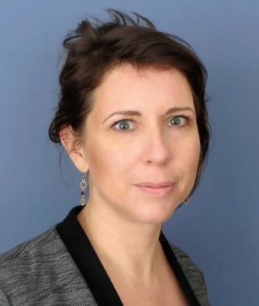
My name is Annelies and I was born and raised in the rainy but beautiful university city called Leiden, the Netherlands, which is about 150 kilometres from my current home town, Brussels, Belgium. I have always wanted a career that would allow me to serve a greater cause, and in 2008 I left Leiden to follow my passion and pursue a career in development and peace consolidation. For the last eight years, I have been working and volunteering as a Communications Officer for various NGOs and United Nations agencies in subsequently Cameroon, Kenya, Senegal, Belgium and Mali.
After completing my Master’s degree in African Peace and Conflict Studies at the University of Bradford, it is my strong ambition to return to the field and use my communications background to connect people and organisations from a wide range of backgrounds.
On my free time I love travelling, exploring new cultures and reading.


Will McInerney is an award-winning spoken word poet, educator, and journalist. Will's work has been featured in media outlets, at universities, and on stages across the US and around the world. Over the past decade, Will has held leadership positions in arts and peace education non-profits, violence prevention programs on university campuses, and in public media organizations. Will is the host of Stories with a Heartbeat, a podcast produced by NPR affiliate WUNC that explores conflict through a poetic lens. In addition, Will works as a freelancer and has reported for NPR affiliates from Egypt, Tunisia, Palestine, Israel, Jordan, Turkey, and the US. Will is a US State Department Program Fellow, a Beacon of Light Award-winner, a Southern Poetry Slam Champion, an International Storytelling Center Teller, and a National Poetry Slam Finalist.
\



Holly White has a professional background in not-for-profit organizations and educational institutions. She has experience in program coordination, student leadership, volunteer management, adult education, the community sector and teaching English as an additional language. Presently, she is an international program officer with Marine Institute International in St. John's, NL, focusing on MII’s internal capacity building and global business development efforts. She was born and raised in St. John’s and has lived in a number of Canadian provinces, as well as Bangkok, Thailand and Blagoevgrad, Bulgaria. She looks back fondly on her 2009 experience with Rotary International in a Group Study Exchange to Japan. She has been the recipient of local and national awards for her enthusiasm, skill and work in community building, leadership, student services and working locally with government assisted refugees.
Holly has a Master’s in Education (Post-Secondary studies), a Bachelor of Arts (German), a Diploma in Teaching English as a Second Language and a Certificate in Leadership, all from Memorial University of Newfoundland. Her passions include community building, diversity, multiculturalism, lifelong learning and youth leadership. She is delighted to have been accepted to pursue a Master of Arts in Peace, Conflict and Development Studies as a Rotary International Peace
Fellow at the University of Bradford in the UK

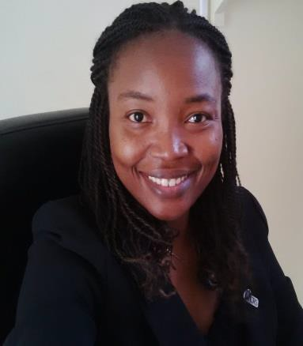
Jody-Ann Anderson is a passionate, self-motivated and flexible professional with substantial experience in youth programming and working in high conflict, disenfranchised urban neighborhoods particularly in her homeland Jamaica. She has successfully managed a complex multi-country, youth-led disaster risk reduction project that sought to strengthen the capacity of vulnerable marginalized urban communities, to prepare and respond to disasters. This approach integrates the people most affected by disasters in formulating strategies and solutions to increase their own resilience. Her portfolio also includes the strengthening of partner capacity/relationships, and supporting local organizations in the improvement of their internal management structures.
A recipient of the Emerging Leaders of the Americas award in 2009, Jody-Ann got an opportunity to study for a semester in Canada, this helped to broaden her perspective and thinking as it relates to learning and international development. Jody-Ann holds a MSc in Applied Social Psychology (Distinction) and a BSc in Psychology and Human Resources Management (Honors) from the University of the West Indies (Mona). Her areas of professional interest include but are not limited to disaster risk reduction, youth workforce development, coping, emergency response, conflict mitigation, relationship building and knowledge management. Upon the completion of the Rotary Peace Fellowship, Jody-Ann aspires to continue her development career with an international agency that addresses complex developmental issues pertaining to peace, conflict and social management.

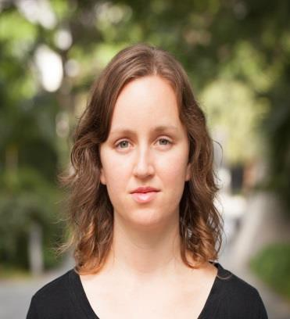
Kristyn Behrends will begin her studies in Peace, Conflict, and Development at the University of Bradford in September 2016.
Previously, Kristyn worked as an early childhood educator in Shenzhen, China. She assisted young children in the development of independence, creativity, and leadership skills in an English-immersion environment.
Prior to her work in China, Kristyn spent twenty-six months in Sierra Leone with the United States Peace Corps as an English teacher. In addition to teaching, Kristyn promoted gender equality and family planning by helping to design and execute the Girls Leadership and Development Initiative conference for young Sierra Leonean women. Kristyn also completed several projects in water and sanitation, including a water pump rehabilitation initiative that increased access to clean water for 2,300 people.

Kristyn earned her BA in Psychology from Stetson University in Deland, Florida in 2012. Kristyn Behrends will begin her studies in Peace, Conflict, and Development at the University of Bradford in September 2016. Previously, Kristyn worked as an early childhood educator in Shenzhen, China. She assisted young children in the development of independence, creativity, and leadership skills in an English- immersion environment. Prior to her work in China, Kristyn spent twenty-six months in Sierra Leone with the United States Peace Corps as an English teacher. In addition to teaching, Kristyn promoted gender equality and family planning by helping to design and execute the Girls Leadership and Development Initiative conference for young Sierra Leonean women. Kristyn also completed several projects in water and sanitation, including a water pump rehabilitation initiative that increased access to clean water for 2,300 people.
Kristyn earned her BA in Psychology from Stetson University in Deland, Florida in 2012.


Melissa Diamond is a social entrepreneur, speaker and writer with a passion for transforming the lives of individuals affected by conflict. She is the Founder and Executive Director of A Global Voice for Autism, a non-profit organization that exists to help children with autism in conflict-affected communities communicate independently as well as the co-founder and American liaison for Roots for Refugees, an initiative that connects vulnerable Syrian families in Jordan with resources, support and companionship to help them rebuild their lives in Jordan. Originally from Minneapolis, Minnesota, Diamond has lived and travelled around the world. She has called Amman, Jordan, Kathmandu, Nepal, Santiago, Chile, and Jenin and Ramallah, Palestine, Richmond, Virginia and Boulder, Colorado home over the past five years.
In addition to her work with these two organizations, Diamond serves as the chair of the Board of Directors for Refugees Welcome U.S., is the official Disabilities Commitment Mentor for the Clinton Global Initiative University in 2016, and is pursuing training in Capacitar International's trauma and empowerment curriculum. She speaks Spanish and English and is learning Arabic. Diamond's work as been recognized by The United Nations, The Resolution Project, The Clinton Global Initiative University, Watson University and the American Middle East Network at Stanford. She has been an invited speaker on topics related to social entrepreneurship, autism and the Syrian refugee experience on five continents. In her free time Diamond enjoys reading, writing, speaking broken Arabic with her "Syrian family," doing yoga and staying in touch with friends around the world. She is honoured and grateful for the opportunity to pursue a Rotary Peace Fellowship in Conflict, Security and Development at the University of Bradford.

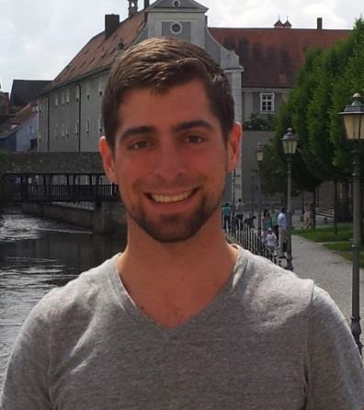
Through the Rotary Peace Fellowship, Michael hopes to gain new perspectives on how stability can be restored to areas torn by terrorism and war, and use that knowledge throughout his Army career to help further the cause of peace. He looks forward to the opportunity to learn from others of different backgrounds while pursuing his Master's in Middle Eastern Politics and Security Studies at Bradford.
While at West Point, Michael's studies focused on the Middle East, Latin America, and non-state violence. By studying abroad in North Africa and Latin America, he was able to gain a better understanding of the unique cultures and challenges to peace in both regions.
During a deployment to southern Afghanistan as an infantry platoon leader, Michael worked with local police and village leaders to increase stability and security in the local area. Stationed in Germany over the last several years, he and his unit have worked with NATO partners across Europe to strengthen the alliance in hopes of deterring future wars. His recent military positions and training have focused on security, threat analysis, and developing an understanding of conflict areas.
Some of Michael's interests include reading, distance running, history, hiking, traveling and learning about new cultures.

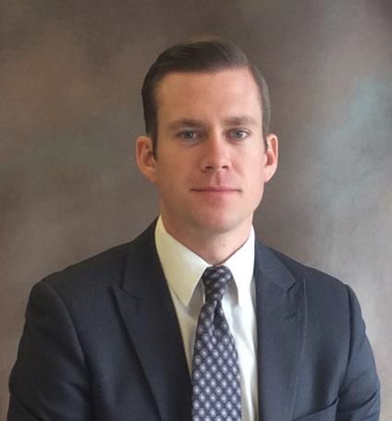
Professional background: After graduating with a degree in Peace building and Business Management, Zach served for over two years as a Youth and Community Development Volunteer for the United States Peace Corps in Morocco. There, Zach worked alongside community members using participatory action research for youth leadership development through service-based learning, conflict resolution training, and sports diplomacy. Upon closing his service in the Peace Corps, Zach worked with Search for Common Ground in their DC headquarters, where he fostered institutional learning by providing support for the design, monitoring, and evaluation of conflict transformation projects.
Zach’s interest in peace building evaluation stems from his time in Hawaii working as a program manager for the McKay Center for Intercultural Understanding, where he recognized the importance of accountability and learning in achieving sustainable outcomes.
Through the Rotary Peace Fellowship, Zach aims to develop cultures of evidence among practitioners and agencies in the conflict transformation field by cultivating skills and sharing the principles of reflective practice.


Hailing from Portland, Oregon in the United States, Sasha Davis is
currently the Director of Communications for Habitat for Humanity’s Portland affiliate, working to end poverty housing in her home city, as well as leading water, sanitation and homebuilding projects with
the Habitat affiliates in Ethiopia and El Salvador. She has over 8 years’ experience managing brands in both the corporate and nonprofit sectors. Sasha has her degree in Journalism: Digital Media, from the University of Oregon. When she is not advocating for her community, she enjoys yoga, climbing mountains, traveling and spending time with her husband.

Board

This is a newly formed governing board for the Bradford Rotary Peace Centre. The objective for this advisory board is to lead the strategic development of the peace center. The advisory board for Bradford Rotary Peace Centre will included the following members:
Professor Roger Mac-Ginty (University of Durham) Keith Davison (Area Host Rotarian)
Chris Bown (Rotarian) Dick Hazehurst (Rotarian)
Christy Bischoff (Refugee Action Children and Families Project Manager) Professor Zahir Irani (the Dean, Faculty of Management, Social Sciences and Law)
Professor Neil Cooper (Head of Division, Peace Studies and International Development)
Paul Goodwin (Senior Product Officer: Marketing and Communication. Faculty of Management, Law and Social Sciences)

Professor Paul Roger (Peace Studies and International Development ) Professor Tom Woodhouse (Peace Studies and International Development) Professor Owen Greene (Peace Studies and International Development) Will Mcinerney (Alumni) (Currently PhD student at Cambridge University) Elected Peace Fellow from each cohort
Professor Behrooz Morvaridi, Director Bradford Rotary Peace Centre

Rotary International Staff:
Jill Gunter (Rotary Peace Centers Program Manager) Emily Ruf (Rotary Peace Centers Program Supervisor) Lauren Pugliese (Rotary Peace Centers Coordinator)
Sarah Cunningham (Rotary Peace Centers Senior Marketing Programs Specialist)
Marina Williams (Rotary Peace Centers Specialist | Duke/UNC, Uppsala, Bradford)

Find more information please see the following websites rotary.org/myrotary/en/get-involved/exchange-ideas/peace-fellowships

University of Bradford Rotary Peace Centre:
https://www.brad.ac.uk/social-sciences/peace-studies/rotary-peace-centre/

Rotary Peace Fellowships at Bradford

The Rotary Peace Centre at the University of Bradford hosts and supports ten fully-funded MA Rotary Peace Fellows from around the world each year and is based in the Division of Peace Studies and International Development (PSID). The Centre was established in 2002 as a founding member of the Rotary Peace Centres network. There are five additional Rotary Peace Centres at the University of North Carolina-Duke University (USA), University of Queensland (Australia), International Christian University (Japan), Chulalongkorn University (Thailand), and Uppsala University (Sweden). Since 2002, the Rotary Foundation has invested more than $150 million (USD) in the global Rotary Peace Fellowship programme. The six Rotary Peace Centres have collectively trained over 1,100 Rotary Peace Fellows.
Rotary Peace Fellows are selected through a highly-competitive international process that is led by Rotary International, the Rotary Foundation, and the Rotary Peace Centres. The Bradford Rotary Peace Centre receives more applications than any other Rotary Peace Centre in the world. Bradford Peace Fellows must have several years of professional experience, an excellent academic record, and show an ability to have a significant, positive impact on world peace and conflict resolution in their future careers.
Applicants for the Rotary Peace Fellowship must apply directly with Rotary International. For more information on the Rotary Peace Fellowship application process visit the Rotary International website .
rotary.org/myrotary/en/get-involved/exchange-ideas/peace-fellowships

For further information, please contact:

Professor Behrooz Morvaridi Director, Rotary Peace Centre Peace Studies  The University of Bradford Richmond Road  Bradford, BD7 1DP UK | Rotary Support Staff  Peace Studies and International Development The University of Bradford  Richmond Road Bradford, BD7 1DP
Emai: b.morvaridi@bradford.ac.uk Tel: 01274233961

