ontents

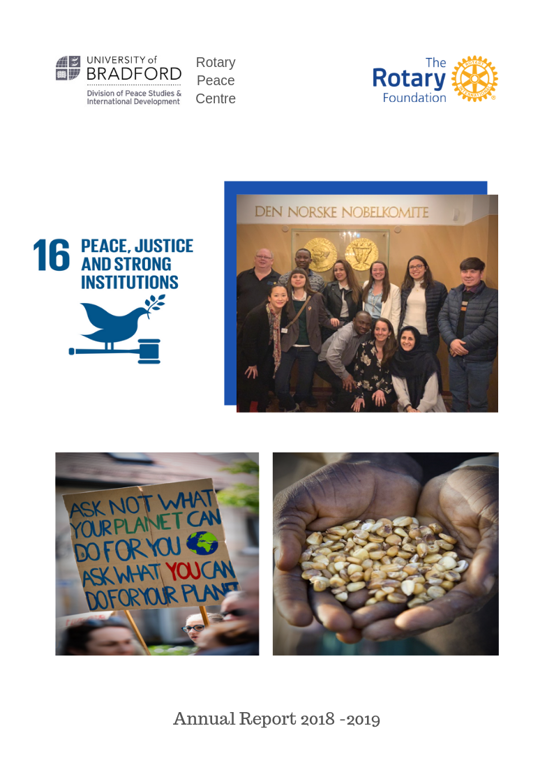

Table of Contents
Page
2
4
14
15
16
19
20
21
23
28
29
36
41
46
54
60

Overview of the Programme, 2018-2019 Class XVI Applied Field Experiences
“Waging Peace” The 2018 Bill Huntley Seminar Away Day Team Building
Extra-curricular Activities & Learning The Hague Study Visit
Oslo Study Visit
African Study Visit: The Gambia Crisis Game 2019
Northern Ireland Study Visit News from our Alumni
Rotary Peace Fellows 2018-2019 – Class XVII Academic & Support Staff
Degree Programme
Further Information Contact

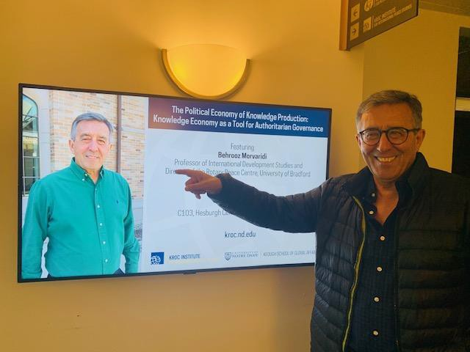
Overview of the Programme, 2018 – 2019
Every year 50 peace fellows are selected to receive fully funded scholarships to study for a Masters Degree
in the following Rotary Peace Centres:
•
•
•
University of Bradford, West Yorkshire, England (15-month program)
Duke University and University of North Carolina at Chapel Hill, USA (21-month program) International Christian University, Tokyo, Japan (20-month program plus 1-2 months of optional Japanese language training)
University of Queensland, Brisbane, Australia (18-month program) Uppsala University, Uppsala, Sweden (21-month program)
And up to 50 scholarships are given to study on a Professional Development Certificate program at Chulalongkorn University, Bangkok, Thailand (3-month program).
•
•
•
I am pleased to announce that Rotary has now selected a new Peace Centre in Sub Saharan Africa at Makerere
University in Uganda. Additionally, Rotary is planning for up to three additional Professional Development Program Centres by 2030 in the Middle East and Latin America and Asia.
I am also pleased to report that Bradford Rotary Peace Centre at the Division of Peace Studies and
International Development undertook a fundamental curriculum review last academic year, which has been successfully implemented. Curriculum topics of the Masters programs include the many global challenges signalled in peace, security and development studies. The courses incorporate Rotary’s six focus areas (Peace and conflict resolution, economic and community development, climate change, water and sanitation, health, education, sustainability, poverty and gender relations). The program's focus is developing conflict resolution, peace building and development skills with the aim of applying knowledge for peace and the well-being of people. Study programs are informed by current research on the contexts and practice within which peace practitioners operate.
The programs provided opportunities for Peace Fellows to engage in analysis, decision-making and problem-
solving around real-world practice-based scenarios. Students developed skills to make informed judgements, based on critical thinking, and learn how to effectively engage with international and local practitioner communities.
2


Our teaching was very interactive and focused on professionalism and employability. We gave Peace Fellows
materials in different formats - verbal, visual and written, as well as opportunities for direct experience and observation. Throughout the program, they were encouraged to actively engage in a diverse range of learning activities designed to develop their capacities for thoughtful analysis and reflective practice. These included individual and group tasks that required them to apply theoretical concepts to real-world dynamics and scenarios. The aim is that Peace Fellows develop a wide range of tangible skills directly applicable to a wide range of careers in peace, conflict and international development. Our teaching and assessment methods are tailored to a wide range of learning styles, and keep peace fellows busy, engaged and stimulated by their course.
In addition to the formal curriculum, we have offered many exciting extra-curricular activities, which included
out-of-classroom study experiences, such as fieldwork, study tours, simulations and role-play scenarios. We have already trialled this through a range of initiatives such as the Oslo Trip, the Northern Ireland Study Tour, an African Trip and the Crisis Game (see detailed reports on various activities in the following pages). By the end of the program, students have had the opportunity to test their knowledge and skills in a range of settings (you can read the Peace Fellows report on their Applied Field Experience from different locales in this report pp 5 – 14).
The peace fellowship program at the University of Bradford trains peace leaders who will have a significant
impact on peace and international development throughout their careers. Since 2002, more than 170 Peace Fellows have graduated from the program and are following careers in peace building in over 60 countries ranging from policy development, advocacy, international development, and academic research. Their impact is being felt in government and non-governmental organizations, international organizations and academia and across a range of sectors, including education, humanitarian action, development and justice (See a brief report from a few of our Alumni students in this report).
This year we implemented our Partnerships for Sustainable Peace initiative with Duke University and
University of North Carolina in USA and Uppsala University in Sweden. This exchange program operates across the centres to share expertise and knowledge, curriculum models, teaching practices and program experiences. The aim of collaboration and partnership working is to ensure that the programs of the six centres remain innovative and pioneering in approach, combining the latest developments in pedagogy with cutting edge research in the field of peace and development studies.
I am pleased to announce that James Barton has taken up the position of Programme Administrator for
Bradford Rotary Peace Centre (see his profile and contact details in this report).
We are looking forward to welcoming this year’s cohort of Peace Fellows who are from 9 different
countries. Throughout this academic year, an exciting range of courses and topics will be offered, and the new peace fellows will have plenty of scope to develop a personal and creative study experience.
Professor Behrooz Morvaridi
Director, Bradford Rotary Peace Centre b.morvaridi@bradford.ac.uk
3

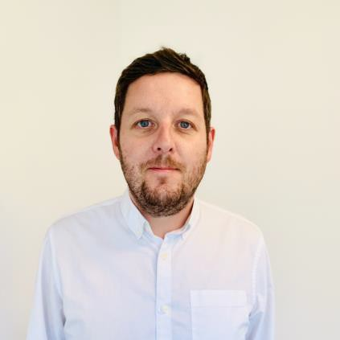
James Barton Programme Administrator, Rotary Peace Centre
James Barton is the new Programme Administrator for the Rotary Peace
Centre, having joined in January of this year. James is responsible for the administrative processes of the Peace Centre, acting as a focal point for communication for the Centre, Peace Fellows, external enquirers, and University staff. He is also involved in the planning of events, our social media channels, and the maintenance of the Rotary Peace Centre website. James’ main focus is support to our Peace Fellows, assisting them with advice and support from Applied Field Experiences to other student administration tasks.
James has experience working in a variety of higher education roles
including careers support, fees and finance, and scholarships. He has previously worked at University of Bradford within the Student Financial Support team, supporting students with financial matters, fees, and scholarship applications. He also has experience of maintaining the social media and web presence of his previous teams.
From James himself – “I’ve very much enjoyed my first six months in the Rotary Peace Centre, and it has been
a pleasure working with our current class of Peace Fellows. I’m looking forward to continuing building relationships, developing the Peace Centre and helping to further improve the Peace Fellows’ experience in the future”
Class XVI Applied Field Experiences
May to September 2018
Class XVI Peace Fellows completed their Applied Field Experiences in September 2018 with a variety of
influential and impactful organizations across eleven countries and 5 continents. The Applied Field Experience is supervised by the Rotary Director who advises Fellows on their choice of placement and maintains contact with Fellows throughout their period away from the university. Fellows have historically chosen placements with a wide variety of organisations, including multilateral organisations such as the United Nations High Commission for Refugees and the United Nations Children’s Fund; international NGOs, such as the Carter Centre and Save the Children; university departments, and various local NGOs, including community groups in Bradford. The following are a summary of Class XVI Applied Field Experience in different organisations and countries.
4

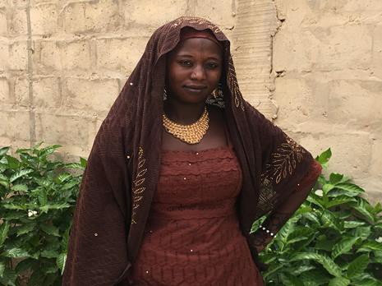
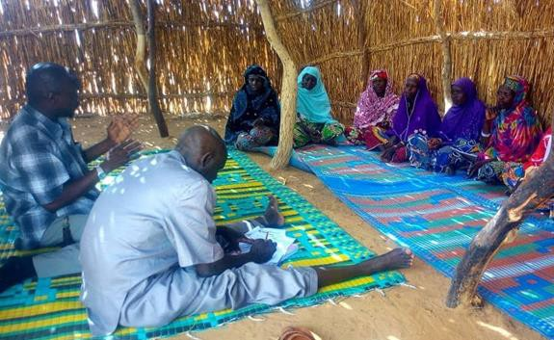
Melody Musser | FROM U.S.A.  AFE IN NIGER/AUSTRIA
My AFE experience consisted of two main components: an internship and an intensive course. I spent 10
weeks in Niamey, Niger as the Institutional Learning Team Intern for Search for Common Ground. In this position I supported the Design, Monitoring and Evaluation (DME) Specialist for West Africa and the Niger
DME team. I developed and reviewed DME tools to
use
for
peacebuilding projects,
including
questionnaires that we used for field research. In
collaboration with a local colleague, we trained surveyors and conducted a study on perceptions of conflict and security among refugees, internally displaced persons, returnees and host communities in four spontaneous displacement sites in Diffa, in the Lake Chad region affected by violent extremism. After analysing the qualitative data set, I wrote a
report that was shared with governmental, non-
governmental and UN agencies working in this
Youth leader that I interviewed about her initiatives to help reintegrate Boko Haram defectors.
region in order to provide more conflict-sensitive interventions. Additionally, I interviewed project
beneficiaries and wrote stories about their participation in conflict transformation and social cohesion activities.
I also participated in a weeklong course entitled Psychosocial work and peacebuilding at the Austrian Study
Centre for Peace and Conflict Resolution. This course examined topics such as fear, trauma and psychosocial conflict analysis. As my dissertation is focused on the social and political implications of collective trauma, this course was useful for better understanding these concepts and how to apply them to my case studies. My internship was also a very useful learning experience.
The process of conducting field research in
a conflict-affected region taught me about research ethics and data security while the content taught me about the daily conflicts people are dealing with due to an ongoing state of insecurity. Working in the DME
department in
organization helped
a peacebuilding
me learn how to
better
integrate
qualitative
and
quantitative data in
order to measure
Conflict scan focus group of women leaders in Diffa
progress on rather intangible topics like
people changing their perceptions and increasing tolerance toward other groups.
5

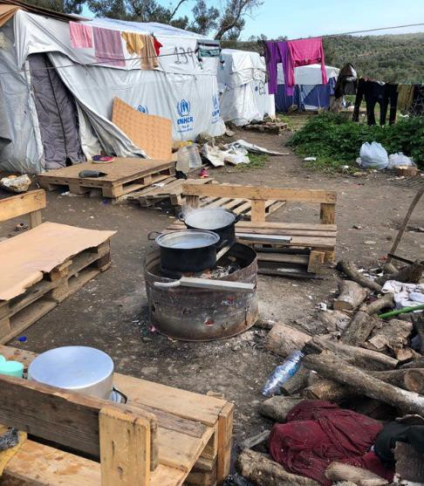
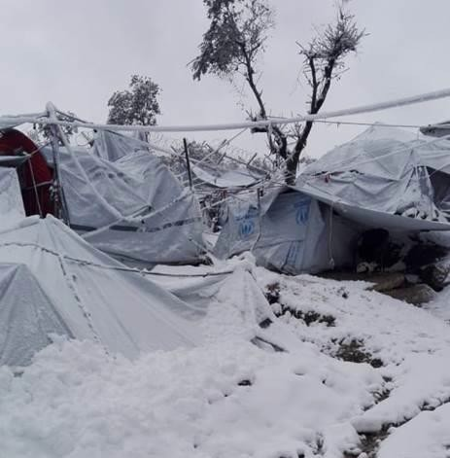
Lydia Kröger | FROM GERMANY  AFE IN GREECE/ETHIOPIA
I spent my AFE partially on Lesvos, a Greek island in the Eastern
Aegean Sea, as well as in Addis Ababa, the capital of Ethiopia. For the first 2.5 months I volunteered at Pikpa refugee camp on Lesvos. Pikpa currently hosts some of the island’s most vulnerable refugees, notably families, pregnant women, the traumatised or severely injured, and includes ‘illegalised’ refugees – those, who have been denied asylum and are hiding from deportation. At Pikpa, I worked alongside several other international volunteers in different areas; mainly the garden, the kitchen, and in construction.
After my first week at Pikpa, an unforeseen crisis increased the
number of residents of the camp from 100 to 400 (a violent conflict at Moria, the island’s largest refugee camp had forced 700 Syrian Kurdish to flee), and I experienced an emergency response situation in which tents and beds had to be set up, mattresses and blankets had to be distributed and food had to be organised. The camp capacity remained at 400 for another three weeks during negotiations between the Greek migration ministry and the UNHCR which resulted in an unfortunate ultimatum being given to the Syrian Kurdish refugees. Although they reported systemic torture and violence in Moria camp, they were given the choice to return to the camp or lose their asylum seeker status in Greece.
The more time I spent on the island, the more I understood the
brutal effects of European migration policy on refugees in Greece. Refugees on Lesvos experience daily racism and remain in a legal limbo waiting for their asylum decision for months, sometimes years. Most live in Moria refugee camp (up to 10,000 of the currently 11,000 refugees on the island) where they are exposed to violent conflicts, terrible hygienic conditions, and inhumane living conditions. Without official permission by the Greek government to leave, which only a fraction receive, Lesvos serves as a sort of open-air prison. During my 2.5 months on the island, I developed a deep empathy for these fellow human
beings, with all the hardship and trauma they have experienced and continue to experience on Lesvos every day.
After Lesvos, I spent 6 weeks in Ethiopia’s capital city Addis Ababa to investigate the country’s civil society
sector as part of my Master’s dissertation.
6

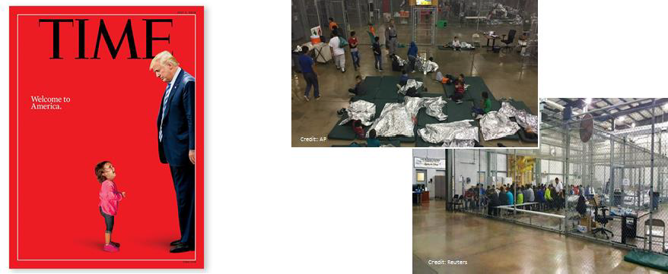
Gabriela Rivera | FROM GUATEMALA  AFE IN AUSTRIA/GREECE/MEXICO
For the first week of my AFE, I participated in the 2018 International Anti-Corruption Summer Academy in
Vienna, Austria, organized by the International Anti-Corruption Academy. This yearly Summer Academy is an intensive programme designed mainly for professionals and has an interdisciplinary approach to address trends and practices in the anti-corruption agenda. The topics ranged from rethinking corruption (defining corruption as an old crime with new forms), to fighting foreign bribery, to what we all can do to drive fair market conditions, and to applicable practice such as corruption investigation techniques. Next, I travelled to Nafplio, Greece, to participate at the Olympia Summer Academy, a yearly academy organized by the Navarino Network and the European International Studies Association with the support of Yale University, the University of St. Andrews and the Institute of International Relations at Panteion University of Athens. The cycle I participated in on Conflict and Political Violence aims to review the most recent academic developments in the field, exploring the intersection of large-scale collective action and political violence, and the dynamics of civil war, ethnic conflict, mass violence, genocide, riots, terrorism, rebel group formation, cohesion and performance, post-conflict violence, peacekeeping and peace-building. Finally, I spent the rest of my AFE at the State of Tabasco in the South of Mexico to volunteer at “La 72, Hogar- Refugio para Personas Migrantes” (“La 72” Home-Shelter for Migrants). La 72 is a migrant and refugee shelter run by the Franciscan Province “San Felipe de Jesús”.
It is a non-profit organization dedicated to providing humanitarian aid and legal representation to migrants,
to promote migrant human rights and campaign to motivate social change in Central American countries. In general terms, volunteers take part in all activities at the shelter related to the humanitarian assistance for migrants and assistance for legal or administrative processes. My time at La 72 provided me with training on medical first aid, psychological first aid, and migrant human rights. The experience of working at La 72 is deeply humanizing and transforming. The shelter uses a human rights-based approach towards the massive forced economic migration that is affecting thousands of Central Americans moving through Mexico to get to the United States. These migrants are escaping from serious human rights violations, lack of jobs, education and health services, extreme poverty and extreme violence. Overall, my AFE experience was broad and enriching. I had the opportunity to be in very different environments starting at the International Anti-Corruption Academy which is focused on training for professionals, to a more academic setting at the Olympia Summer Academy, and ending with La 72 which gave me the opportunity not only to learn, but the opportunity to give back from all of what I have received during the Peace Fellowship.
7

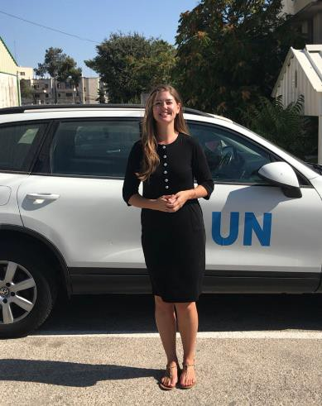
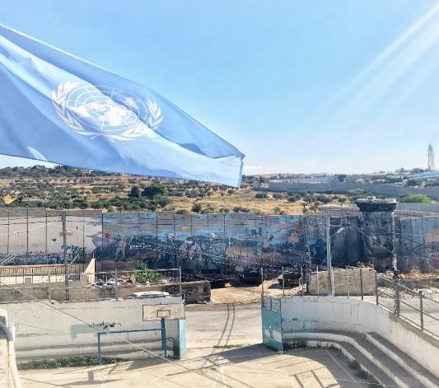
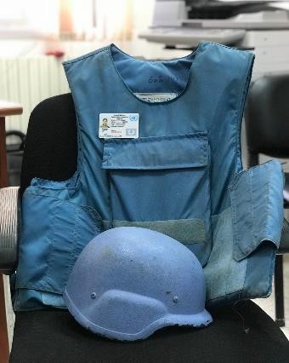
Jessica Tissell | FROM U.S.A.  AFE IN ISRAEL/PALESTINE
I was privileged to spend my AFE working to
protect the vulnerable amidst one of the most protracted conflicts in the world. For three months, I worked in Protection Advocacy for the Jerusalem office of the United Nations Relief and Works Agency (UNRWA). The Protection Advocacy team works to defend the human rights of the more than 800,000 registered Palestine refugees in the West Bank. Among the issues that regularly
consumed our attention were excessive use of force by armed forces in
civilian refugee communities, child detentions, home demolitions, land confiscation and forced relocation. I spent a significant time in the West Bank learning about these issues, as well as in our Jerusalem office improving the documentation and advocacy processes. Beyond the importance of the work itself, this was a tremendous opportunity to spend time within an organization that is at the centre of current international debates about treatment of refugees, aid funding, and an international peace process.
In addition to my role with UNRWA, I also completed a research project for Churches for Middle East Peace
(CMEP). CMEP is a Washington, DC-based organization focused on advocacy for humanitarian assistance,
human rights, and peacebuilding in Israel-Palestine. Throughout it all, I had the privilege of living at the Kenyon Institute, "the home of British research and intellectual life in Israel/Palestine." This meant that outside of my formal internships, I was able to learn from cutting-edge researchers and ideas on Israel-Palestine.
One of the most valuable parts of my AFE experience was engaging
with the Palestinian Christian community, who share cultural bonds with both Muslims and Jews, but are also marginalized by both of those two mainstream communities. As such, they are in a unique position to build bridges of reconciliation. It was here that I met the most extraordinary, humble leaders who are working to plant
seeds of reconciliation in Palestinian and Israeli communities. This summer was a tremendous growth experience for me, personally and professionally. I now have a better understanding of the challenges of providing humanitarian relief in highly politicised conflict contexts, and how to work on human rights protection when this work carries particular conflict risks.
8

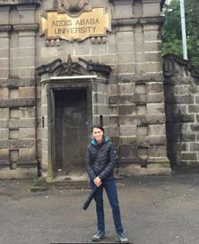
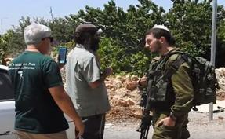
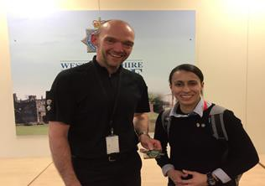
Cinthia Goncalez da Silva | FROM BRAZIL  AFE IN IRELAND/ISRAEL/ETHIOPIA
My AFE began in May with a five-day study trip with the Bradford Peace Studies Department to Northern
Ireland. In Ireland, we met with representatives of non-governmental organisations, the academic community and government sectors, all of them focusing on resilience and post-conflict peacebuilding.
During the month of June, I attended an online course entitled
“Terrorism and Counterterrorism”, offered by the Georgetown University, which gave me a substantial theoretical background to prepare myself both for my dissertation and for my following fieldwork. Additionally, I visited West Yorkshire police units in Bradford and took a Ride Along and Observation Scheme, which consisted of joining police officers in patrolling the city of Bradford. As I am a police officer myself, this practical experience helped me learn about the different
methods and approaches of policing in the UK, especially when it comes to community policing and counterterrorism practices.
In July, I attended a one-month course at the Hebrew University of Jerusalem about security in post-Arab
Spring Israel and the Israeli-Palestinian conflict. The course had academic and practitioner representatives from different nationalities as lecturers, and it also provided me with the opportunity to engage with the different stakeholders of the conflicts. We also had the chance to put in practice our conflict resolution skills.
In August, I went to Addis
Ababa,
Ethiopia,
for five
weeks, where I was affiliated
with the Institute of Peace and
Security Studies of the University of Addis Ababa. Through their facilitation, I developed my independent research about security and community policing in counterterrorism in the context of a semi-authoritarian State.
Finally, during three weeks of September, I did technical visits to police units in both Spain and France to
compare models of policing. Withal, these intensive months have added great value to both my academic and professional backgrounds, and the diversity of my AFE activities certainly contributed to enhancing my perceptions of different conflicts and to improving my conflict resolution skills. I have increased my network in the security and in the academic areas and definitely made new friends.
9

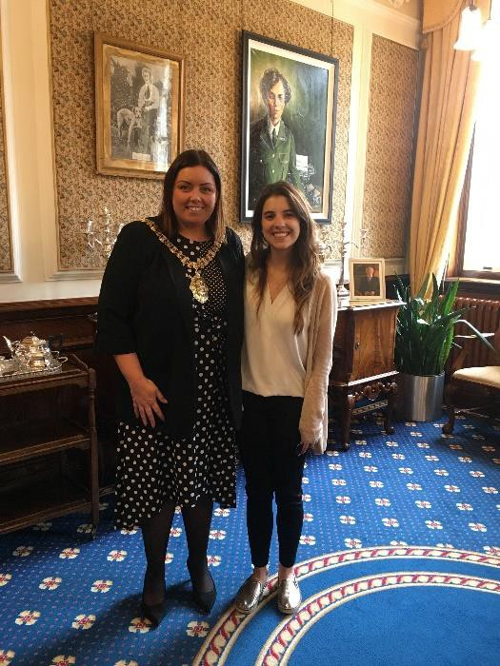
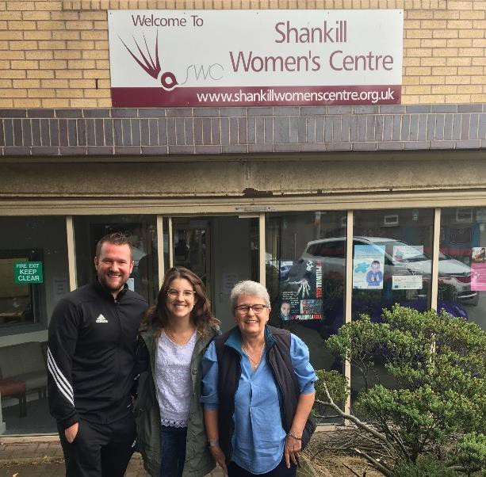
Natalia Gutierrez T. | FROM COLOMBIA  AFE IN FRANCE/ IRELAND
During the summer, I had the opportunity to do two contrasting
AFE experiences that enriched not only my professional and academic interests but also my personal passion for this field.
My first experience was in Paris, France. Here I worked with the
European Forum for Urban Security (Efus) which is the only European network of local and regional authorities dedicated to urban security. My specific role was to support Efus in preparing a proposal to respond to the European Commission H2020 projects on “Secure societies - Protecting freedom and security of Europe and its citizens.” I was given access to the network’s database to analyse the evolution of crime prevention policies in the last 30 years and the existing crime prevention tools that can be adapted and replicated in different European contexts. Additionally, I was in charge of designing and adapting prevention policies and recommendations for local authorities considering the current
and emerging challenges in Europe. During this process I had the opportunity to exchange ideas with recognized academics and to work with representatives of various European cities.
My second experience, in Belfast, Northern Ireland, was a
completely different context since this time I was working from the local authority perspective. I was part of the Good Relations Team at Belfast City Centre and I had the opportunity to interact with the teams that work to build peace and prevent violence in the city (Community Safety, Community Services and Good Relations). For Colombians, Northern Ireland has always been an example and inspiration of how, despite all the challenges and difficulties, it is possible to negotiate an agreement that represents the interests and ideals of all the citizens.
I am deeply grateful to Rotary International for this opportunity. Being able to apply the academic skills I have
learned in the program of Security, Conflict and Development at University of Bradford in a professional context has been the perfect complement to this process of becoming a better person and a more qualified professional to support my country in the long, challenging, promising and – importantly – not impossible journey to peace.
10

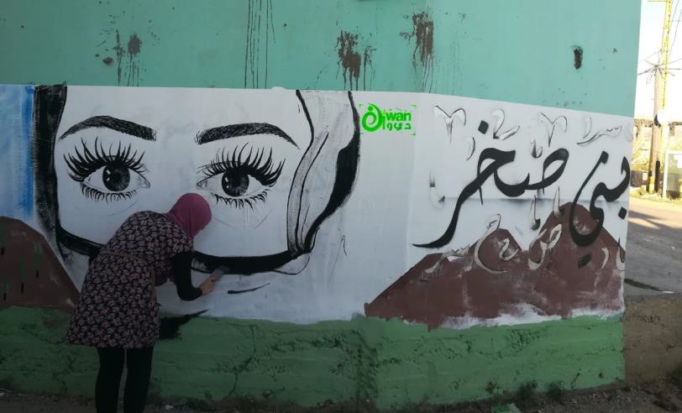
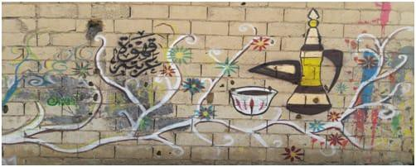
Kate Keator | FROM U.S.A.  AFE IN LEBANON
This summer I interned with the Programs Department at Search for Common Ground in Beirut, Lebanon
for 3 months. I helped write quarterly reports, final evaluations, and other publications going to donors or the public. I also met with potential donors, wrote project proposals, and designed concept notes in order to get the office more funding and projects. Through this work, I not only learned about the interesting projects of Search for Common Ground in
Lebanon, but also practiced proposal writing, budgets, and editing. I also had an opportunity to design my own concept note, following in line with Search's creative mixing of media and community dialogue to contribute to cultural change.
Through supporting Search for Common
Ground,
I learned about
the
organization’s Track II and Track III
mediation efforts in Syria and got to
brainstorm with the project lead about opportunities and challenges. Overall the experience was really helpful for me professionally -- it made me aware of the various peacebuilding projects going on in Lebanon and gave me ideas about creative ways to engage in peacebuilding through media and peace tech platforms. It also connected me to a ton of peacebuilding and conflict resolution organisations in Lebanon and Syria – organisations that don't easily come up in a Google search! Lastly, it gave me practical experience in proposal writing including designing log frames, budgets, narratives, etc.
I am grateful for this AFE experience, which aligned with my professional interests and is a good stepping
stone to my next opportunity.
11

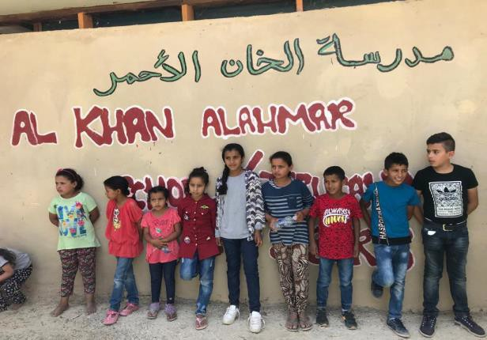
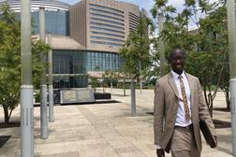
Bol Maywal | FROM U.S.A.  AFE IN ETHIOPIA
I completed my AFE on September 22, 2018 in Addis
Ababa, Ethiopia. While I was in Ethiopia, the warring parties in neighbouring South Sudan formally ended five years of civil war which cost over 50,000 lives and forced more than 100,000 civilians to become refugees. The South Sudanese president signed a peace deal with the rebel leader on September 12, 2018, in Ethiopia. This peace agreement is another chance for South Sudanese leaders to bring lasting peace that is desperately needed by their suffering citizens in refugee camps and back home. My AFE gave me the rare opportunity to witness this important event and this first-hand experience supported dissertation my research.
During my AFE period, I was able to successfully...
1.
2.
Interview members of South Sudanese communities in Addis Ababa, to collect primary data.
Interact with stakeholders involved in South Sudan Peace talks led by the Intergovernmental Authority on Development (IGAD).
Interview members of the opposition party, African Union diplomats, and IGAD dignitaries.
3.
Overall, my three-month AFE was a success and I have gained a lot of experience as a Peace Fellow. I would
like to take this time to thank Rotary International for investing in people like me and my colleagues, that we may become future leaders working to end all wars.
Zachariah Cooper | FROM U.S.A.  AFE IN ISRAEL/PALESTINE
My AFE provided an exciting opportunity in Jerusalem to work with 2018 Nobel Peace Prize nominated
organization, Combatants for Peace (CFP). CFP is a bi-national organization, meaning every position is occupied by both an Israeli and Palestinian representative. In addition, every member of this organization is a prior combatant from one side or the other.
During my time with Combatants for Peace I spent a lot
of time in Khan al Ahmar, a West Bank Palestinian village at risk of being demolished. This village is home to a school – also at risk of being destroyed – attended by approximately 150 children. I got to spend time with the people there, help build a sheltered area behind the school, and stay as protective presence during times we suspected demolition may occur. It was during one of those times when I had one of the most memorable experiences of my trip; the village received word that their demolition had been granted an
12

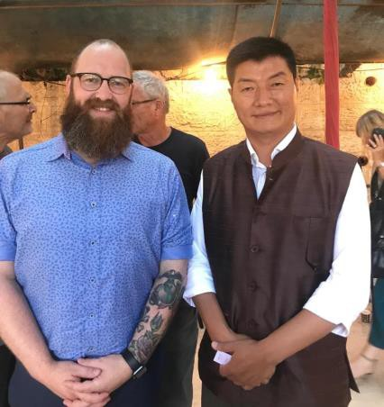
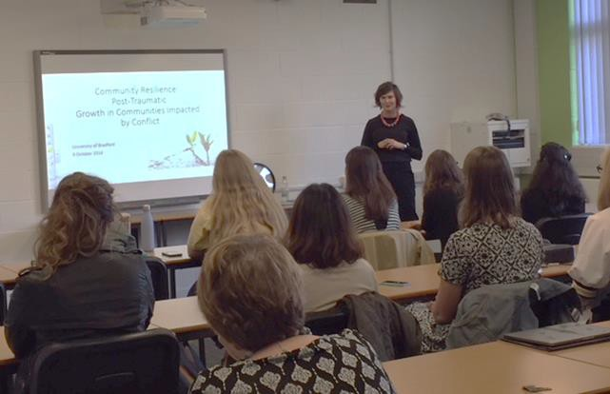
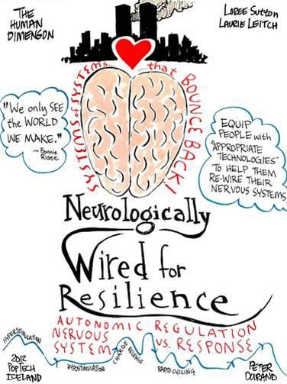
injunction in court and the case would be reviewed again. As soon as the words were announced the people,
young and old, broke out into song and dance. The emotions were incredible and the look on people’s faces spoke volumes – an experience I won’t soon forget. Unfortunately, since my departure the Israeli courts have maintained their original decision and, as of writing this, the village is scheduled to be demolished at any time.
Another highlight of my experience was the opportunity to meet with the President of Tibet. At this meeting
we conversed with the President around the successes and failures of our endeavours and expressed mutual solidarity.
I am so grateful for the opportunity to work with and learn from the
exceptional members of this organization about building common ground amidst conflict. I am excited to watch and see how they progress and continue to impact the people affected by this conflict.
Shorena Duchidze | FROM GEORGIA  AFE IN THE UNITED KINGDOM
I undertook my AFE with Refugee Action, an organization assisting
forced migrants and survivors of conflicts or oppressive regimes arriving to UK to build safe, free and productive lives through legal counsel, resettlement, integration and education. I was affiliated with the Children and Families Project which supports asylum seeking and refugee families in a variety of ways, including with practical issues relating to their immigration case, housing, destitution and access to education. The project uses an empowerment model to seek to improve social and emotional health and support through integration in the local community.
During my AFE I initiated a project designed to address the need for mental health support for refugees and
asylum seekers. I organized (and fundraised) for a workshop supported by the Rotary Peace Centre and
Refugee Action. It was based on the Community Resiliency Model – a trauma-informed method that originated in the USA and has been applied in more than 20 countries. The idea belongs to a team of clinicians that realised that the number of people around the world who have been impacted by natural and man-made disasters far exceeds the number of professionals available for ongoing support. The model captures cutting-edge neuroscience and translates it into six wellness skills that can be easily learned and taught. Thus, it provides very practical and useful
13

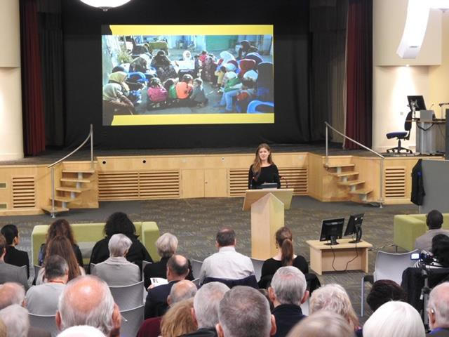
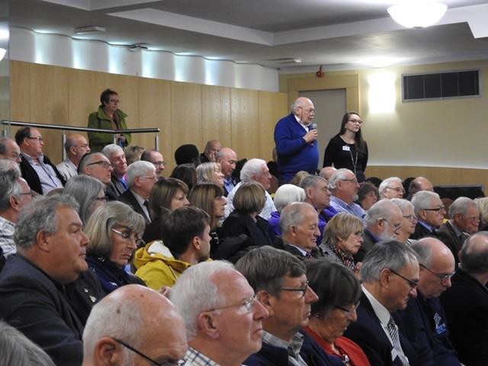
experience for encouraging resiliency in individuals and groups. The first day of the workshop was attended
by Rotary Peace fellows and representatives from several organizations that work directly with refugees/asylum seekers, and took place at the University of Bradford. The next two days were devoted to victims and survivors of different disturbances. The training was carried out by Sara Cook who has more than 15 years' experience in supporting people directly and diversely impacted by the conflict. My hope and belief is that this workshop provided needed support and skills to the most vulnerable category of people to overcome the adversities of their own lives and help others in their communities.
“Waging Peace”
The 2018 Bill Huntley Peace Seminar
On the 27th of October 2018, Rotarians gathered from across Britain to celebrate the work of the outgoing
cohort of Rotary Peace Fellows at Bradford University. The theme of this year’s Bill Huntley Peace Seminar was “Waging Peace,” which the Peace Fellows described as a rally to “bring every bit as much energy, effort and enthusiasm that someone would bring to the battlefield, to the pursuit of a more peaceful world.” Throughout the seminar, Fellows presented passionate accounts of their experiences “waging peace” from Jerusalem to Beirut, Ethiopia to Niger, and from refugee camps in Greece to migrant paths in Central America.
The morning session focused on the exceptionally timely issues of forced migration, refugee crises, and
overcoming dilemmas in humanitarian aid. The discussion transitioned in the next session to topics as diverse as collective trauma, social resilience, and peacebuilding in the age of data. The presenters shared lessons learned on these issues from their time working with the United Nations, with Search for Common Ground, in refugee camps, and in collaboration with various grassroots organizations. The afternoon session centred on current debates on counterterrorism, security reform and peace processes. Students illuminated these topics with personal stories from the Middle East, South Sudan, Colombia, and Brazil.
A key takeaway from the day was that “ultimately, there are no easy fixes,” but that Rotarians must be willing
to engage in the messiness and ambiguity that characterises peace work because the needs are real. One of the most interesting points of the day was the closing keynote, when Rotarians got to hear from a former Rotary Peace Fellow, Claudia Maffettone. Claudia has done exceptional work as a conflict resolution
14

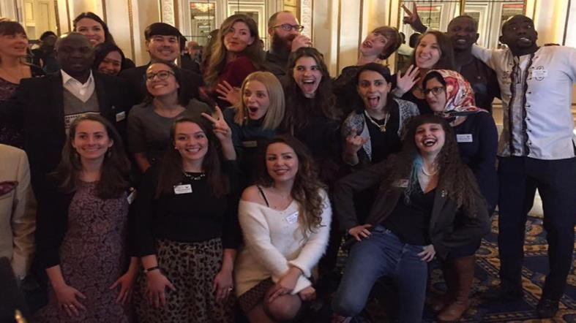
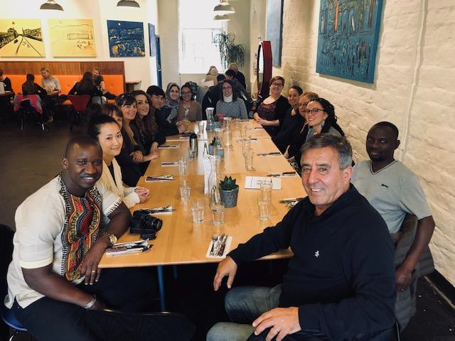
practitioner and a certified mediator in her years since graduating from the Fellowship program. Her session
was a testament to the depth of impact that Rotary makes through the life and work of each peace fellows.
The Peace Fellows closed the day by thanking the University of Bradford and the Rotary International
Foundation, for making it possible for them to pursue their peace goals. The feedback from Rotarians in attendance was overwhelmingly positive, and the incoming class of Peace Fellows look forward to taking next year’s seminar to even greater heights.
Away Day Team Building
Every year in September we organize away day team building on the arrival of Peace Fellows at Bradford. We organised an interactive team-building workshop at the Saltaire UNESCO World Heritage Site. A key theme of the team-building workshop was play and being playful. The aim of the day-long workshop was to encourage trust, reflection, engagement and conversation through movement. The instructor encouraged Peace Fellows to think about how this approach might be applicable and transferable to situations in which they are trying to bring people together on common ground and to create a sense of shared space. The outcomes were positive: the participants felt better connected and a deepened sense of community with their peers.
15

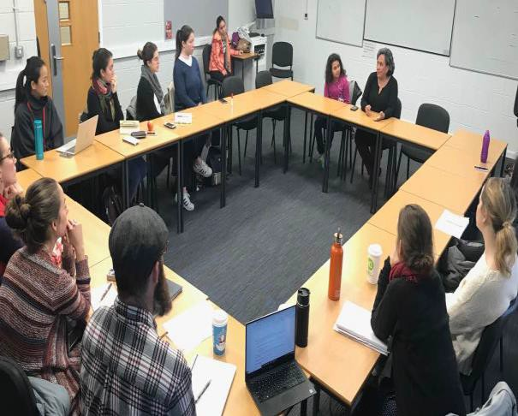
Extra-Curricular Activities & Learning
Practitioner Engagement Workshop on 'Community Resilience Model: A Trauma Informed Method’
The first day of the workshop for the Rotary Peace fellows and representatives of several organizations
working directly with refuges/asylum seekers took place at the University of Bradford. During the workshop Sara Cook talked about the conditions and approaches to mental health issues in Northern Ireland especially after the Good Friday Agreement, also a few approaches they have practiced to enhance/support the community dialogue as well as research-based contributions of the Community Resiliency Model. This was a skills-based programme focused on resetting the natural balance of the nervous system and builds on neuroscience to inform the goal of creating “trauma-informed” and “resiliency-focused” communities of people and is a growth-based model which takes an appreciative approach rather than a deficit approach.
The training was carried out by Sara Cook who has 15 years' experience in supporting people directly and
diversely impacted by the conflict in Northern Ireland. More recently, Sara has been using the Community Resiliency Model to facilitate trauma-awareness and build resiliency with people impacted by conflict from Zimbabwe, Kenya, Egypt, Pakistan, Serbia, Northern Ireland, Turkey and Syria.
Former Peace Fellows Return to Bradford to Share Their
Wisdom Reporting on Two Events in November 2018
On the 20th of November 2018, the Rotary Peace Centre of Bradford brought in a guest speaker to participate
in the University’s “Practitioner Engagement Series,” a series designed to illuminate student understanding of core peace concepts with insights directly from the field. The guest of honour was Carla Castañeda, who is the Readiness and Security Manager for the Canadian Embassy to Tunisia and a former Rotary Peace Fellow. In the intervening years since Carla graduated from the Peace Fellowship, she has managed Canada's conflict resolution and peacebuilding programs toward Colombia, and led regional security analysis on the Americas and North Africa.
“The Rotary Peace Fellowship
was a turning point for me”.
Carla spoke passionately about how her work in security
enables Canada’s peace and humanitarian work in challenging regions where it is needed most. “I am very grateful that Rotary took a chance on me, because it changed how I’ve worked since,” Carla shared. “The Rotary Peace Fellowship was a turning point for me.”
Then, on the 27th of November, former Rotary Peace Fellow Aimé Saba met with current Peace Fellows to
share his insights as a practitioner in disaster relief and peacekeeping operations. Aimé has worked on investigating human rights abuses in Iran, peacekeeping during the Ebola virus outbreak in Liberia, and most
16

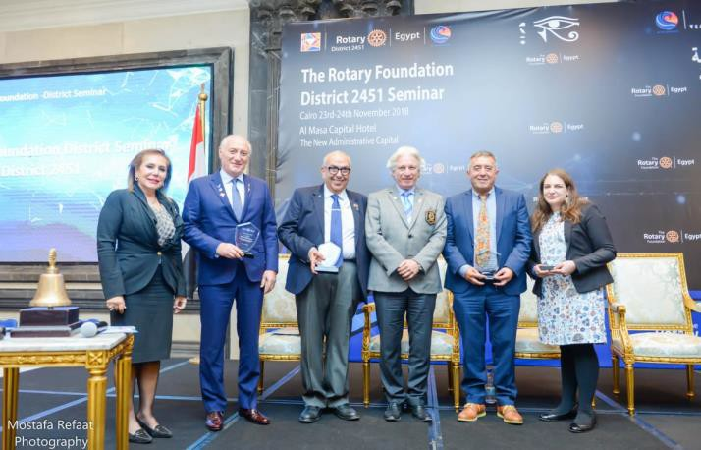
recently working in Bangladesh amidst the Rohingya refugee crisis. In his discussion with current Peace
Fellows, Aimé emphasized individual responsibility for personal professional development and the value of humble self-reflection for identifying areas of growth and passion. The session lasted twice as long as anticipated due to student interest and depth of discussion! Through engaging with former Rotary Peace Fellows, the Rotary Peace Centre at the University of Bradford aims to contribute to fellowship and partnership among the global cohort of changemakers equipped by The Rotary International Foundation to contribute to a more peaceful world.
31 Oct: Dr Aidan Hehir, University of Westminster, 'An Easy Target?: Security Council Resolutions of R2P and
Africa'
1 Nov: Special lecture: Paul Rogers - What ever happened to War on Terror part 2
5 Nov: Lecture: Professor Michael Woolcock, the Harvard Kennedy School and Development Adviser at the
World Bank Building State Capability as the Twenty-first Century Development Challenge
14 Nov: Documentary film viewing and Q&A: Inside Peace - Peace Education Programme in Prisons. The film
was introduced by Tony McLean and Carolyn Kean who are currently delivering this successful, non-religious programme in UK prisons. Following the film there was a Q&A and a chance to discuss the possibility of volunteer work on the programme in local prisons.
14 Nov: JEFCAS Seminar: 'Triggers of Election Violence in Sub-Saharan Africa: A Comparative Perspective'
14 November: Will Mclnerney (PhD student University of Cambridge), former Rotary Peace Fellow, talked
about his research on men's violence prevention education.
23 – 24 Nov: Behrooz Morvaridi (PSID) was invited to a conference in the New Administrative Capital of Cairo
on peace and development and the Rotary Peace Centres.
The seminar was funded by Rotary Foundation District 2451. More than 650 people attended this Seminar.
Melissa Diamond, an alumni postgraduate student from the Division of Peace Studies and International Development at Bradford University, was also invited to talk on ‘The Rotary Peace Fellowship - Outcomes and Impacts’, focusing on her work on autism among Syrian refugees in the north of Jordan. Melissa is an Executive Director of A Global Voice for Autism.
27 Nov: Seminar: Neither Devils Nor Child: How Western Attitudes Are Harming Africa: Talk by Dr Tom Young,
School of Oriental and African Studies, University of Bradford.
17


28 Nov: PSID Practitioner Engagement Session: Darius Tamauskas, Consultant at World Bank, formerly
advisor for Ministry of Economic Development and Trade of Ukraine.
13 Dec: Rotary Peace Fellows and 85 Peace Studies and International Development (PSID) students (UG, PGT,
PGR) and staff got together for the divisional Holiday/Christmas Party at the Great Victoria Hotel in Bradford.
The evening included dinner, live music, a quiz and dancing. Students from different programmes in PSID
had an opportunity to socialise, make new friends, networking informally and have fun. The purpose of the event was to provide a space for this informal exchange and networking, and to create and reinforce a sense of community. Based on student feedback the event contributed substantially towards this goal.
14th Dec: Social Psychology of Peace and Conflict.
Rotary Peace Centre organized a joint interdisciplinary seminar involving Peace Studies and International
Development division and Psychology Division on Social Psychology of Peace and Conflict. The Dean welcomed the participants and pointed out to the importance of the topic and the initiative that comes from ‘clashing the disciplines’. The seminar attended by students and lectures from different division. The Seminar Programme is detailed below:
Chair: Professor Behrooz Morvaridi,
'Towards a critical discursive peace psychology' - Dr Stephen Gibson (Associate Professor of Psychology &
School Research Lead School of Psychological & Social Sciences York St John University).
‘Misogyny, Misandry and Hate Crime’ - Professor Abigail Locke (Professor of Psychology & Associate Dean for
Research and Knowledge Transfer, Psychology Division)
‘Anatomies of War: Reflections on Trauma, Violence and Emotion’ - Professor Donna Pankhurst (Professor of
Peacebuilding & Development, Peace Studies and International Development)
'Peace and Conflict in talk about Refugees' - Dr Simon Goodman (Research Fellow, Centre for Innovative
Research Across the Life Course, Coventry University)
Discussion on follow-up work - Dr Rhys Kelly, Dr Eleanor Bryant
18

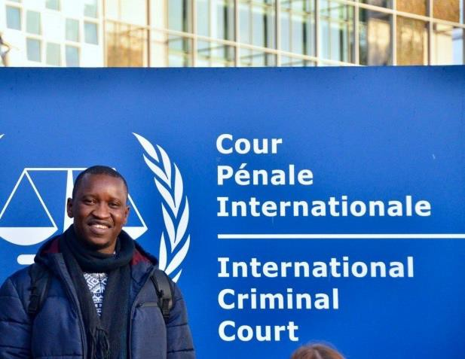
The Hague Study Visit – January 8th-12th, 2019
Division of Peace Studies and International Development – University of Bradford
Camillia Freeland-Taylor
On January 9, 2019 the Rotary Peace Fellows and other University of Bradford students visited the
International Criminal Court where they saw the visitors center, took a tour of the facilities, and listened to a presentation on the court, and current developments. The Universiteit Leiden hosted a presentation OSCE HCNM by Anton Petrenko Thomsen, the OSCE (Organization for Security and Cooperation in Europe) High Commissioner on National Minorities and another meeting on the Women’s Initiatives for Gender Justice by Siobhan Hobbs, a Senior Legal Officer.
On January 10, 2019 the fellows visited the Organization for the
Prohibition of Chemical Weapons where they met with Dr. Alexander Kelle, Director of Policy and strategy and Grant Dawson, the Principal Legal Officer at the Office of the Legal Adviser of the Organization. In the afternoon they heard a presentation at Universiteit Leiden by Anca Elena Ursu, a researcher at Conflict Research Unite of the Clingendael Institute. In the evening they enjoyed a vegan dinner and a humanitarian pub quiz at Humanity House.
On January 11, 2019 the group gathered in the morning to debrief and for discussions/reflective feedback.
In the afternoon they went to the UN Mechanism for International Criminal Tribunals, Previously International Criminal Tribunals for Former Yugoslavia. This experience and the presentation given showed theory and concepts in practice, as well as helped to further ignited great passion and drive for the fellows work in championing peace around the world.
35 PSID students (with 25 different nationalities) participated in the Hague Study Trip. The QPST-funded
Student Liaisons (Sanna and Ulli) plus Dr Fiona Macaulay and Dr Simon Whitby accompanied the students. The trip included an intense programme of visits and meetings with organisations and institutions in the Hague, Netherlands. These visits included prestigious international organisations such as the ICC (International Criminal Court), OPCW (Organisation for the Prohibition of Chemical Weapons), ICTY/MICT (International Criminal Tribunal for former Yugoslavia/ UN Mechanism for International Criminal Tribunals) and OSCE (Organisation for Security and Cooperation in Europe), as well as meetings with other highly relevant organisations such as Women's Initiatives for Gender Justice, and the Clingendael Institute for International Relations. All visits were genuine learning experiences for the diverse group of students, connecting their academic programmes to the realities and issues on the ground.
19

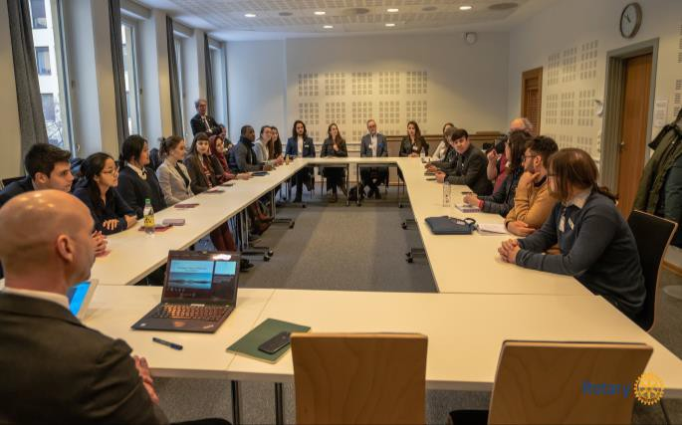
Oslo Study Visit - January 2019
Ana Lucia Pelaez
Following what has become a tradition for Bradford Peace Fellows, Class XVII had this year the incredible opportunity to participate in a visit to Oslo, Norway along with their peers from Uppsala. The visit was hosted by the Norwegian Rotary International District 2310 and included visits to the principal peace-related institutions in the city.
On the first day, we had the opportunity to visit the
Norwegian Ministry of Foreign Affairs where we learned about the commitment that Norway has to promote peace around the world and the means by which they do so. The meeting payed special attention to the facilitation activities that the Ministry has developed and develops in many places such as Colombia, Guatemala and Afghanistan and the challenges that they have encountered in their role as a neutral third party.
In the afternoon, our hosts conducted us to the Norwegian Institute of International Affairs (NUPI) where we
were presented with the current research that the organization is developing in topics of peace, governance and development. Also, we talked about some of the challenges that researchers face nowadays and how they are overcome; this perspective presented us with a realistic image of our field that can help us in the future to engage better with our practice.
The second day received us with a very insightful presentation in the Peace Research Institute Oslo (PRIO)
where we were transported from the usual topics of research of peace and conflict towards the new dynamics of the field. Some of the new issues that the Institute is concerned with are the link between technology and security and the population’s perspectives on peace efforts as a mean to ensure their success. In here, we discussed about the use of data, the reliability of perceptions and how technology creates false senses of certainty in the security field.
Finally, the day ended with the much-expected visit to the Norwegian Nobel Peace Institute where the
Director shared with us the story of Alfred Nobel and the history of the Institute. We had a very interesting talk about how they Nobel Peace Prize candidates are chosen and the criteria that they use to give the awards. We then had time to explore the ceremonial room where the winners are announced and the room where deliberations take place. Sadly, after this, the visit ended but the good memories that we created with the Peace Fellows from Uppsala and Norwegian Rotarians will undoubtedly remain.
20

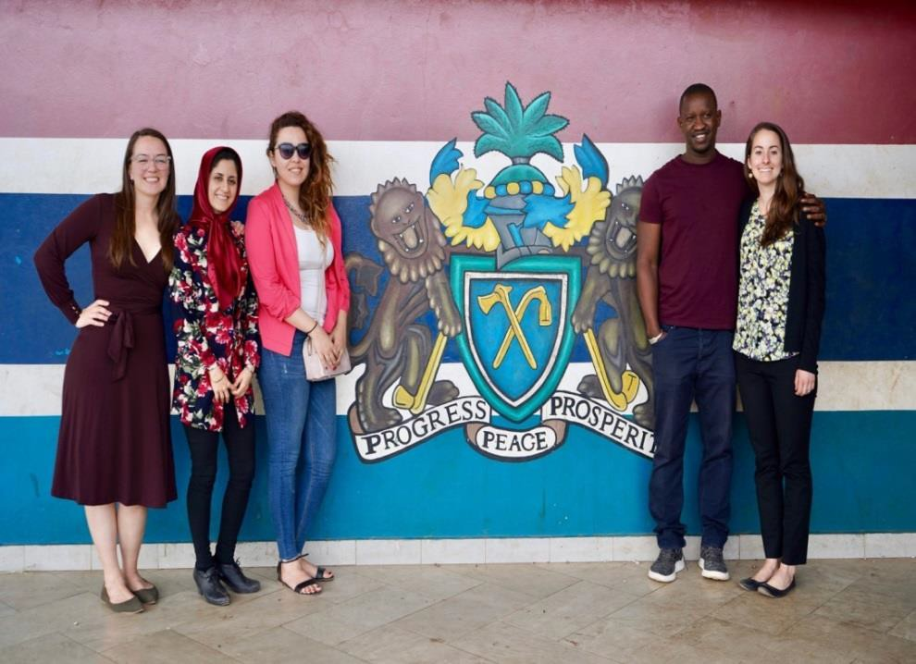
Africa Study Visit: The Gambia
Julia Coffin
This February, I had the unique opportunity to travel to the Gambia with 12 peers (including 4 other Rotary
Peace Fellows) as part of the Africa Study Visit module at the University of Bradford. For two weeks, we immersed ourselves in its rich history and culture. The Gambia is a small country, with a population of approximately 2 million people. It snakes along The Gambia river, engulfed by Senegal on three sides, and 80km of beautiful Atlantic coastline on the fourth. It is regionally known as “the smiling coast”, an identity that exuded from faces and warm demeanor of everyone we met. And while much of their history has been peaceful, the past 25 years have been marked by dictatorial rule, brief political unrest and a slow transition to democracy.
The Gambia is at a unique political crossroads. To offer a little background, President Yahya Jammeh’s 23
year reign came to an end in 2017, when he was voted out of office. Under his leadership, the Gambia experienced significant development, but also faced accusations of human rights violations, including disappearances and imprisonments, the torturing of political opponents, silencing of the media and witch hunts. In 2017, former President Jammeh refused to step-down until regional leaders intervened and sent in troops. President Adam Barrow became the interim leader, and the Gambia has since been striving to rebuild and strengthen their institutions and facilitate national reconciliation and healing.
21

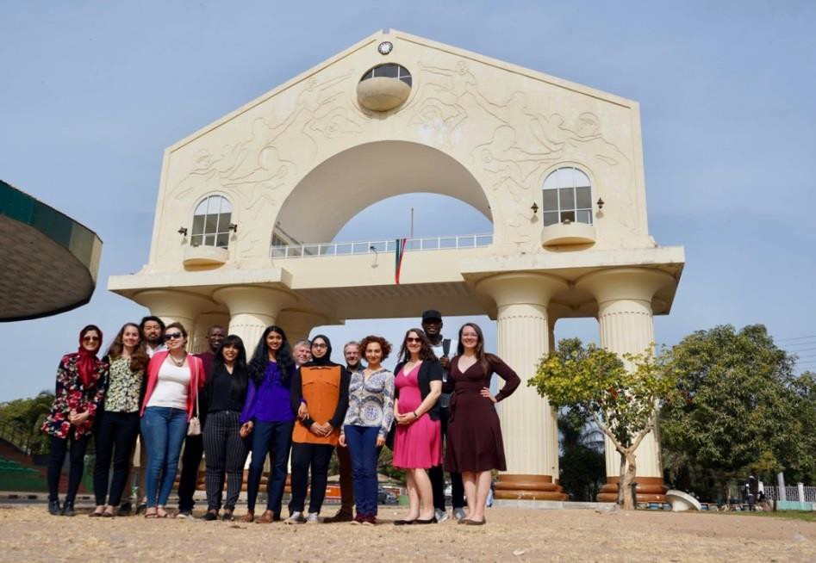
Over 2 packed weeks, we conducted 27 interviews with key stakeholders. This was a really valuable
opportunity to practice the art of fieldwork. We grappled with questions about colonial legacy, the role of civil society, impacts of migration and the challenges of reconciliation. We met with members of the Gambian police force, Ministry of the Interior and the Chief of Defense to better understand the challenge of security sector reform with newfound democratic freedoms. We discussed the forces driving migration and strategies to overcome the stigma of returning with the International Office of Migration and the International Trade Center. We spoke with youth, members of the media, representatives of the European Union and the opposition party. These interviews offered diverse (and at times competing) narratives of the Gambia’s history and priorities for the future.
The highlight of the trip for me was the opportunity to sit in on the Gambia’s Truth, Reconciliation and
Reparations Commission (TRRC) hearings. Earlier this year, the Gambia set up the TRRC to give space for victims and perpetrators to share their story, in an effort to document the truth and offer reparations to victims of President Jammeh’s government. The TRRC is part of the “Never Again” movement to ensure the Gambia does not fall back under authoritarian leadership. Sitting in on the hearings was a powerful opportunity to see transitional justice in action.
We returned home with more questions than answers. The study visit provided a unique opportunity to
understand the challenges that come with building democratic systems. However, I returned feeling hopeful. Over the course of our two weeks, we met with a lot youth who have a clear vision for the future of the Gambia and a commitment to hold their leaders accountability and, one day soon, move into leadership positions themselves. I know we all look forward to seeing how they continue to shape their communities and the country in the coming years.
22

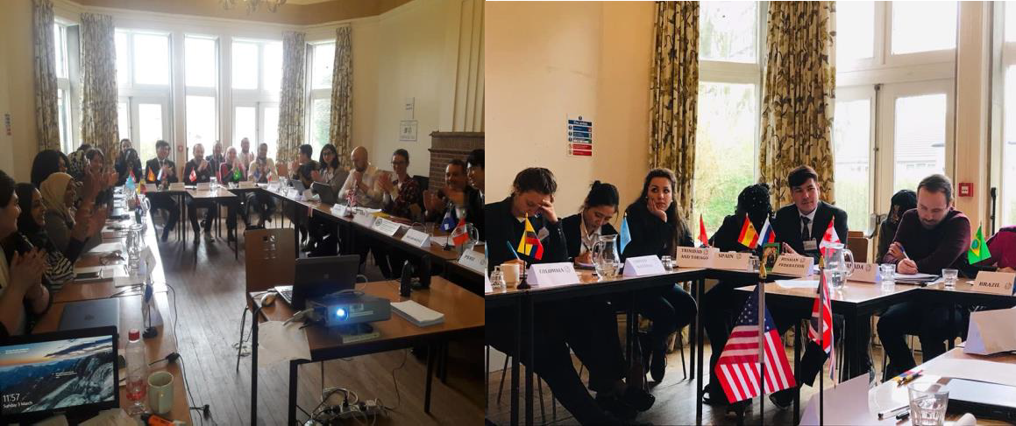
Crisis Game 2019
Peace Fellow Class XVI
This March saw the return of the Crisis Game, a simulated international humanitarian emergency which we
play out over the course of a two-day residential in a youth hostel. It is challenging, both serious and fun, and a great way to apply the knowledge about international conflict resolution and governance that you have learned during the year. The Crisis Game is supported by the University of Bradford Division of Peace Studies and International Development and the Rotary Peace Centre.
The Crisis Game simulation was organised for the third time on the weekend of 2nd-3rd of March 2019. The
activity took PSID students and staff members, including Bradford Rotary Peace Fellows, and Rotary Programme Administrator James Barton, to YHA Haworth, a former manor house turned hostel, near the historic village of Haworth in West Yorkshire. Throughout the weekend the participants stepped into the roles of delegates from various states and international organisations attending a specially convened UN crisis meeting that was called to find ways to deal with an escalating international conflict.
For the purpose of the simulation, a real political and humanitarian crisis in Venezuela was taken as the
starting point, and the scenario was escalated over a series of surprising events unfolding over the course of two days. The students representing their countries and organisations had to rely on their knowledge on international relations, high level diplomacy and conflict resolution, and the research they had conducted in preparation for the game to navigate the complex multilateral negotiations in a volatile international environment. Two media teams formed from the game participants were assigned with documenting the plenary sessions and the negotiations between clusters of states, interviewing the delegates, and contributing to the game dynamics by revealing new information to the participants through media blasts taking place several times a day over the course of the event. The student feedback on the event was once again overwhelmingly positive, with several Peace Fellows taking part, and for the first time the Crisis Game ended with agreements being made and motions passed.
23

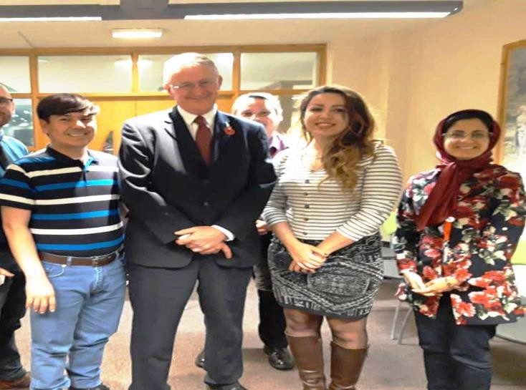
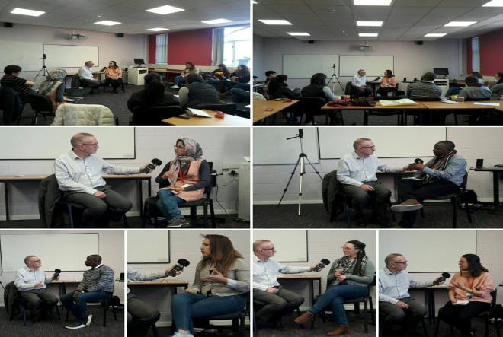
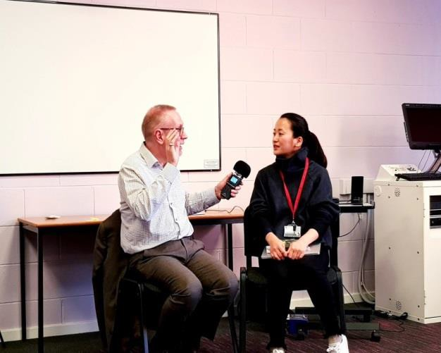
7th Mar: MP Fabian Hamilton (Shadow Minister for Peace and Disarmament) and Author/Peace Activist Vijay
Mehta
Speakers Vijay Mehta, Peace activist and Founder of Uniting for Peace gave a talk based on his new book
‘How Not to Go to War’. Fabian Hamilton MP, Shadow Minister for Peace and Disarmament spoke about his peacebuilding role and UK government.
5 Mar: Media Training, delivered by Richard Horsman of Media Skills UK.
Kiyomi Miyagoe
On 5th of March 2019, University of Bradford Peace Studies and International Development staff and students including Class XVⅡ Rotary Peace Fellows took part in a half-day Media Training Course with Mr. Richard Horsman. Richard Horsman is a radio journalist with more than 30 years’ experience and has taught journalism at Leeds Trinity University.
24

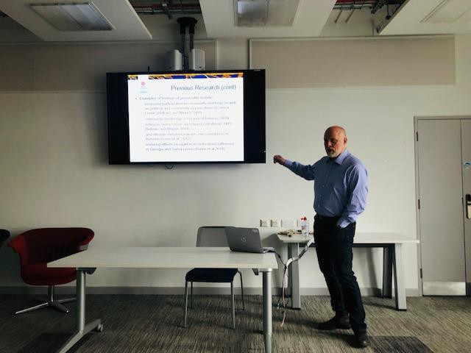
Richard first explain the objective of the session which ‘covers the benefits of communicating with journalists
as the mediators to lay audiences, the way to structure arguments to achieve this and, most importantly, a chance to rehearse a radio interview with an experienced practitioner. The objective is very much to encourage participants and to boost their confidence to initiate interaction with the media, but should researchers encounter a more challenging or hostile interview the techniques learned, and the practice session should help in delivering arguments in the most effective way possible’. The session focused on communicating ideas in a straightforward, accessible way so as to engage lay audiences with the subject.
Too many academics default to 'conference speak' as if engaging with peers or feel under the pressure of
peer review when talking to a journalist.
The training course is sponsored by the Rotary Peace Centre. The training started with teaching how to work
with media and how to prepare for media interview. Each participant was then tasked to speak about their research or issue of their interest with Richard Horsman just like a real interview to practice. After each interview, Richard Horsman as well as other participants gave feedbacks and advice, emphasizing the importance of humanizing messages and telling own stories. This practice helped the participants develop their skills to take control of interviews - even in challenging interview situations - and deliver key messages to a wide audience.
As a researcher or practitioner, they may be participating in a media interview in the future. Therefore, the
training was very valuable and will help peace fellows conveys their messages to the world.
Exchange Programme: Uppsala/Bradford/Duke
Magnus Öberg is the Director of the Uppsala Conflict Data Program (UCDP) and an Associate Professor at the
Department of Peace and Conflict Research, Uppsala University where he has served as Head of Department 2012-2017. Öberg is a member of the editorial board of Journal of Peace Research where he served as Associate Editor 2007-2012. His main research interests are civil war, escalation processes, and forced migration. He has previously worked mainly with large-N statistical research and game theory but is now heavily involved in experimental research and co-founded the Uppsala Peace Lab that runs a lab-in-the-field (currently operating in Eastern Turkey and Mosul, Iraq).
Professor Öberg is involved in two lines of research. The first involves experimental research on the effects
of traumatization on the social preferences of refugees in from Iraq and Syria residing in Eastern Turkey. The
25

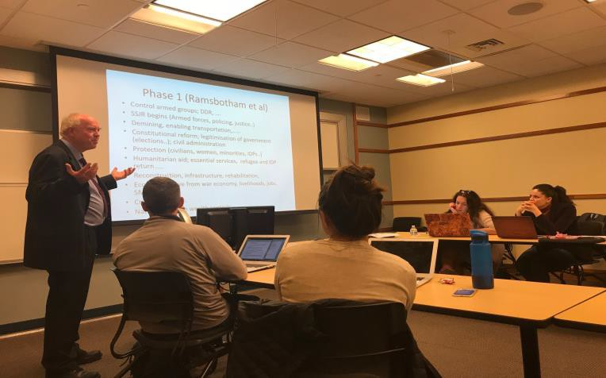
second studies the psychology of grievances in escalating conflicts. Öberg’s research has appeared in inter
alia European Journal of International Relations, Conflict Management and Peace Science, and International Interactions.
During his visit Professor Öberg gave an overview of the Department of Peace and Conflict Research and the
Uppsala Rotary Peace Centre (incl what the masters’ programme looks like) and presented some of the major research programs and activities at DPCR. He also presented the Uppsala Conflict Data Program to both Peace Fellows and PSID academic staff. Finally, he presented his findings from research I am on the effects of exposure to war violence and trauma on social preferences.
Exchange Programme Duke and North Carolina and Bradford University
As part of the faculty exchange initiative, Professor Owen Greene led a two-day workshop on Conflict
Sensitivity, attended by Peace fellows and alumni. The workshop focused on developing their understanding and capacity to use some key concepts and methods for assessing and improving the conflict sensitivity of programmes or activities in fragile or conflict affected areas or countries. Owen also held an open talk at University of North Carolina on the topic of “Violence reduction, poverty alleviation and community development: examining a changing policy nexus”.
22 Mar: Harriet Lamb: Impatient for Peace - A special guest lecture and discussion
with the CEO of International Alert.
International Alert is a global leader in peacebuilding and conflict resolution. Harriet Lamb gave a review of
global conflict trends and sought to make the case for peacebuilding, including examples from International Alert’s own work.
Rotary Peace Symposium
This year the Rotary Peace Symposium was held in Hamburg, Germany. The directors of six centres gave
presentations and exchanged ideas on the current and future work. It was also great to catch up with Bradford Alumina.
26

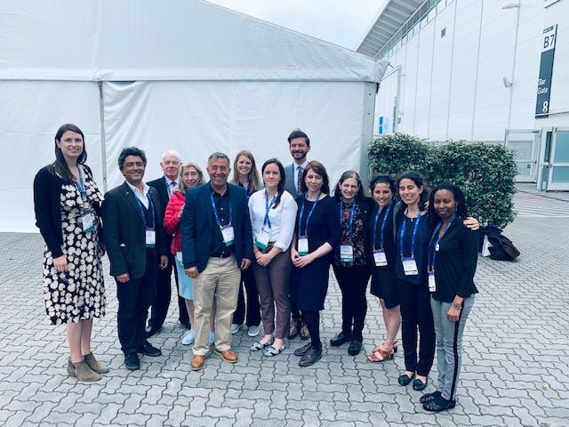
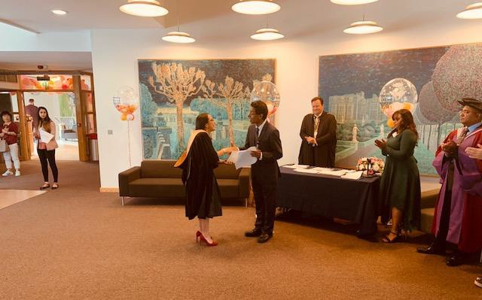
Prize for the best dissertation
Once again, we are delighted by the achievements of our Peace Fellows.
This academic year Natalia Gutierrez received the David Yates Memorial Prize for best dissertation and best
student and Gabriela Rivera received the prize for best dissertation. They were both awarded a distinction for their dissertation and Master degree.
27

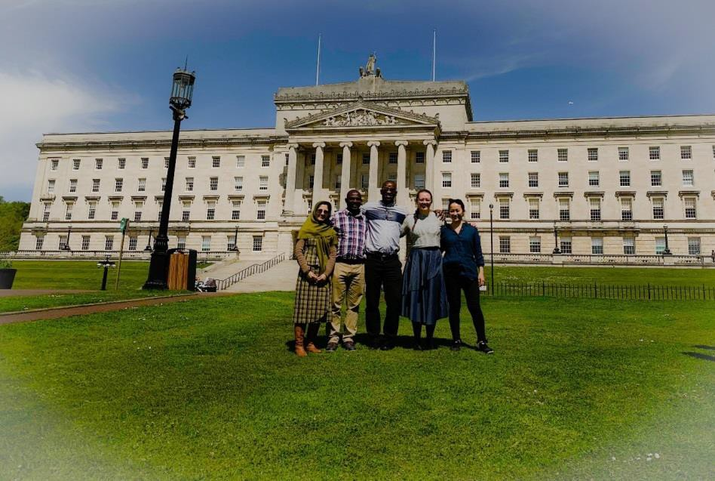
Rotary Peace Fellows Take Part in The PSID Northern Ireland Study Visit
David Kujabi
On Sunday 19 May 2019, five Rotary Peace Fellows together with other students returned to Bradford after
a week-long study visit to Northern Ireland. The study visit was organised by the Division of Peace Studies and International Development at the University of Bradford. It was a wonderful opportunity to practice field research and to experience what we have been reading in books and learning in class.
During our stay we held meetings with several people and institutions who are stakeholders in the conflict
or are taking part in the peacebuilding process. The Paddy Campbell Black Cab Tours took us through some of the historical parts of the conflict and the peace walls. We had meetings with Ex-prisoners, an Ex-British military Officer who served in Northern Ireland during the time of the violent conflict. Furthermore, two victims of the conflict in Londonderry, one a Catholic and the other a Protestant gave an account of the lived experiences of the conflict. The day spent in Londonderry gave us more insight into the conflict and allowed us to see the scenes of the infamous ‘Bloody Sunday’. There were also visits to the Northern Ireland Assembly in Stormont and a meeting with a member of the Policing Board.
Rotary Peace Fellows in front of the Stormont Parliament in Northern Ireland
The Northern Ireland conflict or 'The Troubles' has been long, complex and multi-layered, and the narratives
are many, diverse and puzzling. The quest for answers and solutions have left academics puzzled, politicians perplexed, and the common person frustrated. With the Good Friday Agreement, much seem to improve the situation, but the peace walls still stand, imposing and menacing. They do keep a peace but that is only negative peace. The violence may have stopped, the guns silenced but the it seems the animosity remains within the people.
The murals and epitaphs on cemeteries portray messages that exude sentiments that lay bare the deep-
seated feelings of the people. What we see projected to the outsider, is a facade of everything is okay. There is a perplexing rise in the number of suicides and punishment attacks are prevalent, maiming and grossly traumatizing.
28

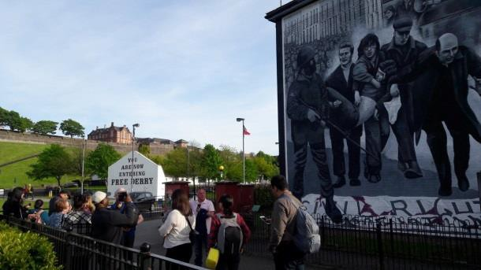
The complexity of this conflict has put to test various peacebuilding initiatives, yet the desired results ever
remain elusive. It reveals the intricacy and changing dynamics of conflict. As peace scholars we undertook the study with the hope to get answers but the more we looked into the narratives, the more confused we became. Humanity will surely not relent in the quest for peace and hopefully this world will someday enjoy peace.
Conflicts are inevitable, they are a part of the human life and we'll continue to experience and deal with
conflict. However, what we must NEVER do, is trying to resolve conflict with violence.
News from our Alumni
From receiving to giving; the story of Regina Mutiru a Bradford Peace Fellow Alumni of 2015/2016.
While getting a fellowship for a master’s degree study may seem a normal thing, for me the prestigious Rotary
Peace Fellowship was a real miracle!
Just imagine this, “for the first time ever, a village girl boards a flight to Leeds, United Kingdom, for a Master
degree in Peace and Development. Not sure what lies ahead of her, she wears a smile and seats back to watch the world open a new chapter in her life. However, she is confident and eager to become a global citizen. She wants to demonstrate to the world that nothing is impossible if you put your mind to it and she exactly does that”. This was me in September 2015 as I started the beautiful journey of peace studies in the University of Bradford.
However, before I cleared my Peace Program in the University of Bradford, I started thinking of ways to give
back to society when back home because Rotary International (RI) Peace Fellowship had changed my life. I reached out to a peace fellow in Kenya and explored this idea with her. From the conversation, we mobilised all Kenyan Peace Fellow alumni and created a strong network that was very influential during the 2017 general elections in Kenya and has since contributed to building peace in the country. The RPFs network is still active and occasionally meet and conduct community peace activities together.
29

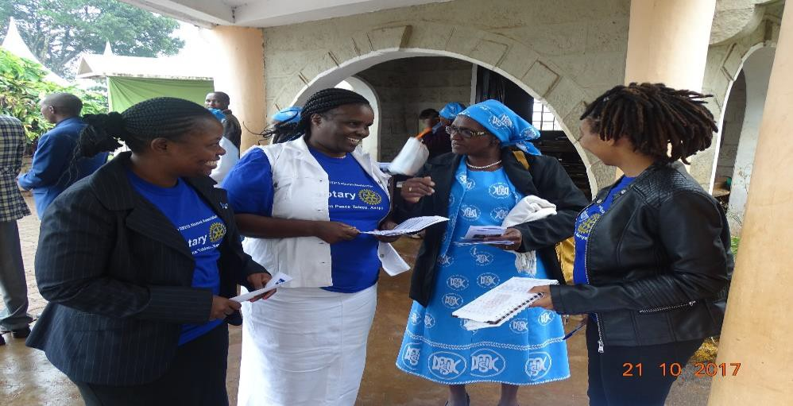
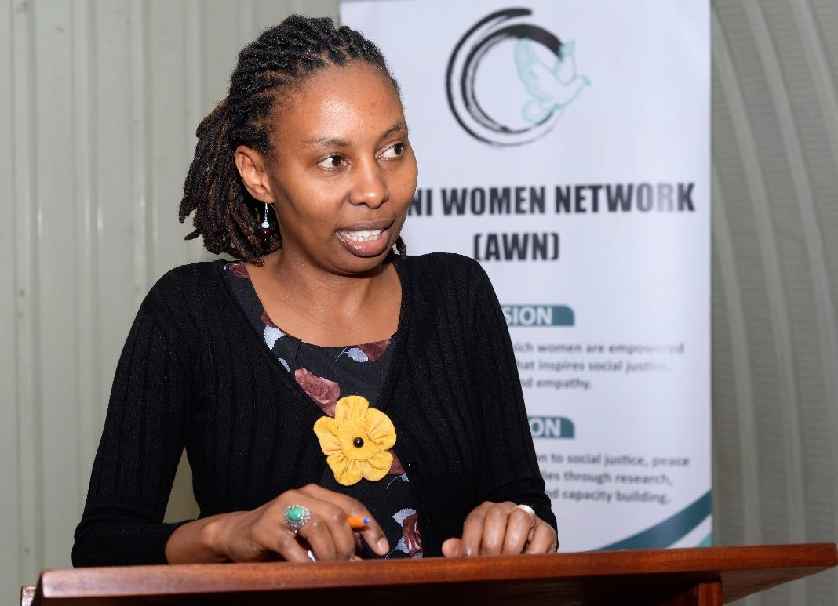
From left Dr. Sellah King’oro (Chula RPF), Dorothy Mutemi (Chula RPF), a participant and myself on the right
participating in an RPF led initiative in Kenya
With the believe that, when women sit at the table, their contributions impact across all genders and
generations, I felt a need to share the knowledge I had gained from Bradford with the Kenyan young women and therefore in late 2017 I co-founded Amani Women Network (AWN). AWN is a registered organization in Kenya that works to consolidate the voices of women peace builders and enhance their impact in sustainable peace while mentoring budding peace builders. Under AWN, I initiated a program where the renowned pioneer women peace builders in Kenya are mentoring the young upcoming ones through a one-year program commonly referred to as Young Women Leaders Program (YWLP). The first cohort of 20 young girls is in process currently.
Regina Mutiru during the launch of Amani Women Network (AWN) in Nairobi, Kenya
YWLP, is an innovative outreach program, providing leadership and practical training to diverse young
women on peace building and conflict resolution issues. The goal of the YWLP is to guide and mentor young women for them to take up roles of leadership and success in the peace building industry. The young women
30

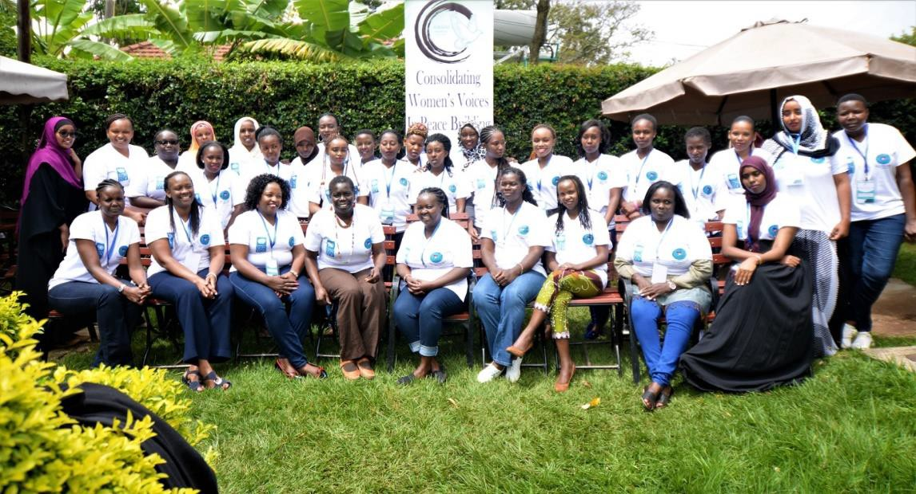
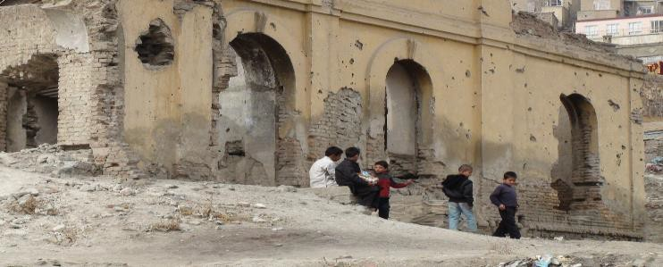
are trained in transformational leadership, Women, Peace and Security Agenda, conflict transformation,
basic proposal writing skills and peace building among other topics, for them to be well equipped in their discipline of interest.
The first cohort of the YWLP participants and some of the mentors during the training in April 2018 in Nairobi,
Kenya.
Sonja Basic
Since my RPF in 2009-2010, I have worked in partnership development for NGOs in Australia such as: RedR
Australia (humanitarian assistance); helping organise the 2014 AIDS conference in Melbourne for the International AIDS Society; and UNICEF Australia, creating corporate partnerships to support their SE Asia programs. I also have married and had two kids: a daughter in 2015 and most recently a son in December last year. Now based in Brisbane, I am currently mid-way through a PhD with the Centre for Social Impact at Swinburne University, looking at women leading social enterprise, and tutoring in the subject (when not on maternity leave). On a side note: I have trained as a yoga teacher and offer classes throughout Brisbane: creating inner peace as well as outer peace is my full circle journey
Francis Kabosha
I was at Bradford during the 2008 - 09 academic year. After
graduating I joined the United Nations Mission in Sudan (UNMIS) as Returns, Reintegration and Recovery Officer. then moved to United Nations Mission in South Sudan (UNMISS) as Civil Affairs Officer before moving to United Nations Mission in DRC as Disarmament, Demobilization and Reintegration Officer till present.
31

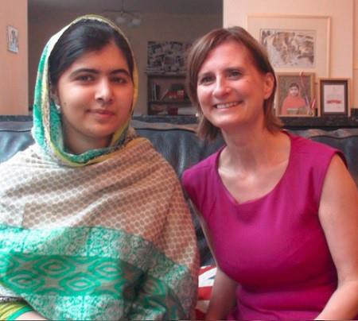
Amanda May – University of Bradford (2006-2008)
I am currently a Ph.D. candidate in the Faculty of Education at the University of Ottawa, Canada. My work
specializes in trauma-informed education within school settings. I am interested in social justice issues, reconciliation, and resilience, as well as working with disadvantaged youth and marginalized groups. In particular, helping students achieve academic success in the face of adversity has been a lifelong passion. Prior to my enrollment as a doctoral student, I had the opportunity to build my knowledge and understanding of reconstruction efforts in Afghanistan.
After overcoming hesitation and fear, I boarded a plane to Kabul, Afghanistan, with Global Exchange as part
of a women’s delegation to celebrate International Women’s Day on March 8th. This international delegation included women from Canada, the USA and Britain who were interested in social justice and women’s rights. Upon arrival in Kabul, we travelled to the guest house on dusty and mostly unpaved roads busy with vendors selling fruits and vegetables, butcher shops with slabs of meat hanging from hooks, shoe shiners crouched down shining shoes, women in burqas carrying their children, and men in military uniforms. Looking out the van window, I also saw young children holding hands walking quickly in front of a building destroyed by war. Ironically, the 2nd floor above a shop selling building construction materials showed scars left by bullets in its crumbling façade. The natural beauty of the snow-capped mountains contrasted with the devastation of abandoned buildings bombed during the conflict.
Our delegation learned about the challenges that Afghan women face and met with organizations working in
areas such as education, de-mining, arts and culture. The itinerary included meetings with the Revolutionary Association of Women of Afghanistan (RAWA), the Halo Trust, the Aschaina Street Children Training Centre, National Archives, Women for Women International, the International Committee of the Red Cross, the Orthopedic Centre, Afghan Women’s Network, schools, the Minister of Women’s Affairs, an orphanage run by RAWA, and the Omar Mine Museum.
My desire to understand the impact of trauma within conflict zones led me to develop an art project at an
elementary school in Afghanistan. Inspired by the Afghan people, I returned a second time to Kabul three years later to facilitate an art project hosted by the Afghans4Tomorrow School and the Aschaina Street Children Training Centre. I worked with a group of female students in grade five and a group of boys who were street children. Using bright acrylic paint and brushes, the paintings they created depicted images of flowers, peace doves, tea pots, homes, medical clinics as well as scenic landscapes of mountains and rivers.
32

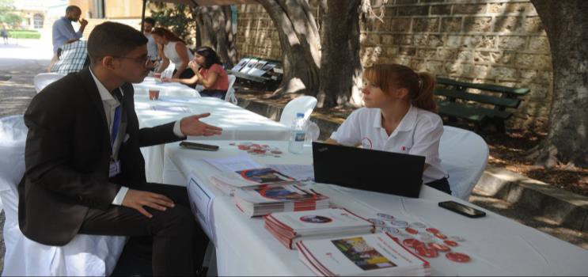
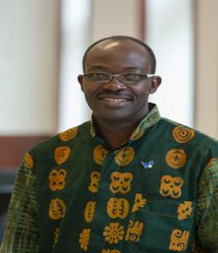
Some paintings also expressed pain, violence and suffering. I have also travelled to Birmingham (UK) to meet
with well-known Pakistani activist and Nobel prize winner Malala Yousafzai and her family at their home to learn about her advocacy work in the area of education for girls.
My recent Master of Arts in Education thesis (2018) explored the intersection between childhood trauma
and learning. I have presented my current research at conferences including the 2019 Congress of the Humanities and Social Sciences held in Vancouver and the Creating Trauma Sensitive Schools Conference held in Washington, DC.
Opata Peter Paul
I Completed Rotary Peace Fellowship with an MA in African Peace and Conflict Studies
– University of Bradford (UK) 2011 - 2012 – Class IX. Peter is married. He has 3 boys and 3 girls, in addition to 2 other boys he supports through school. Prior to the fellowship, he worked for CRS as the Partnership, Justice and Advocacy officer. The Rotary Peace Fellowship granted Peter the opportunity to interact with world leaders from different backgrounds and perspectives that greatly enhanced his appreciation for peaceful coexistence, a basic requirement for human progress. Work experiences: Peter works as a Project Manager with Danish Refugee Council, on a 4-year project funded through the European
Union Emergency Trust Fund. He is based in Yumbe field office which is less than 100 Kilo meters from the
South Sudan boarder, and oversees project implementation in the districts of Adjumani, Arua, Kiryandongo and Yumbe. The project is implemented through a consortium led by DRC comprised of Save the Children, ZOA and CEFORD, with close collaboration from ENABEL - Belgian Technical Agency and the Austrian Development Agency (ADA), both EUTF fund recipients in Uganda. The project is designed to deliver 4 broad objectives focused on Refugees and host communities Livelihoods, Conflict Management, Education and Research. Peter would like to contribute his skills and knowledge to the operations that improve the lives of those most in need.
Amelia Charles
I wanted to share with you a brief note on my work since leaving the RPF at Bradford. I concluded my thesis
while working for IOM in Tajikistan on livelihoods in displacement, and went on to consultancies with both UNICEF and the World Bank.
I then moved to Tunisia, where I was a Protection Manager for two different agencies working remotely on
the Libya response. In 2017, I relocated to Lebanon, and currently work as the Social Protection and Livelihood Advisor for Save the Children.
33

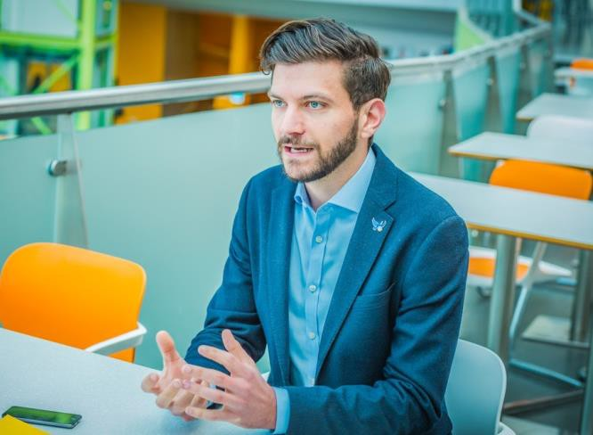
Will McInerney
Will McInerney is a Gates Scholar, Rotary Global Scholar, and PhD student at the University of Cambridge
researching creative, narrative, and arts-­­based approaches to engaging men with peace education. Before coming to the UK, Will worked as an arts, peace, and men’s violence prevention educator in the US, a journalist covering conflicts in the Middle East and North Africa, and as a poet performing works related to peace, conflict, and the power of storytelling around the world.
Will is a proud PSID alumnus and a former Rotary Peace Fellow at the Bradford Rotary Peace Centre. Here
is his narrative on his journey to and from Bradford Rotary Peace Centre:
‘I grew up in North Carolina, and there’s a Rotary Peace Centre in North Carolina at Duke University in UNC
Chapel Hill, so I was familiar with Rotary Peace Fellowships.
One of my first mentors in the peace studies and conflict resolution field was a man named Arthur Romano,
and he was a Rotary Peace Fellow at the University of Bradford some 10 years before I was. He played a really critical role as a mentor in my life, both personally and professionally, and he always spoke really highly of Bradford; that it was an amazing community, it was a great academic experience, and it was a moment in his life that really helped transform his career path - so Bradford was definitely on my radar.
When I was thinking about going back to school the Rotary Peace Fellowship was one of the top opportunities
I was seeking, and when I looked at the Rotary Peace Centres around the world Bradford seemed like the best fit. Coming back to school and doing a masters as a Peace Fellow at the University of Bradford was an incredible opportunity for me to pause, to think, to reflect and ultimately to learn and grow,
I had a phenomenal experience as a student here at the University of Bradford. I think Bradford does a really
great job of balancing theory and practice, and giving the students the opportunity to pause, reflect and refine ideas – and then immediately start practicing those ideas. As a Peace Fellow I had the opportunity to travel, to go to Australia to work with their UN Women National Committee, to go to Cambridge and do research in the middle of programme, and then come back and apply that knowledge to my dissertation. It was a crucible for me at a really pivotal moment in my life.
34

Stepping out and coming into such the incredible, diverse and rich academic environment at the University
of Bradford, where I was learning from students and professors from all around the world, showed me that yes I need to keep working in the classroom, but I also need to have a multi-layered approach if I actually want to create systemic and lasting change. For me that looks like teaching, research and policy implications
When I think about my time at Bradford I recall all the conversations I had, whether they be with professors
or with students around a table at a pub down the street, and recall thinking this is incredibly rare and incredibly valuable. To be able to constantly engage with people from multiple continents, all of whom have a fairly refined common purpose of wanting to make the world a better place, wanting to make the world more peaceful and resolve conflicts. To know I can walk into the Pemberton Building on any given day and know that I will find colleagues there, that I will find allies, I will find friends, I will find people I’d like to work with again one day – those relationships, those connections are what stand out.
It was the precursor for the research that I’m going to be doing at Cambridge University, which was examining
the potential role of spoken word poetry education as an asset to men’s violence prevention education.
My dissertation mapped the challenges and limitations of men’s violence prevention education, and the
opportunities of spoken word poetry education – and then saw there was alignment between those opportunities and challenges……I’m interested in being a scholar and a practitioner and I would love to continue to research at the edges of our knowledge around education and peace, poetry, and men’s violence prevention – and I would love to teach in those areas. But I’m also really invested in education policy reform, and so I’d like to figure out a way to balance that role of a scholar-practitioner with that of someone who is invested in fundamentally changing some aspects of the way we engage education in our public systems.
I’m particularly interested in trying to bring forth the conversation that gender equality education and men’s
violence prevention education should be core subjects, core focuses, that we engage learners in – the same way that we value math and history and science I think we must also value peace and conflict transformation and gender equality, because I believe the majority of us want to live in a society where all of those things are practiced and valued.
If we value them then we must teach them, so we need to figure out creative and effective ways to infuse
these subjects into core education; I can do that as an educator myself, but I also understand from a structural standpoint that if I want to have large scale impact I need to understand how these policies are crafted, and hopefully be one of the people at the table that is offering alternatives and new ideas.
35

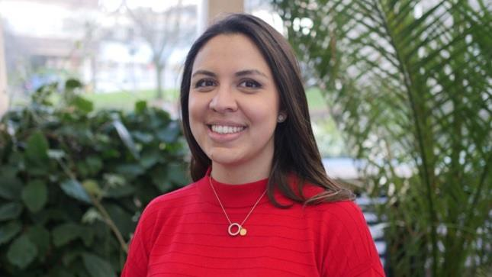
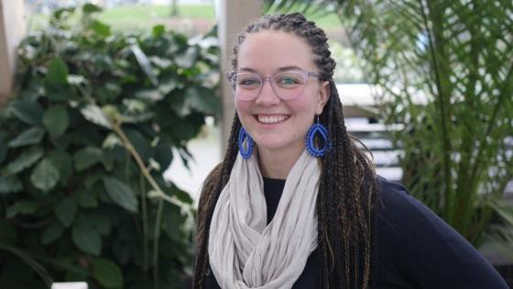
Rotary Peace Fellows 2018-19 - Class XVII
Ana Lucía Peláez
Academic Background: BA in Political Science and BA in International Relations with a minor degree in
Foreign Trade from Francisco Marroquín University (Guatemala).
Areas of interest: Social conflict, communications, crisis management, conflict narrative, intercultural
dialogue.
Since university, Ana Lucía has been working in subjects related with social conflict in Guatemala, especially those between private companies and indigenous communities in the rural area of the country. Initially, her focus was on mapping, monitoring and identifying the most common causes of those conflicts. However, she wanted to do something more with the issue and changed her focus from observing to acting. Since then, she has been working in the area of communications, community relations and sustainability for hydroelectric plants in the private sector. Additionally, she has experience working with the sugar industry, energy distribution and transport sector, agrochemicals, and medical and industrial gases in the aforementioned subjects.
Besides her work, Ana Lucía has collaborated in the establishment of the first social co-working space in her
country and the promotion of a Manual of Legislative Transparency for the Guatemalan Congress.
Through the Rotary Peace Fellowship, Ana Lucía hopes to deepen her knowledge about the origin, prevention
and resolution of conflicts, in order to combine the current needs of Guatemala with traditional indigenous concepts of the world. She wishes to bring this knowledge back to her country and become a university teacher. She plans to continue working with development projects to help rural areas achieve better living standards, without sacrificing the social issues and rule of law in the process.
Camillia Freeland-Taylor
Camillia was Contracting Officer for the United States Department of Agriculture from 2015-­2018.
36

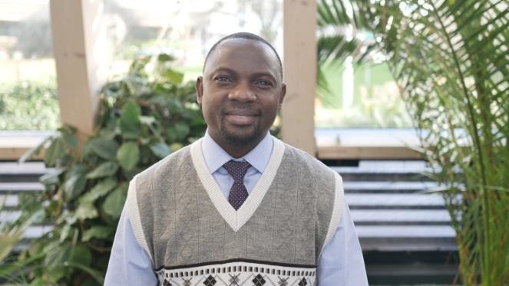
Prior to her experience at the USDA Camillia served two years in the United States Peace Corps where she
taught animal husbandry, Agroforestry, and beekeeping to rural farmers in Zambia. She has helped to build a school in the same village and has returned each year since her Peace Corps Service to help expand the school.
Camillia grew up on a small farm in Minnesota and earned a B.A. in Business and Chinese from Concordia
College in Moorhead, MN.
Chance Kalolokesya
Academic Background: BA in Biblical Studies and Education; Postgraduate Diploma in Management Studies.
Chance is a social development practitioner specialized in project management, human rights, gender and
youth empowerment, advocacy and lobbying, and conflict resolution through Alternative Dispute Resolution mechanisms and investigations.
Having work experience of over ten years he taught English and History at a public secondary school for two
years. He then worked in the NGO sector for several years in the areas of HIV and AIDS management, advocacy and lobbying, community mobilization, gender and civic education.
Besides designing and implementing interventions, some of his roles included staff supervision and finance
management. He championed and coordinated the zero-school dropout intervention in primary schools, as well as reduced school related gender-based violence. Chance also participated in the disaster relief response in 2015 when many people were affected by floods in Malawi.
He managed one of the flood camps which accommodated over 6000 victims. Currently he is working with
the Human Rights Commission (which is a national human rights institution in Malawi) as a Civil and Political Rights Officer.
His work at the Commission involves investigations of human rights violations and resolving conflicts through
Alternative Disputes Resolution. Chance has a passion to serve in peace building initiatives at local and international level.
37

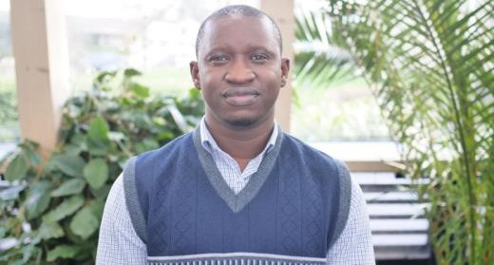
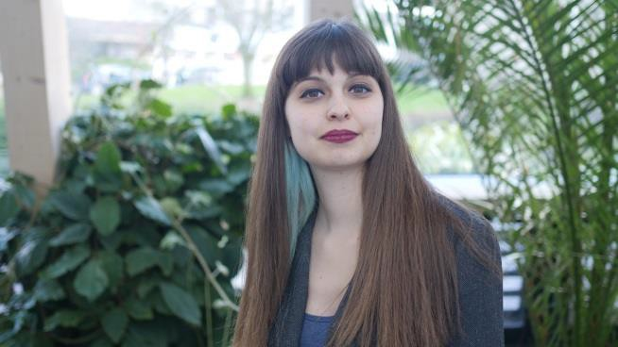
David Kujabi
Academic Background: BA English Language & Sociology. Higher Teacher’s Certificate – Certificate, Cadet
Officers Course.
Head of UNAMID Police Public Information Office (PIO) Gambia, Editor-in-Chief POLISO Magazine, David has
academic and work experience in various fields.
He has gathered extensive peace keeping experience in Darfur – UNAMID as a Police Advisor working as a
Public Information Officer. David is a Police officer with a wealth of experience in Public Relations and Community Policing and has a strong desire to learn and explore new ideas and concepts and put them into practice.
Elif Avci
Elif has been a dedicated member of Lambdaistanbul Association since 2009 where she delivered consultancy
to LGBTIs and their relatives. She also organized events, supervised joint activities with academic/student groups, and gave informal lectures at universities upon request.
She worked as a psychologist at The Foundation for Educating Children (TOCEV), where she supported
children's social and cultural development by holding special workshop activities. She also delivered psychological counselling for all students and their families. Since its establishment, she worked in the Social Equality Unit of the Şişli Municipality to develop and monitor equitable, participatory and inclusive municipal policies.
She also gave counselling to the Mayor about LGBTI+ issues and was assigned as General Secretary of Şişli
Citizen Council in November 2016. While in her role she increased the cooperation between the municipality and right­based civil society organizations, and built a new children’s council, a women’s council, and the first refugee council in Turkey inside the Şişli Citizen Council.
She established the Local Monitoring Research and Implementation Association (YERELIZ), having realised
the lack of dialogue and cooperation between civil society and public institutions. The aim of the YERELIZ is to transform the association into a well-known institution providing building opportunities and knowledge hubs, as well as focusing on developing research studies in relevant subjects.
38


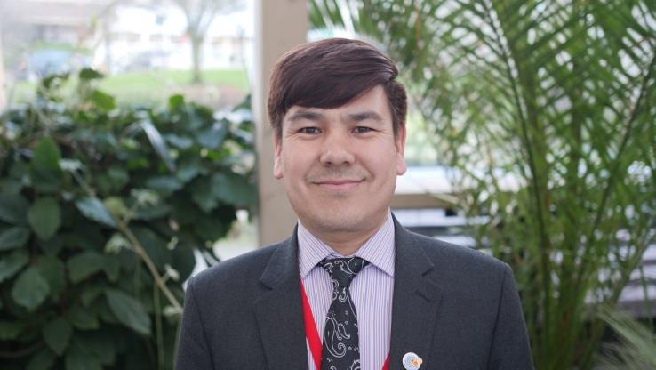
Ghenwa AL-Shoumari
Over the past seven years Ghenwa has worked with several civil society groups giving relief to Internally
Displaced People in her city during the Syrian Revolution. She worked with her colleagues to found the “Syrian Peace Building Network”, which is a civil movement aimed to spread the culture of peace.
She has also served as a project manager for the British organization RTC, “Responding To Conflict “, in
Lebanon, taking the knowledge back to her home country. After leaving Syria to the UAE, she was chosen to be the youngest member in a Feminist Euro-Mediterranean initiative, dealing with the issues of empowerment of women. Ghenwa created a number of activities aimed at raising awareness among women about their role in building sustainable peace among Syrian migrants’ women in Lebanon.
Ghenwa participated on behalf of the lobby in the Equality and Raising Gender Concept in Constitutions
Conference that was held in Beirut in 2016, under the auspices of the Feminist Euro-Mediterranean initiative. Now with the lobby, she is part of The Syrian Women Initiative for Peace, which was formed to activate the role of women in negotiations that are happening between the Regime and the Syrian opposition to solve the Syrian conflicts.
Hassan Fahimi
Academic Background: BA in Law.
Areas of interest: Gender issues, Women’s and Human Rights, Peacebuilding, Women, Peace and Security
agenda, Management and Coordination of Development Programmes, Research and M&E.
Language Proficiency: Farsi/Dari (mother tongue), English, Pashto, Urdu and basic of Arabic.
39

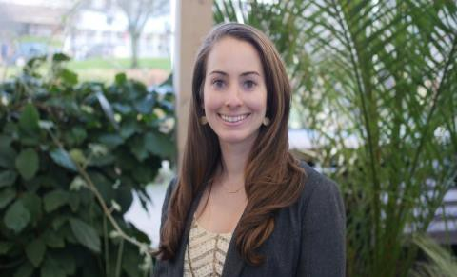
Ali Hassan Fahimi was born in Afghanistan but spent around two decades of his life in Pakistan as a refugee.
He returned to Afghanistan in early 2000 and started working with different national and international organizations for the reconstruction and development of his country. He has worked in the fields of gender, human rights and peace-building for the last 12 years.
From 2006-2009 he worked as a Research Assistant and Research Officer with the Afghanistan Research and
Evaluation Unit in the gender and livelihood departments. His topics of research included family dynamics and family violence, gender mainstreaming in government institutions and women’s participation in community development initiatives.
In 2009, he joined UN Women Afghanistan Country Office in the Women, Peace and Governance Unit as
Research Programme Officer. He served as Unit Manager until 2013, then moved to the Political and Economic Empowerment Pillar of UN Women as Deputy Programme Manager but served most of his time as Acting Programme Manager for the mentioned pillar and Women, Peace and Security Pillar since January 2018.
His portfolio for UN Women included women’s leadership & participation, governance, political and
economic empowerment and women, peace and security. He left his role at UN Women when he joined the University of Bradford in Sept 2018.
Julia Coffin
Academic Background: Bachelor of Arts in Anthropology/Sociology and Religion.
Area of Interest: Peace, Conflict and Development.
Julia was born and raised in Concord, NH, USA. Following graduation from St. Olaf College, Julia spent a year
as a Fulbright Scholar living and working in Gorkha, Nepal. Julia taught English and co-taught an afterschool program focused on English language acquisition, cross-cultural exchange and leadership development. She collaborated with local organizations to better resource local English teachers and to debunk myths on migrant labour. She has since returned to Nepal numerous times to plan and lead teen service trips, and to conduct follow up research on student drop-out rates and teacher accountability. Most recently, Julia served as the Program Specialist for Detention and Visitation at Lutheran Immigration and Refugee Service in Baltimore, Maryland, USA. She organized advocacy campaigns, developed educational tools and facilitated workshops to help communities explore the impacts of the U.S. immigration detention system and respond with compassionate action. She provided training and technical support to community leaders, equipping them to launch and grow immigration detention visitation ministries and related supportive services. After completing a Master's in Peace, Conflict and Development Studies at the University of Bradford, Julia hopes to support the creation and implementation of development projects in Nepal, and other countries deeply impacted by migration.
40

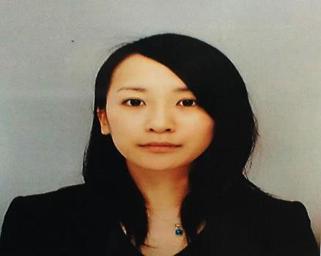
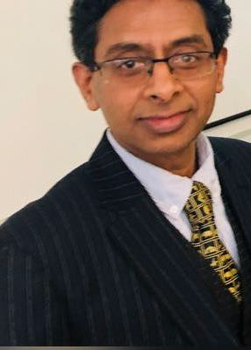
Kiyomi Miyagoe
Academic background: Middle Eastern studies with a concentration on Persian language at Osaka
University of Foreign Studies in Japan.
During her university years, Kiyomi was given an opportunity to teach Persian language to Afghan refugee
children residing in Japan. This experience helped her deepen her understanding of the challenges facing refugees. Subsequently, Kiyomi decided to dedicate her life to peace building and conflict resolution. Since 2010 she has worked with vulnerable people, such as refugees and survivors of violence, at NGOs for over seven years, travelling to Jordan, Iran, Tajikistan and Turkey. After completing her studies Kiyomi plans to advance her career in human resource development for peacebuilding.
Academic & Support Staff
Dr PB Anand Interim Head of the Division of Peace Studies and International Development
Current research is focused on three main strands. The first one is on Inclusive,
Smart and Sustainable Cities as part of a three-year British Academy grant project in collaboration with Prof Sudhir Rajan of the Indian Institute of Technology, Madras (IITM) Chennai, India. The second strand of his research is focused on completing a large edited volume on the BRICS and Emerging Economies, a four- year project involving 40 chapters written by 49 experts from all continents. The
third strand focuses on human development challenges in natural resource-rich societies. Dr Anand is a specialist in environmental economics and public policy for promoting equality, human development and sustainability. He has over 25 years of professional experience including 8 years in public and private sector positions. Since April 2007 he has been a Reader. Countries of his expertise include India, China, Mongolia, Tajikistan, Nigeria, Ethiopia, and the Caribbean.
Academic Staff
Dr Karen Abi-Ezzi’s research interests lie in the areas of social constructionism and discourse analysis and their application to conflict resolution processes. Her research also focuses on the Middle East, specifically on the Israeli-Palestinian conflict and also on Lebanon.
Dr Gábor Bátonyi’s research encompasses various aspects of twentieth century Central and Eastern
European history, such as the legacies of authoritarian and totalitarian regimes; the memory of Soviet
41

occupation and anti-communist resistance; and the pursuit of foreign policy objectives by small states under
conditions of limited sovereignty.
Professor Christoph Bluth is a specialist in nuclear weapons policy and his research is concerned with the
prevention of nuclear proliferation, the role of nuclear weapons in crisis regions and trajectories towards nuclear disarmament. Professor Bluth’s work on crisis regions also includes work on South Asia and the role of nuclear weapons in strategic relations between India and Pakistan as another case study of a conflict region where there is a serious risk of escalation to a nuclear conflict.
Dr Graeme Chesters is a political sociologist by training and his work includes researching, teaching and
writing about social movements and collective action and their role in transformative change processes, as well as in shaping ideas of the good society. Central to all his work is a focus on the relationship between agency, participation and change in a complex global society.
Owen Greene is Professor of International Security and Development, and Director of Research and
Knowledge Transfer at PSID. He is an internationally recognised researcher and policy expert, working mainly on the following areas: international and regional security; conflict, security and development inter- relationships and conflict sensitive development; conflict analysis and prevention and community security; post-conflict peace and security building (including DDR); development and effectiveness of international agreements (on arms, security; environment and development); security and justice sector reform, arms management, and armed violence reduction; and preventing and combating arms proliferation and illicit trafficking.
Dr David Harris continues to research and write on two broad strands of the study of African politics. The
first concerns elections in Africa, and 2016-17 was a very busy period. A pre-election briefing, ‘Liberia’s run- up to 2017: continuity and change in a long history of electoral politics’, co-authored with R. N. Pailey, came out in early 2017 in Review of African Political Economy 44:152, and a post-election article is planned for 2018.
Dr Hossein Jalilian is Reader in Economic Development and is a development economist (with research
interests and publications in various aspects of economic growth and development, with emphasis on quantitative data analysis. More recent research relates to the role that manufacturing and financial development have on growth in developing countries,
Professor Farhad Analoui’s research interests are in strategic management and human resource
management, leading work on managerial effectiveness and capacity building and development.
Dr Rashmi Arora’s main research interests are finance and development, inequality, economic growth and
development and her areas of study are South Asia, Asia and developing economies in general.
Dr Rhys Kelly’s recent research has been driven by a desire to understand the nature and implications of an
emerging ecological crisis – including, but not limited to climate change – with a critical interest in the intersections between environmental issues and peace research. Working closely with Dr Ute Kelly, he has been engaging with emerging scholarship and practice around the concept of ‘resilience’. More recently, he has been developing research into the nature and management of conflict within climate adaptation processes, recognising that communities/societies face difficult choices and trade-offs in the process of responding or adapting to climate change.
42

Dr Ute Kelly Over the last few years, Ute’s research interests have been centred on the complex challenges
facing social-ecological systems now and into the future, and on a range of different ways of framing, exploring and responding to these challenges. This has included a survey of different discourses and practices of ‘resilience’ on the ground, which led to the publication (with Rhys Kelly) of ‘Resilience, solidarity, agency
– grounded reflections on challenges and synergies’ in the journal Resilience: International Policies, Practices and Discourses 5 (1) in 2017.
Dr Fiona Macaulay’s main areas of research continue to be Latin America, specifically Brazil, criminal justice
reform, especially prisons, and gender relations, giving presentations on her work at a number of academic centres – Cornell and Cambridge universities, Johns Hopkins (SAIS Bologna), Central European University in Budapest, University of São Paulo, and King’s College London.
Professor Behrooz Morvaridi’s research is focused on developing a critical understanding of the political
transformations in modes of aid and development, conceived as intentional practice in countries of the Global South, from a perspective of social justice. He has examined this in the context of rural transformation in the Middle East and Africa, and in the context of Refugees or forced migration. He is currently writing a book on Peace and Development Jointly with Professor Caroline Hughes, Chair of CSC, Kroc Institute of International Peace Studies, University of Notre Dame.
Professor Donna Pankhurst’s research has focused for the past couple of years on Soldiers After Wars. The
first stage of this project has looked at Ex-Army Servicemen in the UK, ‘best practice’ in the care of veterans, and its limitations. She continues to research and teach on wider gender issues in peacebuilding and conflict, as well as in countries of the Global South not affected by recent war. She is currently working on a gender- focused chapter in a series of volumes about the Cultural History of Peace, edited by Ronald Edsforth in the USA.
Professor Munro Price has continued working on his main research area, the history of international relations
since the French Revolution. Over the last year, Professor Price has also undertaken several wider impact- related activities connected to his last book, Napoleon: the End of Glory (Oxford University Press, 2014). As in previous years, Professor Price is a member of the judging panel for two national book prizes, the Franco- British Society Literary Prize and the Elizabeth Longford Prize for Historical Biography. In July 2017 he was elected a Trustee of the Society for the Study of French History, the main learned society for British historians of France.
Dr Afshin Shahi Over the last two years, Afshin Shahi continued working on a number of research projects.
One of his substantial journal articles, with H. Forozan, ‘The Military and the State in Post-Revolutionary Iran: The Economic Rise of the Revolutionary Guards’, was published in 2017 in The Middle East Journal which is considered as a high impact outlet in his area. Since 2016 he has conducted over 200 press, radio and TV interviews. He has been a regular commentator for various BBC programmes and has contributed to Al Jazeera, France 24, Sky News, ITV News, Bloomberg Business and Forbes Magazine.
Dr Simon Whitby has continued his academic and policy work at the interface between the life-science,
international security, ethics and law discourses, and has expanded his research and teaching profile with work he (with others) have pioneered on transformative research and teaching on dual-use bioethics and biological security. In an article written with former PhD student Giulio Mancini ‘The Securitization of Life Science: Alongside his acceptance to the Higher Education Academy as Senior Fellow, Simon has further developed pioneering work on dual-use biological security awareness-raising, education and (CPD) training through team-based learning. This builds on the experience of delivering team- based biological security
43


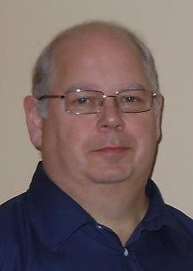
training (July 2017) for the EU’s Human Brain Project for neuroscience experts at the Karolinksa Institute,
Stockholm, Sweden.
Support Staff
Sanna Tukiainen, Student Liaison Officer
Sanna is our current Student Liaison Assistant (SLA), following her predecessor Aleksandra Czech. Together
they gave superb administrative support to the Adam Curle Symposium. PSID is very fortunate to have this post funded by the Quaker Peace Studies Trust, as it enables us to provide unique support to all our students, enriching their learning experience and helping them through their university studies, signposting help where needed, and organising social and extra-curricular academic activities to enhance their classroom studies. In collaboration with the academic staff, she is also responsible for organising many of the activities that you have read about in this Report: our annual study visits to The Hague and to Northern Ireland, the Crisis Game, and several smaller events including the Peace and Development Breakfasts, various guest lectures and workshops, and the annual Peace and Development Ball. Sanna, like all our SLAs, is a graduate of PSID, and completed her MA in International Politics and Security Studies with a focus on Baltic Sea regional security in 2017. She previously studied and worked mainly in Finland and Austria and she is just about to embark on a doctorate.
Oliver Denton, Careers and Alumni Officer
Oliver Denton holds our newly re-established post of Careers and Alumni Officer, made possible by the
generous support of the Quaker Peace Studies Trust. The department is proud to have thousands of alumni, working around the world in government, in NGOs, in international organisations, running their own social enterprises, innovating, advocating for social justice and generally trying to make the world a better place! Our alumni are an amazing resource for each other, for our students, and for the department. So, we have begun to invite alumni back to the department to talk about their work in our new ‘Practitioner Engagement Programme’. Oliver is also a PhD student in PSID, working on a thesis entitled The role of The Times newspaper and its editor, Geoffrey Dawson in the policy of appeasement from March 1935 to December 1940. Oliver also holds an MA in International Politics and Security Studies from PSID, as well as this Oliver has a number of research interests including: European security and politics; US politics; Media and journalism; Veterans and PTSD; Social Justice. Prior to PSID Oliver worked and volunteered in a range of industries including party politics, higher education and executive search.
Area Host Rotarian
Rotarian PDG Keith J Davison, Rotary Club of Birstall Luddites
Since joining Rotary I have been an active member at Club and subsequently District,
RIBI and RI level, firmly believing that you only get out of anything as much as you put in. I have been a member of Rotary in the Rotary Club of Birstall Luddites since January 2000. I was President of the Club in 2002-03. I served for 3 years from 2004 – 2007 as the District Training Officer arranging and running all the District training events. In
44

2013 following my Year as District Governor I took this role on again to date. I have been a member of the
District Conference Committee for the past 13 years responsible for the IT and Stage Management. In 2010- 2011 I was the Conference Chairman. For 3 years from 2007 – 2010 I was the Assistant Governor for the Inner 9 Group of Clubs within the District. I served as District Governor for District 1040 in the Rotary year 2012- 2013. On an International front, I have been a member of the District Healthcare and Literacy Ukraine Convoy team since it started in 2001, having been on all the Convoys since 2001, 12 in total as well as making 2 private visits to monitor the on-going progress of Projects. In 2004 I was appointed as the Chairman of the Project Team and as such, I report back to the District International Committee as the Chair of one of its Sub- Committees.
From 2013-2016 I was a member of the RIBI Leadership Development and Training Committee. In 2016 I was
appointed as the Training Facilitator for the District Governor Group 2018-2019. I took this team through their training programme until they took office on the 1st July 2018. In 2013 I was appointed as one of the Assistant Rotary Co-ordinators for Zone 17. I held this office for 3 years through to the end of the 2016 Rotary Year.
Currently I am in my first year as Rotary Host Co-ordinator for the Rotary Peace Centre in Bradford. I am very
proud to be undertaking this new role and have been a supporter of the Peace Centre for many years through helping with the Technical side of the annual Seminar in October each year.
Rotary International Staff
Jill Gunter, Rotary Peace Centers Program Manager
Sarah Cunningham, Rotary Peace Centers Senior Marketing Programs Specialist
Lauren Pugliese, Rotary Peace Centers Program Supervisor
Marina Williams, Rotary Peace Centers Coordinator
Jacqueline Azpeitia, Rotary Peace Centers Specialist | Chulalongkorn , Queensland, Bradford
Find more information please see the following website rotary.org/myrotary/en/get-involved/exchange- ideas/peace-fellowships
Board
This is governing board for the Bradford Rotary Peace Centre. The advisory board for Bradford Rotary Peace Centre includes the following members:
Professor Roger Mac-Ginty, University of Durham
Keith Davison, Area Host Rotarian
Dick Hazehurst, Rotarian
Christy Bischoff, Refugee Action Children and Families Project Manager
Professor Zahir Irani, the Dean, Faculty of Management, Social Sciences and Law
Dr. P.B. Anand (Acting Head of Division, Peace Studies and International Development) Professor Paul Roger, Peace Studies and International Development
Professor Tom Woodhouse, Peace Studies and International Development Professor Owen Greene, Peace Studies and International Development Will Mcinerney, Alumni (Currently PhD student at Cambridge University) Elected Peace Fellow from each cohort
Professor Behrooz Morvaridi, Director Bradford Rotary Peace Centre
45

Degree Programme
Peace Fellows can choose from a range of programmes offered within the Division of Peace Studies and
International Development. The postgraduate programmes available in 2019 – 2020 academic years are as follows:
MA Advanced Practice in Peacebuilding and Conflict Resolution
This programme will develop your understanding of the causes and dynamics of social conflict, with a strong
focus on case-study analysis. It will allow you to develop informed judgements about when and how to engage constructively with conflict, recognising the strengths and limitations of different approaches to intervention. And you will consider critical questions surrounding and problematising efforts to build peace in different contexts, and in the light of contemporary trends, including converging environmental, economic and political developments. Through a diverse programme of study, including a significant applied, practical element, you will build a portfolio of work that demonstrates your knowledge and achievement of a set of professional competencies essential to effective, ethically-aware practice within conflict engagement and peace practice - locally, nationally or internationally - relevant to employment in the peace, conflict and development fields.
46
SEMESTER ONE
Applied Conflict Research (core)
Theories and Practices of Conflict Resolution (core)
African Politics and Security Dynamics
OR Studying Peace in a Changing World
OR Elective
SEMESTER TWO
Creative Practice in Conflict Engagement and Peacebuilding (core)
Natural Resource Governance
Movements for Social and Ecological Justice
Peacekeeping and Peacebuilding
Gender, Conflict and Development
Africa Study Visit
Terrorism and Political Violence
Sustainable Cities
Middle East Politics and Security Dynamics
SEMESTER THREE
Dissertation

MA International Relations and Security Studies
The new MA in International Relations and Security Studies explores themes of peace and conflict studies,
including:
▪
▪
war, violence and security-building between and within states and regions
tackling weapons of mass destruction, conventional arms proliferation, political violence and terrorism
development and operation of international and regional institutions
past and present transnational challenges in international and regional diplomacy
contemporary global challenges such as environmental degradation, trafficking/crime and migration
▪
▪
▪
You will develop an advanced academic and policy-relevant understanding of international relations and
security, along with analytical skills that are in high demand within institutional politics, NGOs and lobbying organisations.
You will have the opportunity to take specialist pathways, including a focus on selected regions (Europe,
Africa, Middle East and North Africa, Asia, or Latin America and the Caribbean), with opportunities for study visits, or on thematic specialisms such as international governance, modern diplomacy, security studies, or political violence and terrorism.
47
SEMESTER ONE
The International System in Theory and Context (core)
Contemporary Security Challenges (core)
African Politics and Security Dynamics
OR Elective
SEMESTER TWO
Environment, Trafficking and Crime: Transnational Issues and International Governance (core)
Natural Resource Governance
Africa Study Visit
Middle East Politics and Security Dynamics
Gender, Conflict and Development
Peacekeeping and Peacebuilding
Terrorism and Political Violence
Assessing Development Practices, Needs and Outcomes
SEMESTER THREE
Dissertation

MA Peace, Conflict and Development
This degree will provide you with an advanced understanding of the inter-relationships between conflict,
development, security, and governance in developing, fragile, transitional and/or conflict-affected regions and countries. You will gain the understanding and skills you need to pursue or develop a career in what is now a major area for international, national and local policy and practitioner communities. You will be equipped to work across many sectors including:
▪
▪
▪
▪
▪
international development
conflict prevention and peace building post-conflict recovery
humanitarian aid
natural resource management
You will have the opportunity to take specialist pathways, including a focus on selected regions (Europe,
Africa, Middle East and North Africa, Asia, or Latin America and the Caribbean), with opportunities for selected study visits. The programme will provide enhanced training and engagement with widely used policy and practitioner analytical tools and models, enabling you to develop your skills and employability.
48
SEMESTER ONE
Applied Conflict Research (core)
Security and Development in Fragile and Conflict-Affected Areas (core)
African Politics and Security Dynamics
OR Elective
SEMESTER TWO
Natural Resource Governance (core)
Environment, Trafficking and Crime: Transnational Issues and International Governance
Gender, Conflict and Development
Terrorism and Political Violence
Middle East Politics and Security Dynamics
Assessing Development Practices, Needs and Outcomes
Peacekeeping and Peacebuilding
Sustainable Cities
Africa Study Visit
SEMESTER THREE
Dissertation

MA Peace, Resilience and Social Justice
This new MA is designed for those seeking an advanced understanding of the major contemporary
trends shaping our world, such as environmental crisis, widening inequality and social division, resource scarcity, and violent conflict.
The programme critically examines how society is responding to these challenges, from contentious
collective action and political resistance through to efforts to design and create more resilient, sustainable communities.
You will explore topics such as:
▪
▪
▪
▪
▪
the implications of climate change for peace and social justice
the role of resource limits and land-grabbing in the promotion of conflict the emergence of movements for indigenous rights and food sovereignty the crisis of democratic institutions and the rise of political populism
the increase in contentious collective action – in both the real and virtual realms
49
SEMESTER ONE
Studying Peace in a Changing World (core)
Social-Ecological Resilience: Discourses and Practices (core)
Applied Conflict Research
OR Theories and Practices of Conflict Resolution
OR African Politics and Security Dynamics
OR Elective
SEMESTER TWO
Movements for Social and Ecological Justice (core)
Natural Resource Governance
Sustainable Cities
Environment, Trafficking and Crime: Transnational Issues and International Governance
Creative Practice in Conflict Engagement and Peacebuilding
Gender, Conflict and Development
Assessing Development Practices, Needs and Outcomes
Middle East Politics and Security Dynamics
Peacekeeping and Peacebuilding
Africa Study Visit
SEMESTER THREE
Dissertation

MSc Sustainable Development
Sustainability is an important national and international concept and policy issue. Yet, there are serious
challenges facing any society, country or city aspiring to adopt a sustainable path. This programme critically examines how sustainable development shapes policy and strategy on a range of issues at different levels - global, national, regional and local community. It takes a multi-disciplinary approach to sustainability and looks at the three traditional pillars -- economic, social and environmental -- as well as historical, cultural, political, institutional and gender dimensions to understand the issues and challenges of vulnerability, powerlessness, agency, responsibility and resilience. The programme aims to develop comprehensive and systematic understanding of the various dimensions of sustainable development and the complexities of shaping, influencing and informing policy analysis and achieving impact in the world.
50
SEMESTER ONE
Critical Perspectives on Sustainable Development (core)
Policy Analysis for Governance and Development (core)
African Politics and Security Dynamics
OR Issues in Development Theory
OR Elective
SEMESTER TWO
International Environmental Governance (core)
Sustainable Cities (core)
Gender, Conflict and Development
Natural Resource Governance
Movements for Social and Ecological Justice
Assessing Development Practices, Needs and Outcomes
Finance for Development
Africa Study Visit
Peacekeeping and Peacebuilding
Middle East Politics and Security Dynamics
SEMESTER THREE
Dissertation

MA International Development Management
Human development processes and practices continue to be at the forefront of most governmental and
societal concerns, particularly for developing countries or countries in political transition. There are keen debates about principles, policies and practices of international development co-operation assistance and investment, and their links with humanitarian challenges and wider processes of globalisation. Issues of international development management need to address in the full complexity of political, institutional, economic, social and cultural contexts. This requires a multi-disciplinary approach that brings together research, policy and practitioner communities.
This degree will provide you with the critical and analytical skills to operate effectively in international
development environments. It covers macro and micro level perspectives and draws on cutting edge debates around development theory, policy and management to provide an integrated, cross-disciplinary framework for the postgraduate study of development. The unifying focus is the analysis of strategies for overcoming poverty. You will gain knowledge of different development paradigms and their evolution and be encouraged to develop comparative perspectives (between different regions/countries, disciplinary approaches, schools of thought).
51
SEMESTER ONE
Issues in Development Theory (core)
Policy Analysis for Governance and Development (core)
Security and Development in Fragile and Conflict Affected Areas
OR African Politics and Security Dynamics
OR Elective
SEMESTER TWO
Assessing Development Practices, Needs and Outcomes (core)
Natural Resource Governance
Sustainable Cities
Gender, Conflict & Development
Peacekeeping & Peace-Building
Africa Study Visit
Project Implementation and Management
Middle East Politics and Security Dynamics
Environment, Trafficking and Crime: Transnational Issues and International Governance
SEMESTER THREE
Dissertation

MSc Project Planning and Management
This course builds knowledge and skills in the planning and management of development projects and
programmes. It is designed to deepen critical understanding of the strategies, processes, techniques and issues involved in taking ideas for international development and turning them into practical realities with identifiable outcomes and benefits. The degree provides an excellent basis for career enhancement or conversion. The focus is on international development projects in the public or third (voluntary or community) sectors, but the underlying principles are applicable to all types of project, including those for commercial benefit.
The course covers
▪
The discipline of project and programme management, within an overall appreciation of the nature
and purpose of projects
The principles and practice of project planning, design, preparation, and appraisal techniques for projects in an international development context
The theory and practice of management skills for project and programme management, focusing particularly on 'hard' and 'soft' skills for successful project implementation
▪
▪
52
SEMESTER ONE
Project Planning and Design (core)
Project Appraisal (core)
Issues in Development Theory
OR Economic Growth for Development
OR Elective
SEMESTER TWO
Project Implementation and Management (core)
Assessing Development Practices, Needs and Outcomes
Natural Resource Governance
Sustainable Cities
Finance for Development
Gender, Conflict & Development
Africa Study Visit
Middle East Politics and Security Dynamics
SEMESTER THREE
Dissertation

MSc Economics and Finance for Development
This course will provide you with a systematic and advanced understanding of economic approaches to
development and in particular the role of finance and financial institutions. This is a fascinating time to study such questions and you will engage with current debates in economic and financial development and be able to evaluate the merits of the various mechanisms of financing development. You will develop the skills required for the analysis of development issues using relevant software packages and to understand the bases for financial policy and the interlinkages between statistics and econometrics and develop expertise on international trade and exchange rate policies and related economic matters. You can also develop particular specialist interests through a range of options, including project and programme management, public policy, and development policy
For further details of each programme, including curriculums, please visit
https://www.bradford.ac.uk/social-sciences/psid/
53
SEMESTER ONE
Economic Growth for Development (core)
Applied Econometrics (core)
Project Planning and Design
OR Project Appraisal
OR Elective
SEMESTER TWO
International Economics (core)
Finance for Development (core)
Assessing Development Practices, Needs and Outcomes
Natural Resource Governance
Project Implementation and Management
Sustainable Cities
Gender, Conflict & Development
Africa Study Visit
Middle East Politics and Security Dynamics
SEMESTER THREE
Dissertation

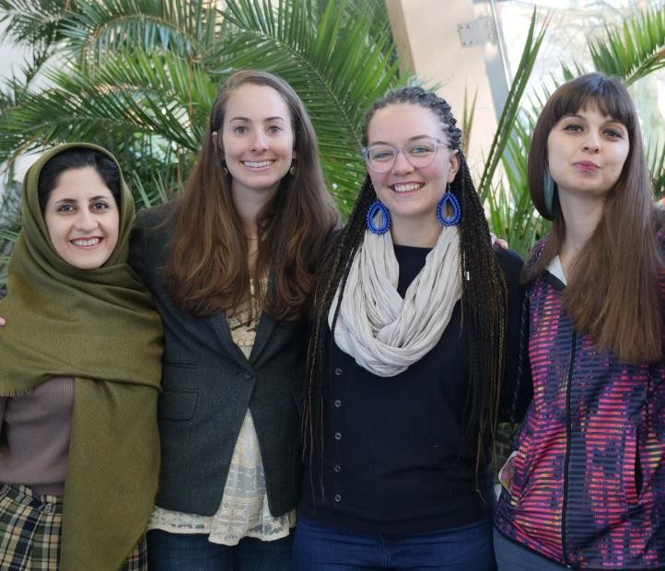
Further Information
Rotary Peace Fellowships at Bradford
The Rotary Peace Centre at the University of Bradford hosts and supports ten fully-funded MA Rotary Peace
Fellows from around the world each year and is based in the Division of Peace Studies and International Development (PSID).
Rotary Peace Fellows are selected through a highly-competitive international process that is led by Rotary
International, the Rotary Foundation, and the Rotary Peace Centres. The Bradford Rotary Peace Centre receives more applications than any other Rotary Peace Centre in the world. Bradford
Peace Fellows must have several years of professional experience, an excellent academic record, and show
an ability to have a significant, positive impact on world peace and conflict resolution in their future careers.
Applicants for the Rotary Peace Fellowship must apply directly with Rotary International. For more
information on the Rotary Peace Fellowship application process visit the Rotary International website.
rotary.org/myrotary/en/get-involved/exchange-ideas/peace-fellowships
The Master Course and Dissertation
For Rotary Fellows, the Postgraduate course is fifteen months in length and comprises four semesters. In Semesters 1 and 2, the Fellows study six core and optional modules, which differ depending on their programme. In Semester 3, the Fellows undertake a period of Applied Field Experience of 8-12 weeks. This takes the form of a placement with an organisation engaged in peace work of some form and must be approved by the Centre Director. In Semester 4, the Fellows complete a 15,000 words dissertation on a topic of their choice under the guidance of a supervisor from within the Division of Peace Studies.
The programme is structured around compulsory core modules, with flexibility built in through optional
modules chosen by students to meet their own objectives and interests. Students must normally complete a total of 120 credits of taught modules. They also must complete a dissertation (60 credits). To be awarded the degree of MA or MSc, students must complete a total of 180 credits. While at Bradford, Rotary Peace Fellows develop a balance of theoretical and practical knowledge and skills by completing a rigorous MA
54

programme, working and volunteering with Rotarians across the UK and engaging in a three month Applied
Field Experience (AFE). AFEs occur during the middle of the fellowship and give Peace Fellows an opportunity to extend their professional skills and knowledge into new areas while collecting data for their Master’s dissertation.
The MA dissertation comprises 60 credits and is the capstone project of the MA programme. Fellows are
invited to submit their chosen topics for consideration in early February and then allocated a supervisor. Supervisory meetings begin in March. Fellows will receive supervisory meetings throughout the dissertation process; these are generally group meetings with other Masters students working on similar topics, and also individual meetings. The timing of these meetings is arranged between the Fellow and the supervisor, and Fellows may elect to take their individual supervisory sessions before or after their AFE as appropriate.
Admission Requirements
Peace Studies and International Development admits about 100 postgraduate students a year. The Master student body is diverse: some 55 nationalities are represented by men and women of all ages and with a wide range of backgrounds and experience. The University welcomes applications from all potential students regardless of their previous academic experience; offers are made following detailed consideration of each individual application. Most important in the decision to offer a place is our assessment of a candidate’s potential to benefit from their studies and of their ability to succeed on this particular programme. Entrance requirements for each programme will vary but consideration of your application will be based on a combination of your formal academic qualifications and other relevant experience.
The University of Bradford has always welcomed applications from disabled students, and these will be
considered on the same academic grounds as are applied to all applicants. If you have some form of disability you may wish to contact the programme leader before you apply.
Learning Resources
The JB Priestley Library on the city campus and our specialist library in the School of Management provide a wide range of printed and electronic resources to support your studies. We offer quiet study space if you want to work on your own, and group study areas for the times when you need to discuss work with fellow students. Subject librarians for each the faculty provide training sessions and individual guidance in finding the information you need for your assignment and will help you organise your referencesproperly.
Student PC clusters can be found in all our libraries and elsewhere on the campus. Many of these are open
24/7. You can also use the University's wireless network to access the internet from your own laptop. Most of our journals are available (both on and off campus), and you can also access your University email account, personal information and course-related materials this way. Staff are on hand during the daytime to help you if you get stuck, and there is a 24/7 IT helpline available.
Student Support
Support for you personally and in your course of study, will be provided both by the University and the Programme Team. You will be allocated a personal tutor who is someone with whom you will be able to talk about any academic or personal concerns. The School will ensure that there is someone available with whom you feel comfortable to help and support you. You will be provided with a comprehensive series of handbooks that you can consult on a range of learning issues and your course tutors will be available to consult on subject specific queries.
55

Students’ Union
We value the feedback provided by students and collaborate with the Students’ Union, through a system of course representatives and formal staff student liaison committees, so that any issues you wish to raise are addressed rapidly. The Students Union provide professional academic representation and advice. The
Students’ Union and the University of Bradford work in partnership to provide confidential counselling and welfare services where you can get help with any aspect of your personal or academic life. Student Financial and Information Services (part of the Hub) will provide you with information about a diverse range of issues such as council tax, personal safety and tourist information. International Students can access a range of additional advice and support services through the Student’s Union.
Careers and Employability
The University is committed to helping students develop and enhance employability and this is an integral part of many programmes. Specialist support is available throughout the course from Career Development Services including help to find part- time work while studying, placements, vacation work and graduate vacancies. Students are encouraged to access this support at an early stage and to use the extensive resources on the web site www.careers.brad.ac.uk.
Discussing options with specialist advisers helps to clarify plans through exploring options and refining skills
of job-hunting. In most of programmes there is direct input by Career Development Advisers into the curriculum or through specially arrangedworkshops.
The specific provision on this programme is intended to meet the employability expectations of Peace
Studies graduates. These are typically focused on careers in conflict management, international organisations, non-governmental organisations, civil service, local government, police, journalism, diplomacy, research and education. Teaching on the program is research informed and delivered by an academic team that is engaged in knowledge transfer activities with employers and practitioners, enabling us to constantly review our employer engagement capability. The MAs provide a mix of both discipline and personal transferable skills. Graduates develop an independent and critical ability to gather, organise and analyse relevant primary and secondary evidence or data, to use communication and information technology for the retrieval of and presentation of information, to demonstrate initiative,and to collaborate with others to achieve common goals. The calibre and diversity of our student body adds value to our programme in terms of the networking opportunities provided.
Academic Skills Advice Service
For students who are looking to improve their marks during their time at university, study skills and maths advice is available to all regardless of degree discipline or level of study. Students can access a programme of interactive workshops and clinics which is delivered throughout the year. This is in addition to our extremely popular face-to-face guidance from our advisers, who also offer a wide range of online and paper based materials for self-study. http://www.bradford.ac.uk/academic-skills
Disability
Disabled students will find a supportive environment at Bradford where we are committed to ensuring that all aspects of student life are accessible to everyone. The Disability Service can help by providing equipment and advice to help you get the most out of your time at Bradford and is a place where you can discuss any concerns you may have about adjustments that you may need, whether these relate to study, personal care or other issues.
56

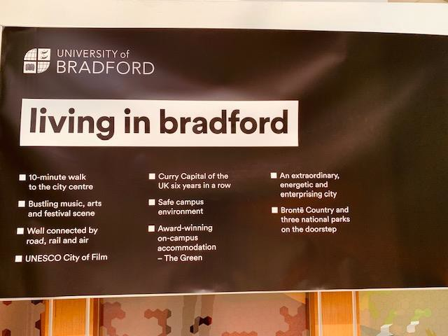
For more information contact the Disability Service by phoning: 01274 233739 or via email:
disabilities@bradford.ac.uk
Ecoversity
Ecoversity is a strategic project of the University which aims to embed the principles of sustainable development into our decision-making, learning and teaching, research activities campus operations and lives of our staff and students. We do not claim to be a beacon for sustainable development, but we aspire to become a leading University in this area. The facilities we create for teaching and learning, including teaching spaces, laboratories, IT labs and social spaces, will increasingly reflect our commitments to sustainable development. Staff and student participation in this initiative is crucial to its success and its inclusion in the programme specification is a clear signal that it is at the forefront of our thinking in programme development, delivery, monitoring and review. For more details see www.bradford.ac.uk/ecoversity/
Student Facilities
Our award-winning sustainable campus is modern, compact, and just five minutes from the city centre. The campus is a green oasis in the urban centre of Bradford. We have some of world’s most environmentally friendly buildings, loads of edible planting and prime places for relaxing and learning informally about social and ecological sustainability, at the heart of the University of Bradford’s philosophy and your degree. You can even learn to be a beekeeper whilst you are here!
The centrepiece of our bustling City campus is the three-story Student Central building – the heart of
student activity and home to University of Bradford Students’ Union. The Union Mall has open spaces for group study, student advice centres, socializing, eating and a well- stocked shop. There are also teaching rooms, student services and a computer cluster.
Our Fitness and Lifestyle sports centre has a range of top facilities including a gym, swimming pool and
climbing wall, with a packed programme of classes at hugely competitive prices (visit www.bradford.ac.uk/unique for more details). There are also multisport hard courts right in the centre of campus, by the library. There’s also plenty of open green space for you to enjoy on campus, including the grass amphitheatre outside Student Central which plays host to barbecues and the end-of-year Party in summer and sledging in winter.
57

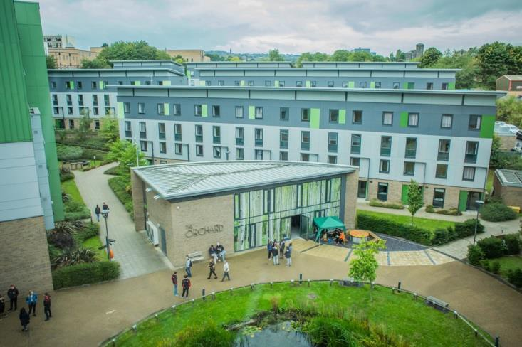
For food you can choose from a wide range of places to eat and drink, including the Atrium Restaurant,
which offers vegan and halal options, and several bars and cafés where you can catch up with your course mates over a cappuccino or celebrate with friends on a night out.
The campus has its own theatre, art gallery and music centre. The University’s Theatre in the Mill is an
intimate space that hosts some ground-breaking and thought-provoking pieces, often by global artists. Many of the shows speak directly to issues related to your PSID degree.
Accommodation
Many Masters students live in our new £40m award-winning eco-friendly student village, The Green. The buildings meet the highest standards of sustainability, costing very little to heat and light, and are arranged as a small village, with rooms available in apartments or townhouses. The Green has a real community feel. It is set in beautiful landscaped gardens, with places to relax and socialise. For more details about what’s available for our students, and for costs, visit www.bradford.ac.uk/accommodationOthers choose to live in privately rented accommodation which is cheaper, easier to find and more conveniently located in Bradford than in most other university cities. Unipol Student Homes offers a free advice service to students (www.unipol.org.uk/bradford), and is a good way of finding a good-quality, safe place to live at a reasonable cost.
Bradford: A Global City
Bradford is a vibrant, friendly, creative and cosmopolitan city with a population of over half a million people
speaking around 70 different languages. This diverse community hosts a diverse range of dazzling street events and festivals such as the annual Mela, a colourful celebration of Asian culture attracting 100,000 revellers. The city’s restaurants serve up a delicious menu of world cuisine including Russian, Chinese,
Ukrainian, Polish, Iranian and Middle Eastern, while our famous curry houses earned Bradford the title of Curry Capital of Britain in 2011, 2012 and 2013.
It is the perfect multicultural setting for the Peace Studies and International Development department. The
city has even had its own Nobel Peace Prize winner and Peace Museum, Bradford was at the heart of the
58

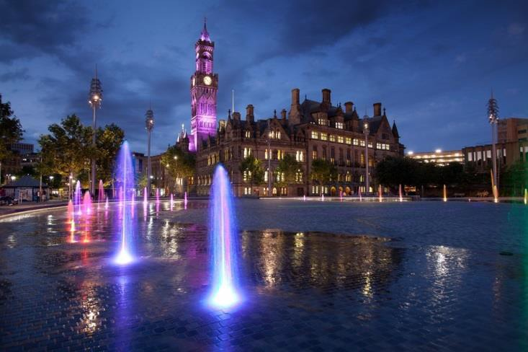
Industrial Revolution and the appalling social conditions of the nineteenth century ensured that it became
the cradle of a lot of important movements for social justice in the past, such as the Methodist movement and the Labour party. It introduced the first municipal schools and nurseries in the country. This rich Victorian heritage is also evident in the city’s abundance of handsome architecture. More recent introductions include City Park, an award-winning landscaped space in the city centre. The mirror pool, spectacular laser light projections and over 100 fountains attract the widest range of people and it is also the setting for many open-air cultural events.
Almost three-quarters of the City of Bradford district is green open space. The beautifully landscaped Lister
Park, next to the University’s School of Management, is within walking distance of the city centre. The surrounding countryside is equally breath-taking. The towns and villages of Saltaire, Ilkley, Haworth and Skipton are all popular tourist attractions, and all host seasonal cultural festivals. They are easily accessible by train or bus services that will also take you into the Yorkshire Dales and spectacular walking and hiking country.
It’s also one of the least expensive student cities in the UK – offering great value for money for housing,
food and nightlife. Social life in Bradford thrives in small, quirky independent bars, including the extraordinary Sunbridge Wells, a rabbit-warren of bars and eateries in old Victorian tunnels beneath the city centre. There are plenty of cinemas, sporting venues, theatres, all within a few minutes’ walk of the City Campus. The National Science and Media Museum is the most visited museum attraction outside London, the Alhambra Theatre is a major touring venue offering top West End shows, contemporary dance and ballet and St George’s Hall hosts top class classical concerts. There is also a wealth of grassroots culture to explore, from artist sound walks around historic Manningham to the flourishing poetry and local music scenes, and literature festivals in Ilkley and in Bradford. Indeed, Bradford was voted ‘Emerging destination of the year’ by tourist bible, The Luxury Travel Guide.
59

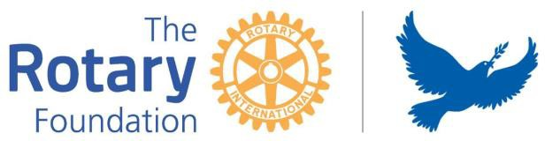
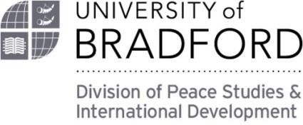
Contact
For general enquiries to the Rotary Peace Centre please email us at:
rotary.peace@bradford.ac.uk
Professor Behrooz Morvaridi
Director, Rotary Peace Centre
Peace Studies & International Development University of Bradford
Richmond Road Bradford
BD7 1DP, UK, 01274 233961
b.morvaridi@bradford.ac.uk
James Barton
Programme Administrator, Rotary Peace Centre
Peace Studies & International Development University of Bradford
Richmond Road Bradford
BD7 1DP, UK, 01274 238115,
j.barton3@bradford.ac.uk
Follow us
Instagram - ubrotarypeace
Twitter - @UBRotaryPeace
Facebook – Rotary Peace Centre – University of Bradford (UBRotaryPeace)
60

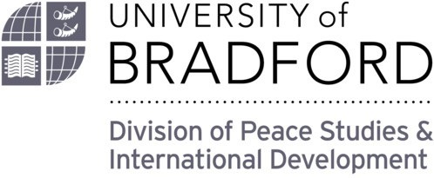

Rotary Peace Centre Peace Studies & International
Development
University of Bradford Richmond Road Bradford
BD7 1DP, UK
01274 238115
rotary.peace@bradford.ac.uk

